Coalition „Pod lupom“ organised 6 public debates for citizens and participants in electoral process 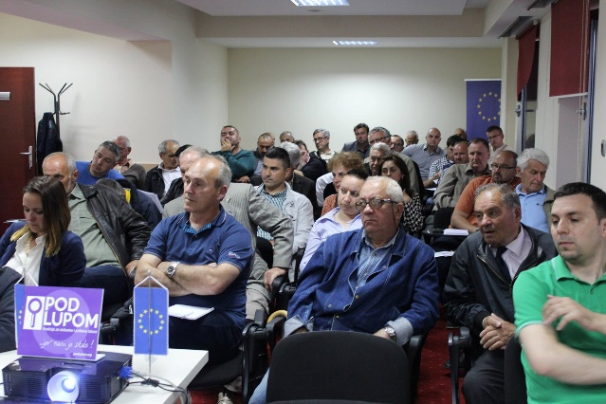
Over the course of the past three months (April-June), the Coalition held three public debates with citizens in Travnik, Brčko District and Cazin as well as three regional conferences with representatives of electoral administration and political subjects in Livno, Bijeljina and Bihać. More than 300 people participated on these events. Final Report on observation of 2016 Local Elections together with Coalition's recommendations to improve electoral process have been presented and irregularities in elections in BiH have been discussed. 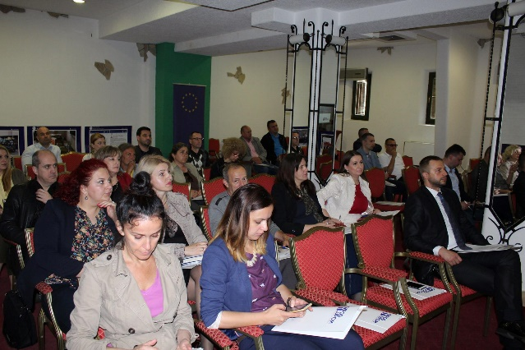Participants of these events had also an opportunity to see Coalition’s photography exhibition pertaining to electoral irregularities as well as to directly address state-level parliamentarians and members of the Central Election Commission of BiH (CEC BiH) by sending them illustrated postcards containing Coalition’s recommendations to improve electoral process.
Online data base ,,Pod lupom” among the best in the world
Coalition’s online data base for registering, deploying, reporting and evaluating observers has been assessed, by relevant stakeholders in the field of elections, as the most comprehensive and excellent in the field of civic and non-partisan observation of elections. In April and May the base has been presented as an example of good practice at events held in Washington and Belgrade where new technologies in the electoral process have been discussed.
CCI's representative participated on ENEMO General Assembly
CCI's representative and director of the Coalition ,,Pod lupom” Mr. Dario Jovanović attended the regular annual meeting of the General Assembly of the European Network of Election Observation Organizations (ENEMO). CCI is one of the founders of this network. Secretary General and members of the Secretariat have been elected on this occasion. In addition, there were discussions on results accomplished over the course of the previous year as well as on strategic orientations in the near future. Two CCI's employees also participated in training for long-term observers and were certified to participate in international election observation missions.
Creation of analyses on electoral legislation and practices in BiH and OSCE member states
Coalition „Pod lupom“ has formed a Working group of young researchers who will be engaged during the period March to June 2017. Researchers have already prepared two analyses: Analysis of Election Deadlines in BiH and Neighbouring Countries and Analysis of the Legislation and Practices of European States Pertaining to Implementation of Binding Judgments of Domestic and Foreign Courts. In addition to this, in this segment, a very important Comparative Analysis of Electoral Irregularities pertaining to the period 2006 - 2016 in BiH has been created, which will be presented to the public in September 2017.
Representative of the Coalition „Pod lupom“ attended a meeting with Mr. Zvizdić
Representative of the Coalition „Pod lupom“ attended a meeting held on May 16 between the Chairman of the Council of Ministers of Bosnia and Herzegovina Mr. Denis Zvizdić and representatives of civil society in BiH, in order to intensify its cooperation. Mr. Zvizdić said that cooperation with civil society would be institutionalized through an agreement that would be tied to the Council of Ministers' agreement with civil society, an office for non-governmental organizations and civil society. He added that they also received responses to the European Commission's Questionnaire from civil society as well as BiH citizens. We use this opportunity to remind that the Coalition ,,Pod lupom" also submitted its answers to 12 questions from the European Commission's Questionnaires pertaining to the area of ​​election and electoral process.
Gathering data in order to improve the quality of elections in BiH
CEC BiH refused to submit to the Coalition ,,Pod lupom” the Central Election Register in electronic form although the public disposal of this document implies an international standard in the area of elections and is guaranteed by the Election Law of BiH. The Coalition ,,Pod lupom" is actively working on gathering data from local election commissions and political parties in the segment of publicity of the work of the electoral committees and the financial operations of political subjects, which will be discussed in the second half of 2017.
Cooperation with entity and cantonal ministries of education
Coalition ,,Pod lupom" obtained permissions from 10 out of 12 ministries of education to continue its activities "First - Time voter" in order to educate young voters who are registered to vote for the first time on 2018 elections. After obtaining all permissions, the Coalition will commence to realise above-mentioned activities in order to educate 15,000 young people on elections and voting methods.
Monitoring of the work of CEC BiH and interdepartmental working groups to improve electoral process
Representatives of the Coalition „Pod lupom“ monitored over 20 sessions of the CEC BiH as well as the work performed by the two interdepartmental working groups (Interdepartmental Working Group to Change Electoral Legislation in BiH and the Interdepartmental Working Group to Analyse the Condition and to Propose Modalities to Introduce new Technologies to the Electoral Process in BiH. Coalition ,,Pod lupom” sent to representatives of both Interdepartmental Working Groups letters containing Coalitions's recommendations to improve Elections in BiH in the field of introduction of new technologies and main technical improvements.
Representatives of the Coalition ,,Pod lupom” held a meeting with the president of the CEC BiH
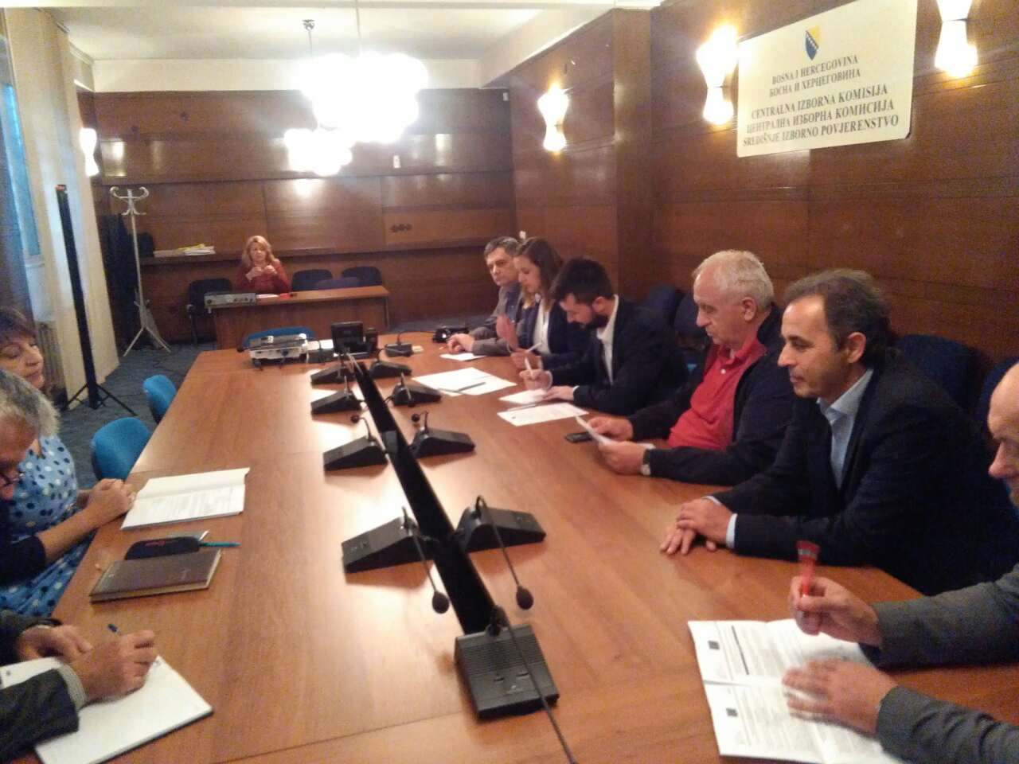
On May 26, the Coalition ,,Pod lupom" held a meeting with the chairman of CEC BiH, Mrs. Irena Hadžiabdić. The purpose of the meeting was to discuss on priority recommendations proposed by the Coalition in order to improve electoral legislation. Four priority recommendations, out of twelve that were presented at the meeting, are pertaining to the CEC BiH, which can independently implement them. Mrs. Hadžiabdić supported most of the recommendations. The Coalition's representatives will also ask other members of the CEC BiH to submit their opinions on recommendations in written form so to provide a unique attitude of this institution on the issue.

For all additional information please follow us via www.podlupom.org, or fb, twitter and Instagram. Thank you!

