Coalition „Pod lupom“presented its Final Report on Observation of 2016 Local Elections
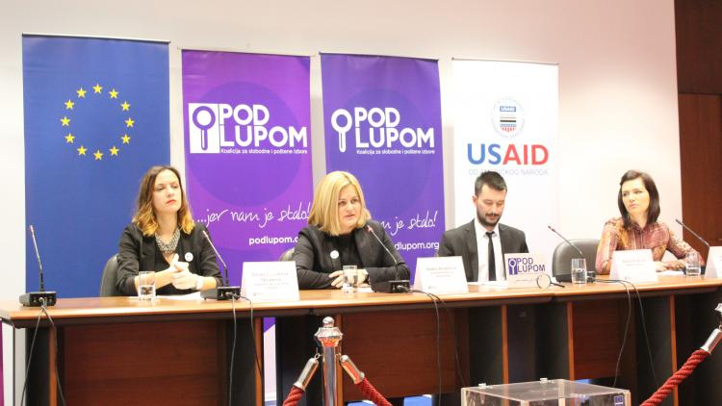
On December 22, at a press conference in Sarajevo, the Coalition "Pod lupom" presented its final report on observation of 2016 Local Elections and gave 34 recommendations to improve electoral process in Bosnia and Herzegovina. General assessment of 2016 Local Elections is that the elections were held in accordance with the Election Law of BiH and implementing acts, mostly in a democratic and fair atmosphere, except in Stolac municipality where Election Law has been violated and electoral process has been interrupted. Findings and recommendations the Coalition "Pod lupom" summarised in its Final Report on 2016 Local Elections were also presented at the State Department and USAID in Washington DC. The final report can be downloaded on the Coalition's website www.podlupom.org.
Observation of repeated local elections in Stolac municipality
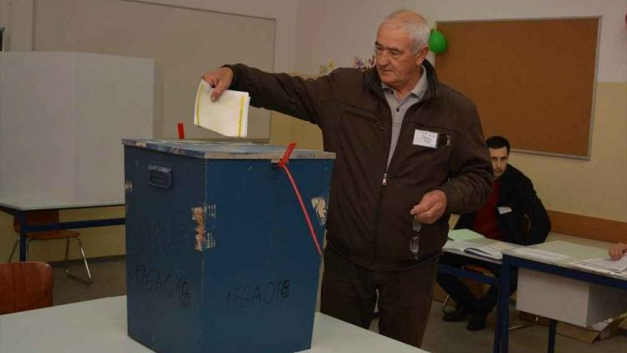
On February 19, the Coalition "Pod lupom" observed repeated local elections in Stolac municipality. Coalition's observers were deployed at all 20 polling stations. Repeated elections in Stolac municipality were held in free and fair atmosphere. Only one incident and several irregularities have been recorded. Citizens of Stolac municipality have shown that it is possible to conduct free and fair elections. Voter turnout has been higher than average, ranging 75.57%.
Coalition „Pod lupom“answered 12 questions contained in the European Commission Questionnaire
Coalition "Pod lupom" answered questions on elections and electoral process contained in the European Commission's Questionnaire. The Coalition sent its relevant responses to the Directorate for European Integration of BiH. By January 31, the Coalition provided following answers: Twelve answers on Political Context; one answer on Social Policy and Employment (Chapter 19); one answer on Judiciary and Fundamental Rights (Chapter 23) and one answer on External, Security and Defence Policy (Chapter 31).
Advocacy activities/Monitoring the work of Interdepartmental Working Groups
Coalition "Pod lupom" monitored the work of two Interdepartmental Working Groups (IWGs) as follows: IWG to Amend Electoral Legislation of BiH and IWG to Analyse Situation and Propose Modality to introduce new Technologies in Election Process in BiH. Coalition's recommendations will be addressed over the course of 2017 at sessions to be held by these IWGs. Through conducting its advocacy activities, the Coalition will demand at least 10 recommendations to be adopted in order to advance electoral process in BiH.
Comparative analysis of electoral irregularities
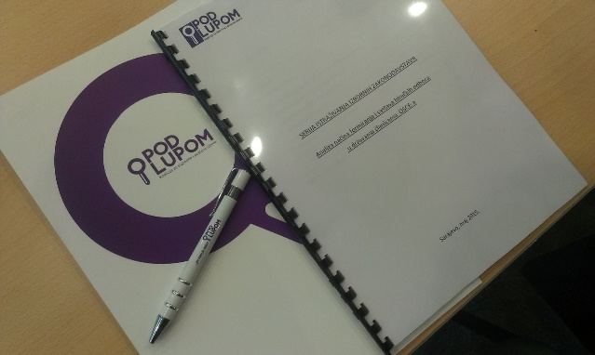
The Coalition is being conducting a research on Comparative Analysis of Electoral Irregularities. The research covers the period 2006-2016, i.e., the last 6 electoral cycles (General Elections 2006; 2010; 2014; Local Elections 2008; 2012; and 2016). The purpose of the research is to collect data and create an analysis on number of complaints on the work of polling station committees; number of objections sent to the electoral administration; number of appeals sent to the Court of BiH pertaining to decisions of the BiH CEC; number of judicial proceedings before the courts in BiH pertaining to electoral irregularities and / or offenses related to elections; number of cases / investigations on electoral irregularities and / or offenses pertaining to elections that have not experienced a judicial epilogue i.e., they are still at the level of the prosecution. Ongoing is gathering of data and developing of the analysis.
Preparation to organise central conference on“ Free and fair elections: Condition that has no alternative!''
Conference "FREE AND FAIR ELECTIONS FOR ALL CITIZENS: A Condition That Has No Alternative!" will be held on March 29, 2017 in Sarajevo. The Final Report on Civic, Nonpartisan Monitoring of 2016 Local Elections in Bosnia and Herzegovina will be presented at the conference. In addition, three panel sessions on elections will be held covering following topics: election deadlines and calendar, polling station committees, and technical improvements in electoral process. For the purpose of the conference there will be prepared and disseminated two analyses, as discussed in the next sections.
Analysis of the Evaluation questionnaire that has been sent to all election commissions in BiH after 2016 Local Elections are held
Coalition „Pod lupom“ sent a questionnaire to all local election commissions in BiH (with the exception of the election commission of the City of Mostar). The questionnaire is composed of 4 parts: general information pertaining to evaluation of the implementation of elections and challenges and / or problems faced by the commissions; the second part is pertaining to the preparation of the Election Day, with reference to the process of appointment and the work of polling station committees; the third part is pertaining to the Election Day, while the fourth part refers to the cooperation between local election commissions with all relevant stakeholders in the electoral process. 119 out of 142 local election commissions submitted completed questionnaires (ranging 84%). The aim of this analysis is to present data and opinions submitted by local election commissions in BiH on 2016 Local Elections. The analysis will be presented at the Central Conference to be held on March 29, 2017.

Analysis of election deadlines in regional countries
Working group, composed of three researchers engaged at the beginning of March 2017, is working on researching of election deadlines in countries in the region (Montenegro, Croatia, and Serbia) in order to compare the length of the electoral process, i.e., duration of the individual electoral process segments in these countries as opposed to those in BiH. This analysis will also be presented at the Central Conference to be held on March 29, 2017.
Monitoring the work of BiH CEC

The Coalition is continued to monitor the work of BiH CEC over the course of 2017. We use this opportunity to remind you that civic, nonpartisan observers did not attend sessions of BiH CEC in the period before the Coalition "Pod lupom" is established.

For all additional information please follow us via www.podlupom.org, or fb, twitter and Instagram. Thank you!

