Local election „under magnifier“; 2.883 nonpartisan observers
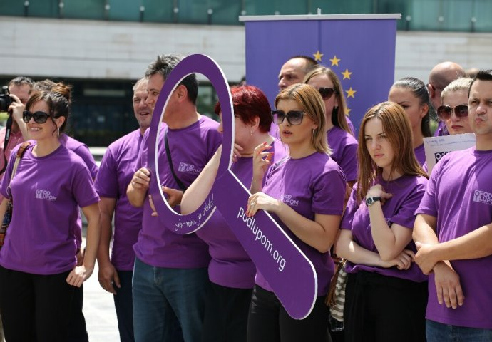
On 2016 Local Elections, the Coalition "Pod lupom" engaged 2,883 observers, out of which 2,562 observers were deployed on polling stations, 120 observers were engaged in mobile teams, 141 observers in local election commissions and 60 volunteers operated in Call centre. 30,000 text messages were received by operators in Call centre on Election Day. The mobile teams additionally covered more than 600 polling stations, ultimately implying that the Coalition covered 3,162 polling stations, or 60.4% of the total number of regular polling stations. After observing Election Day, the Coalition also monitored the work of the Centre for Counting and Local Election Commissions until recounting of ballots on particular polling stations is finished.
Preliminary assessment of Election Day
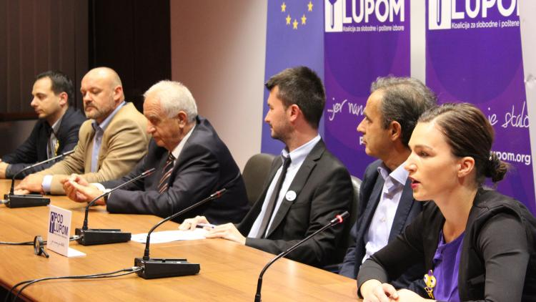
Electoral process at most polling stations and local election commissions in BiH was conducted in accordance with the Election Law of BiH, except in Stolac where elections were cancelled. Incidents and irregularities occurred in some municipalities in the form of violations of the Election Law and implementing acts. Observers of the Coalition „Pod lupom“ reported 299 serious violations of the Election Law and / or implementing acts of BiH CEC on Election Day and night. About 120 citizens' notifications on incidents and irregularities received indicating there are problems in relation to conducting elections. Its Final Monitoring Report on 2016 Local Elections the Coalition "Pod lupom" will present on December 22, 2016 and will publish in February 2017.
Coalition „Pod lupom“ in media
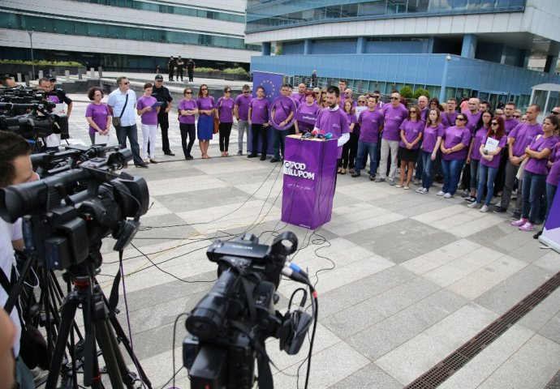
More than 900 media reports on activities conducted by the Coalition „Pod lupom" were recorded in the period November 15, 2015 - October 2016. The Coalition organized 12 press conferences during above-mentioned period and published 26 press releases. Three audio and three video clips were broadcast on radio and TV stations across BiH. As part of the paid promotion, the Coalition achieved cooperation with 41 media outlets in BiH, and additional 18 media outlets provided free space for the promotion of Coalition's activities.

Request to recount ballots sent to BiH CEC
On October 20, 2016 the Coalition "Pod lupom" applied for re-counting of ballots on 12 polling stations. The Central Election Commission of BiH (BiH CEC) rejected the request stating it is incomplete. Such rejection of the request, from which it is clearly apparent that the Electoral Law and / or implementing acts of the BiH CEC have been violated, reinforces the arguments of the Coalition that it is necessary to amend the Election Law in the part pertaining to persons who may apply to claims and objections.
Sending the list of irregularities to local election commissions
The Coalition „Pod lupom“ compiled the list containing 299 irregularities recorded in over 50 local election commissions. Currently, the Coalition is collecting responses from all local election commissions in municipalities where observers submitted their comments into the Register on the work of the electoral committees. After the analysis of responses is completed, the Coalition will develop a plan of possible actions pertaining to electoral irregularities.
Analysis of election irregularities in the period 2006-2016

In order to gain insight into trends, processes and sanctions, the Coalition is preparing analysis of complaints, appeals and judicial processes pertaining to violation of electoral rules in the previous 10 years (2006-2016).

Evaluation seminar organised in October 2016
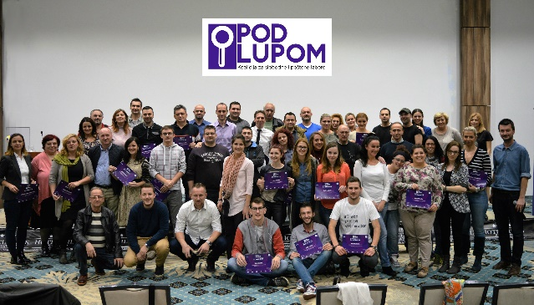

In the period 17-19, October 2016 the Coalition "Pod lupom“ organised evaluation seminar that gathered more than 60 Coalition employees who were engaged in the project of civic, nonpartisan observation of 2016 Local elections. The purpose of seminar was to discuss questions pertaining to results achieved and lessons learned during observation of 2016 Local Elections. In addition, the process of monitoring of elections and election period has also been evaluated so this evaluation will serve to improve all Coalition's activities in the period to come. All participants on seminar, all long-term observers, representatives of the regional offices and headquarters staff received a Thank-you note for their unselfish contribution and achievements during the work in the Coalition "Pod lupom“.

For all additional information please follow us via www.podlupom.org, or fb, twitter and Instagram. Thank you!

