Coalition „Pod lupom” held public debate in Stolac and regional conference in Mostar
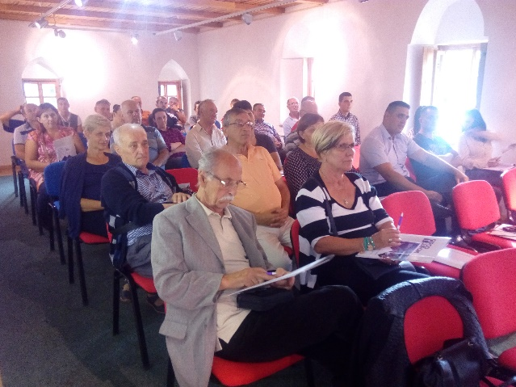
On September 12 and 13 2017, the Coalition "Pod lupom" held two public events in Stolac and Mostar as part of its advocacy campaign to change electoral legislation.
Public debate organised in Stolac focused on interruption of the electoral process, while the regional conference organised in Mostar focused on not holding of elections in this city since 2008.
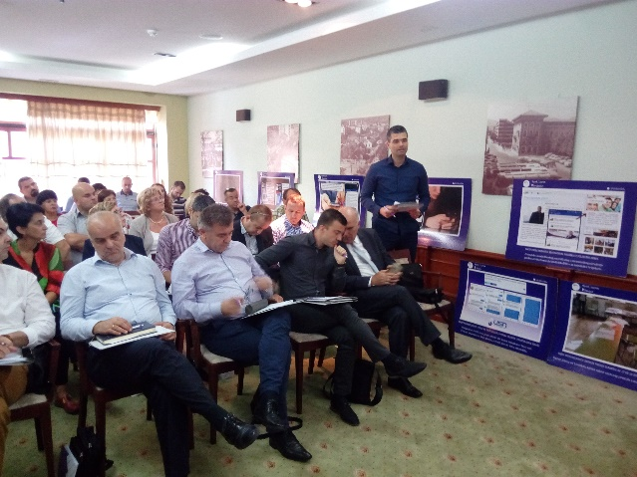
More than 80 participants attended these events. The Final Report on observation 2016 Local Elections was presented together with Coalition's recommendations to advance electoral process. In addition to this, election irregularities also were discussed.

Analyses and advancing public policies
Analysis of election irregularities for the period 2006-2016 and three analyses on technical aspects of the electoral process, resulted from the work of the Working Group of Young Researchers / Associates, have been successfully developed. They will be publicly promoted by the end of 2017 together with three additional analyses that were completed at the beginning of 2016 on following issues: budget allocations for elections, financial reports of political parties and the protection of electoral rights.
Observation of early elections in municipality of Trnovo RS
Early elections to elect mayor of the municipality of Trnovo RS were held on Sunday, September 24, 2017. The Coalition engaged seven observers to observe these elections. These elections were held due to the death of the former mayor.
First time voting! – The second cycle (2017/2018)
The second cycle to educate young people to be voting for the first time on 2018 General Elections will be organized in academic 2017/2018 year. Permits to conduct education of young people are obtained from all relevant cantonal ministries of education. Our goal is to organise 700 workshops and educate at least 16,000 pupils. This activity will be launched in October.
Platform for online citizens' advocacy
In order to advocate changes to electoral legislation, citizens will be able to send Coalition's recommendations to MPs at state-level as well as to CEC members. For this purpose, the Coalition's staff developed the Platform to be used by the citizens. Our goal is to provide citizens an easy way to address MPs thus contribute in advocating the Coalition's recommendations. The Platform will be publicly promoted in the forthcoming period.
Coalition, Pod lupom“ attended OSCE/ODIHR event in Warsaw
Office for Democratic Institutions and Human Rights at the Organization for Security and Co-operation in Europe (OSCE / ODIHR) promoted a 3-year project in Warsaw, on September 08, 2017. Representatives of the Coalition "Pod lupom, attended this event and presented its work.
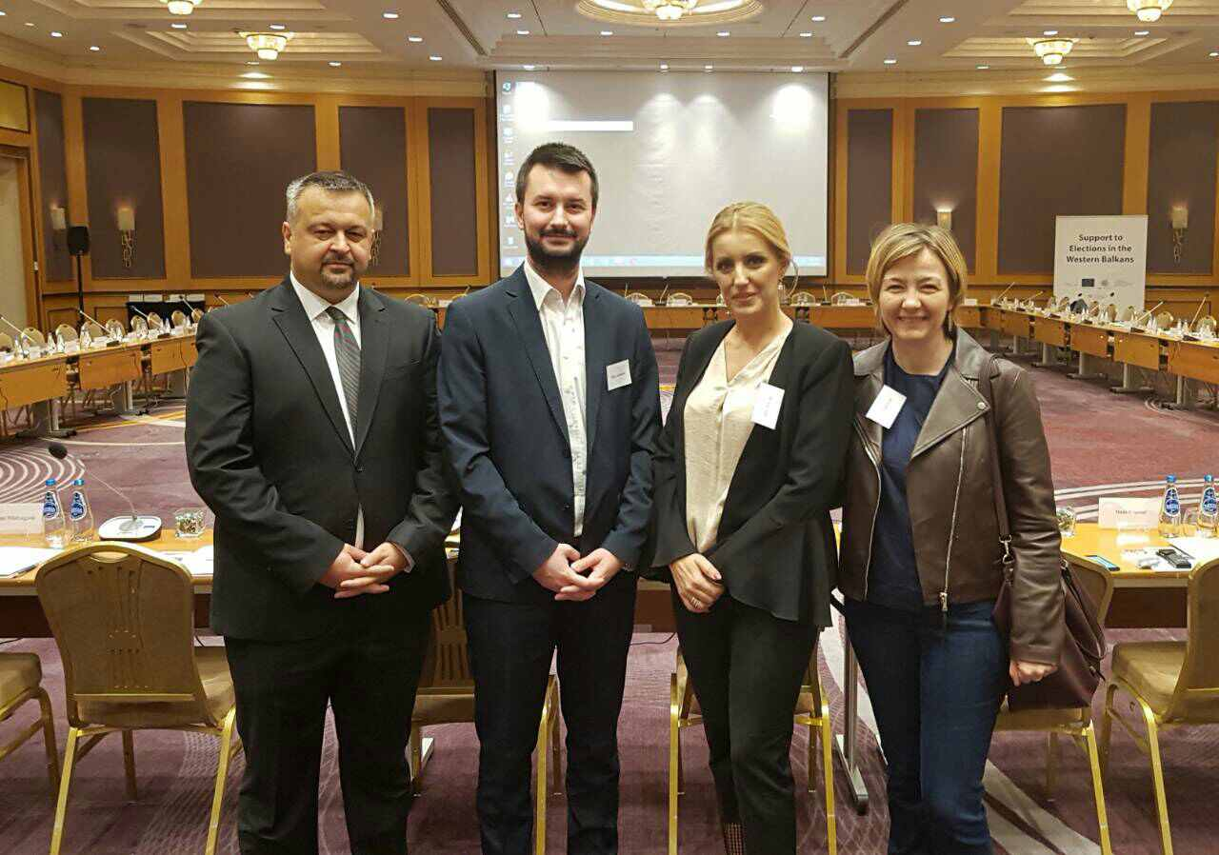
The importance and advantage to implement election observers' recommendations highlighted at the centre of the expert meeting. OSCE / ODIHR project on „Supporting the Elections in the Western Balkans" will provide assistance to Bosnia and Herzegovina, Serbia, Montenegro, Albania and Macedonia in their efforts to implement recommendations on election observation in areas pertaining to implementation of elections, voter registration, and the role and work of the media during election campaigns. The project will also support the bodies in charge to implement elections in Pristina.
Monitoring the work of BiH CEC and Interdepartmental Working Group (IWG) to change electoral legislation in BiH
Representatives of the Coalition attended most of BiH CEC sessions. During the previous three months no session of IWG has been organised.

Meetings with delegates/representatives of the Parliamentary Assembly of BiH
Coalition "Pod lupom" currently is organising series of meetings with representatives of the House of Representatives of the Parliamentary Assembly of BiH and delegates of the House of Peoples of the Parliamentary Assembly of BiH, within its advocacy campaign to change electoral legislation and adopt Coalition’s recommendations. So far, meetings were held with the president of the House of Peoples Mr. Bariša Čolak (HDZ BiH), a delegate of the House of Peoples Mrs. Ljilja Zovko (HDZ BiH) and the delegate of the BiH House of Representatives Mr. Šemsudin Mehmedović (SDA).
Strategic Board meeting
On September 19, 2017 in Coalition's Head Office has been organised Strategic Board meeting in order to discuss activities planned to be conducted by the of 2017.
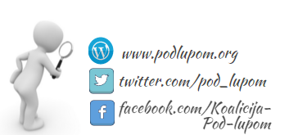

For all additional information please follow us via www.podlupom.org, or fb, twitter and Instagram. Thank you!!

