Proposal of the Coalition to change and amend Election Law of BiH adopted at the first reading
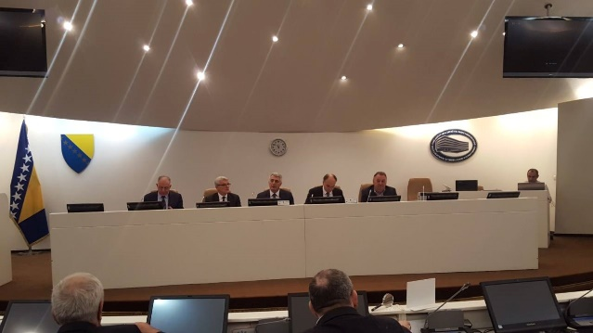
Proposal of the Law to change and amend Election Law of BiH, the Coalition prepared and presented to the public on November 16, has been adopted at the first reading at the 54th session of the House of Peoples of the Parliamentary Assembly of BiH. Authorized proposers of the proposal were Mr. Senad Šepić, Mr. Salko Sokolović and Mr. Sadik Ahmetović. In addition, the conclusion of the Constitutional-Legal Committee of the House of Peoples of the Parliamentary Assembly of BiH to ask for the opinion from the Central Election Commission (CEC BiH) also has been adopted. The CEC’s opinion should be provided prior to the second reading.

Promotion of online advocacy platform has been presented
On November 16, at the press conference held in Sarajevo, the Coalition "Pod lupom" presented its online advocacy platform www.podlupom.org/mail which enables citizens to send parliamentarians proposals to change Election Law of BiH, in just „three clicks“ on their PCs.
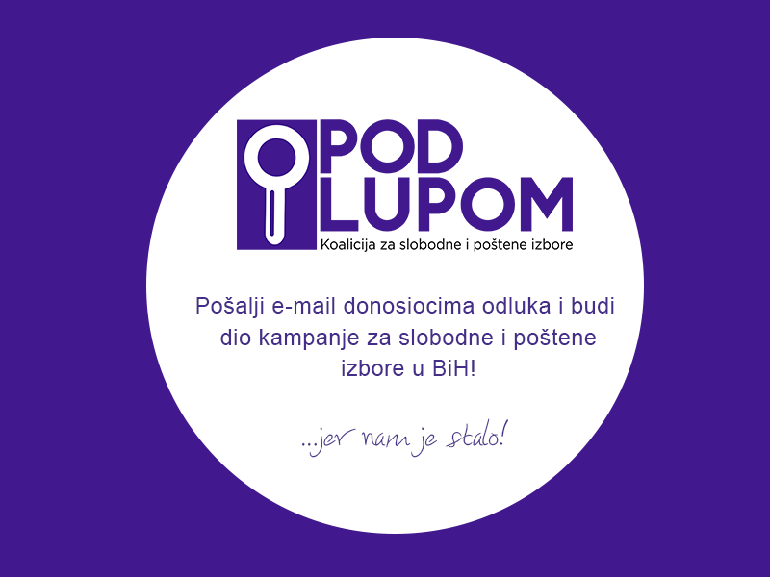
Proposals to advance Election Law of BiH and media and journalist's obligation in the election process have been presented
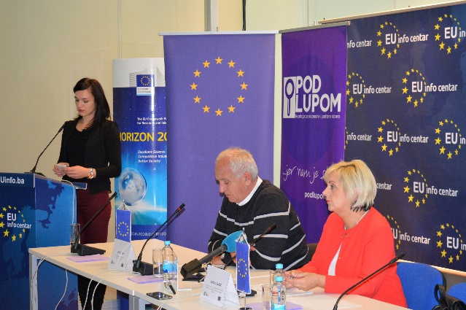

At press conference held on October 31, 2017, in Sarajevo, the consortium composed of the „Association of BH Journalists“ and „Boram“ Agency, presented the proposals to advance the Election Law in the part pertaining to the media and journalist's obligation in the election process. These recommendations are result of mutual cooperation between the Consortium and the Coalition "Pod lupom“ within the project „Building Accountability and Systems in the Elections", supported by the EU.

Meetings with parliamentarians of Parliamentary Assembly of BiH have been organized

Coalition "Pod lupom" held meetings with 16 representatives from both Houses of Parliamentary Assembly of BiH, as part of its advocacy campaign to amend election legislation and adopt recommendations of the Coalition "Pod lupom". Parliamentarians supported Coalition's recommendations pertaining to technical improvements in the Elections and emphasized they will support the same once they are sent into the parliamentary procedure.

Observing early local elections in the municipality of Glamoč
Early elections to elect the Mayor of the municipality of Glamoč were organized on Sunday, December 17, 2017. The Coalition observe elections engaging 10 observers who were deployed on 8 regular polling stations, one mobile team and Municipal Election Commission of the municipality of Glamoč. The elections were held in accordance with the Election Law, without major irregularities and with minor procedural errors occurred at two polling stations.
Coalition „Pod lupom“ organized public events in Zenica, Tuzla, Prijedor and Banja Luka
In the period October-December 2017, the Coalition "Pod lupom" held four public events as follows: in Zenica (October 24), Tuzla (October 25), Prijedor (November 22) and Banja Luka (November 23), by which the Coalition completed a series of 13 public events organized throughout Bosnia and Herzegovina in order to advocate changes to the Election Law of BiH and to improve election legislation in BiH.

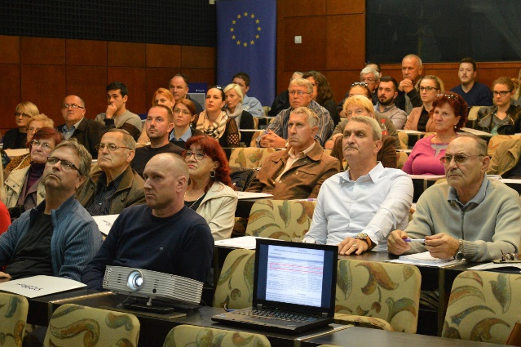
These events gathered over 700 participants who agreed that substantive improvements are needed in order to have free and fair elections and that the Election Law of BiH must be changed as soon as possible.

Training of peer educators and continuation of activity „I vote for the first time“!
A training of peer educators was organised during the period October 22 – 24, 2017, in Sarajevo. In this way, the second cycle of activity to educate young people reaching age of majority prior to upcoming 2018 General Elections was commenced. 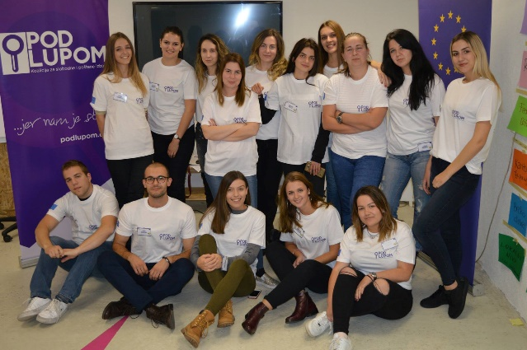 17 educators trained 4000 high–school students from entire BiH

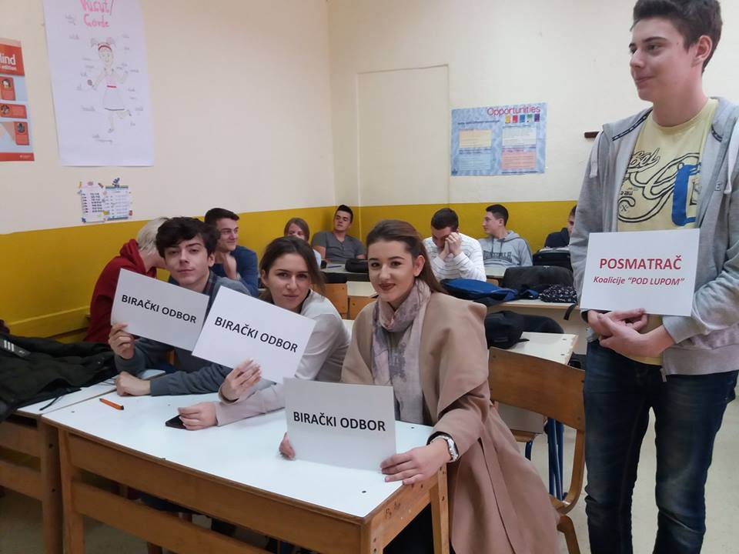

Ambassador of the Republic of Italy visited Coalition „Pod lupom“
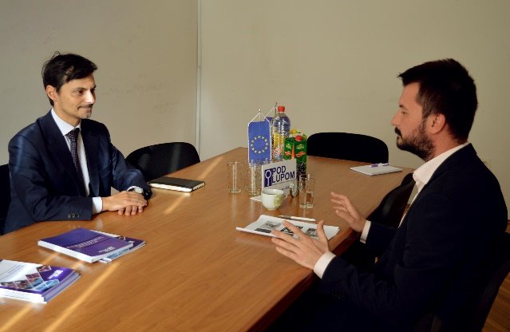
Italian Ambassador to Bosnia and Herzegovina, HE Nicola Minasi, visited the Coalition "Pod lupom" on November 9, and spoke about Coalition’s activities with Mr. Vehid Šehić, President of the Coalition ‘s Strategic Board and Mr. Dario Jovanović, Project Director. The Coalition has also held a series of meetings with representatives of domestic and international institutions and organizations over the past three months, including different embassies in BiH, ODIHR, IFES, etc.

Strategic Board session
On November 24, In Banja Luka was organized the session of the Coalition’s Strategic Board, at which they discussed results and activities to be conducted by the end of 2017.

For all additional information please follow us via www.podlupom.org, or fb, twitter and Instagram. Thank you!

