Coalition „Pod lupom“ attended seminar in Podgorica
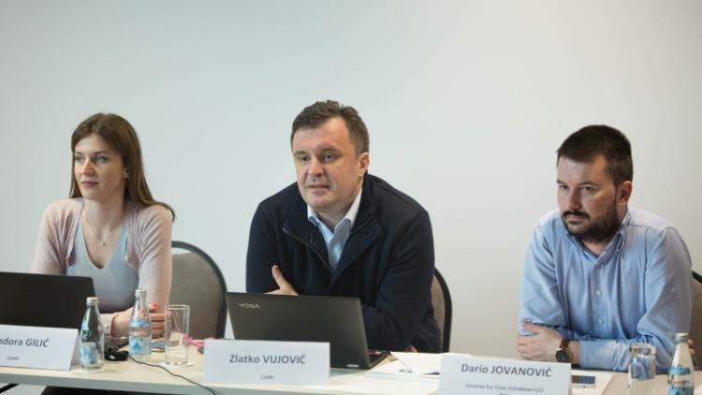
The European Network of Election Observation Organizations "ENEMO" held a seminar on Strategic Planning on February 12-15, in Podgorica. Mr. Dario Jovanović, Project Director of the Coalition “Pod lupom”, attended the Seminar. This event gathered participants of several members organisations of the ENEMO Network, including the Center for Civic Initiatives (CCI), a member organisation of the Coalition "Pod lupom".
Analysis on Election Irregularities over the period 2006 – 2016 has been presented
The Coalition "Pod lupom" presented its Analysis on Election irregularities in the period 2006 – 2016, at the press conference held on March 14, in Sarajevo. The Analysis contains information on objections, complaints and appeals to the election process in Bosnia and Herzegovina, as well as on investigations and sanctions pertaining to irregularities and offenses in the field of elections over a 10 years period.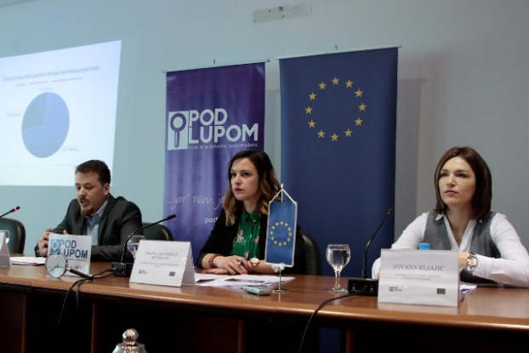 90 Municipal/City Election Commissions in BiH, out of total 143, did not submit requested information on election objections and complaints, upon Coalition’s request. Based on reports received, the Coalition "Pod lupom" concluded that more than 1,000 election complaints have been received. Most of them referred to the Election Day (837) and the process of appointing the members of the pooling station committees (210).
Proposal of the Coalition „Pod lupom “ to change and amend the Election Law of BiH did not have the second reading in the Parliamentary Assembly of BiH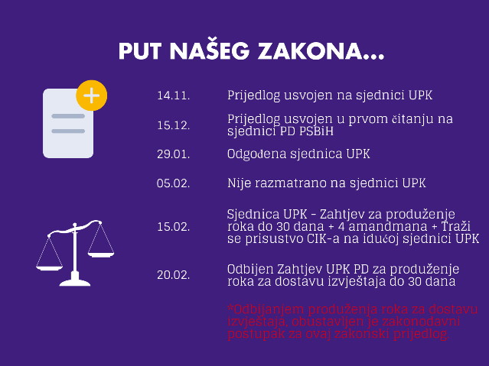
After it was adopted in the first reading at the 54th session of the House of Peoples of the Parliamentary Assembly of BiH, the Draft Law to Change and Amend the Election Law of BiH, prepared by the Coalition „Pod lupom“, was given a negative opinion from the Central Election Commission of BiH (CEC BiH). After the Constitutional-Legal Committee of the House of Peoples of the Parliamentary Assembly of BiH requested deadline extension in order to make a statement on the Proposal, House of Peoples of the Parliamentary Assembly of BiH rejected a 30 - days deadline extension to submit the Report on the Proposal of the Law to Change and Amend the Election Law of BiH. By rejecting deadline extension to submit the Report, the legislative procedure for this legislative proposal was suspended. We use this opportunity to remind you that the authorized proposers of the proposal were Mr. Senad Šepić, Mr. Salko Sokolović and Mr. Sadik Ahmetović.
Meeting with CEC BiH members was organised
Representatives of the Coalition "Pod lupom" held a meeting with the members of CEC BiH on March 13, 2018. The meeting also was attended by the president of CEC BiH, Mrs. Irena Hadžiabdić.
10.000 high-school students throughout BiH have been educated on elections
In the period November 2017 - March 2018, peer educators of the Coalition "Pod lupom“" educated 10,000 high-school students across BiH. By the end of April 2018, 15,000 high-school students will be educated as part of the project activity „I vote for the first time".
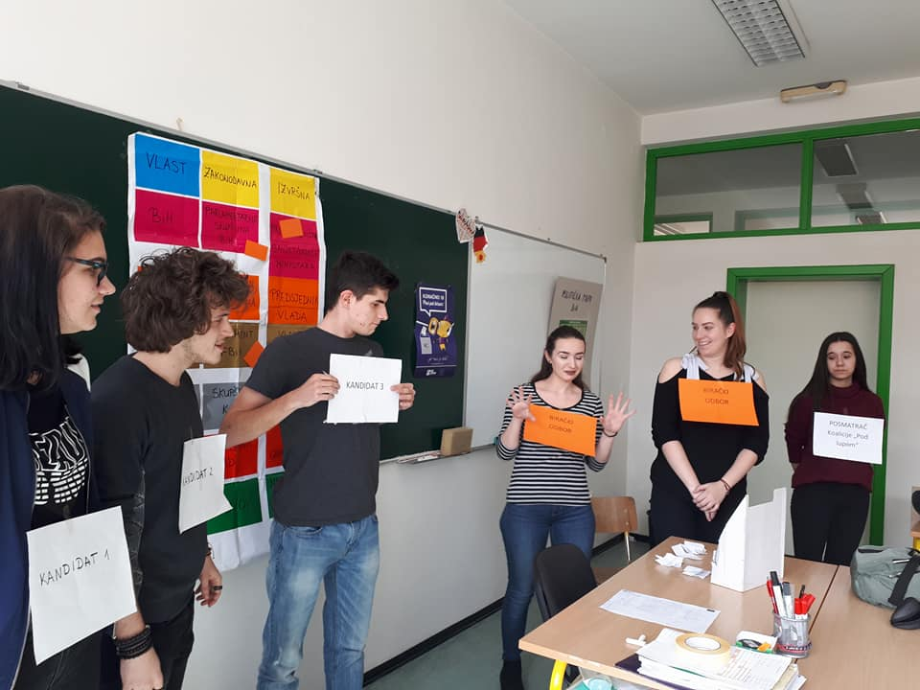
Financial Staff training / Strategic Board members session held
The Financial Staff training on „Capacity building to implement projects funded from EU funds“ has been organised on March 15 and 16, in Teslić.
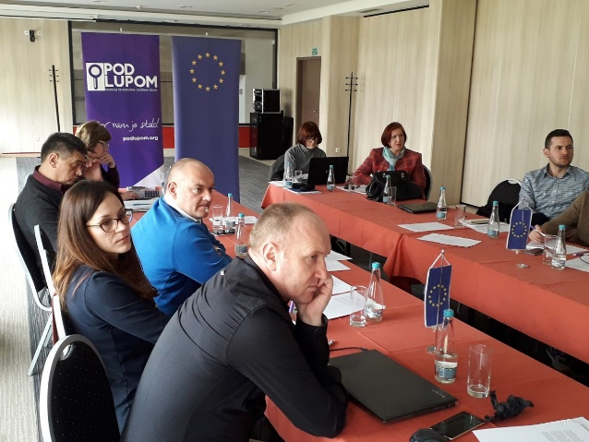
Members of the Coalition’s Strategic Board organised session during the same period, discussing activities of the Coalition to be conducted in the forthcoming period.
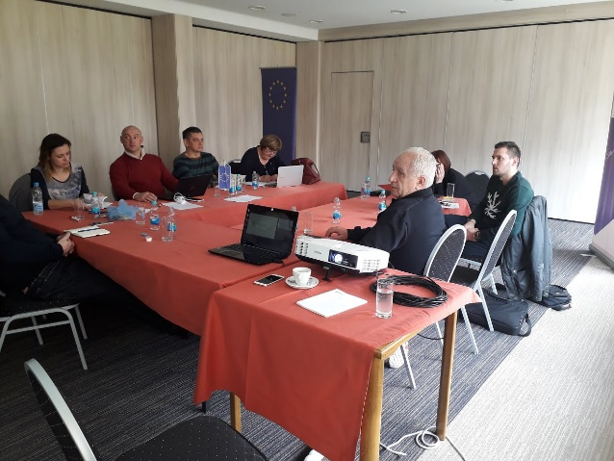
International conference “Free and fair media – fair elections”
International Conference on „Free and fair media - fair elections" held on March 20, in Jahorina, as part of the project “Media monitoring in election process”, conducted by the “Consortium of BH Journalists” and the “BORAM Agency”. Three panel discussions were held at the conference as follows: Regulators and Election Process, Media and Election Process, and Citizens and Election Process.
Coalition "Pod lupom" attended the Forum on Domestic Monitoring of Elections in Brussels
Forum on Domestic Monitoring of Elections in Transition Countries in Europe and Central Asia held on March 20-22, in Brussels. Among the panelists was Mr. Dario Jovanović, Project Director of the Coalition “Pod lupom”.
4 street actions of the Coalition were organised
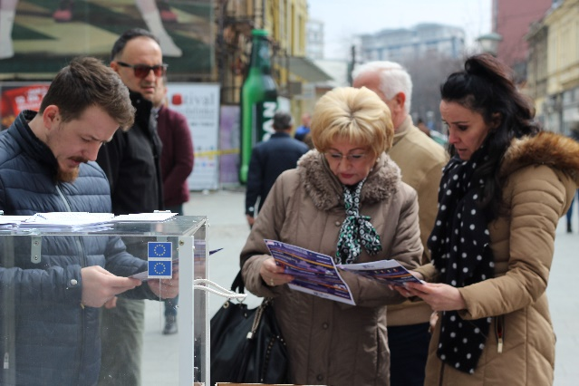
The Coalition "Pod lupom" organised four street actions in four BiH cities (Tuzla, Banja Luka, Sarajevo and Mostar), over the period March 27-30. 2018. Street actions were used to present to citizens of BiH actual polling station settings as opposed to the polling station settings advocated by the Coalition “Pod lupom”, which contains transparent ballot boxes and shortened voting screens. Photographs of election irregularities and TOP 10 Coalition’s recommendations for better elections also were presented on street actions.

For all additional information please follow us via www.podlupom.org , or fb, twitter and Instagram. Thank you!

