

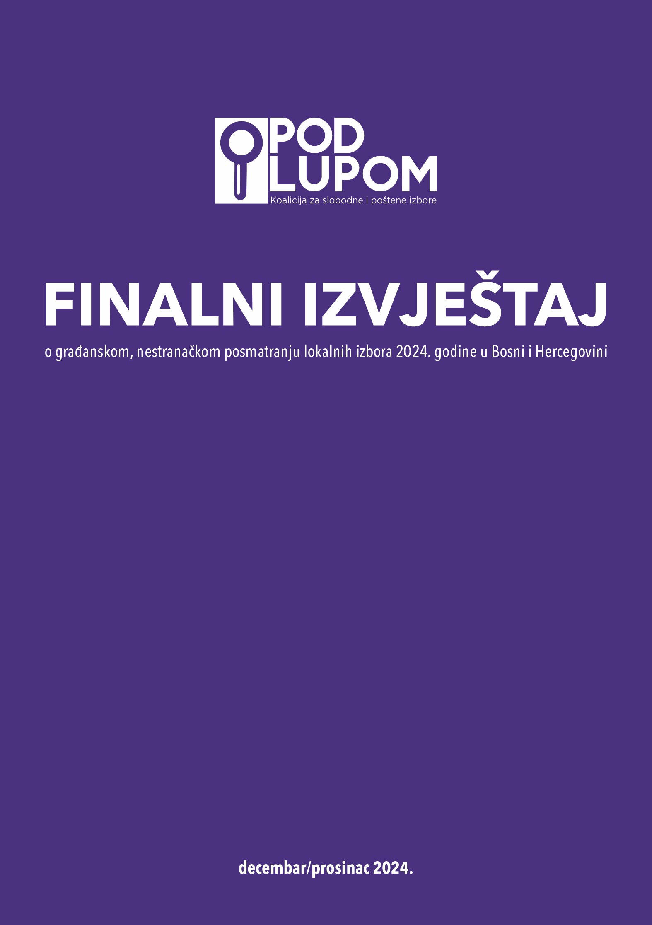

TABLE OF CONTENTS

THANK YOU! 7

SUMMARY 9

RECOMMENDATIONS FOR IMPROVING THE ELECTORAL PROCESS IN BIH 14

NEW PRIORITY RECOMMENDATIONS 14

NEW OTHER RECOMMENDATIONS 15

UNFULFILLED PREVIOUS RECOMMENDATIONS 18

ELECTORAL SYSTEM IN BOSNIA AND HERZEGOVINA 21

LEGAL FRAMEWORK 21

ELECTORAL ADMINISTRATION 23

LOCAL ELECTIONS IN BOSNIA AND HERZEGOVINA 2024 29

POLITICAL CONTEXT 29

BASIC INFORMATION 33

MONITORING OF THE PRE-ELECTION PERIOD 34

GENERAL INFORMATION 34

ASSESSMENT OF THE PRE-ELECTION PERIOD 37

IRREGULARITIES IN THE PRE-ELECTION PERIOD 38

GENERAL FINDINGS OF OBSERVATIONS 38

PRESSURE ON VOTERS 40

IRREGULARITIES RELATED TO POLLING STATION COMMITTEES 43

IRREGULARITIES IN THE ELECTION CAMPAIGN 47

SHORTCOMINGS IN THE WORK OF LOCAL ELECTION COMMISSIONS 49

IRREGULARITIES IN THE WORK OF THE MEDIA 53

OTHER IRREGULARITIES 54

MONITORING THE SOCIAL MEDIA OF POLITICAL ENTITIES 56

MONITORING OF ELECTION CAMPAIGN 59

MONITORING OF THE ELECTION DAY 62

GENERAL INFORMATION 62

ASSESSMENT OF ELECTION DAY 64

ACCESS OF OBSERVERS TO POLLING STATIONS AND VIOLATIONS OF OBSERVERS' RIGHTS 65

ORGANIZATION AND OPENING OF POLLING STATIONS 67

VOTING PROCESS 70

CLOSING OF POLLING STATIONS 72

COUNTING OF VOTES 73

PACKING OF POLLING MATERIAL 74

TURNOUT 74

CRITICAL SITUATIONS ON ELECTION DAY 76

NEW TECHNOLOGIES IN THE 2024 LOCAL ELECTIONS 78

MONITORING OF THE POST-ELECTION PERIOD 88

GENERAL INFORMATION 88

RECOUNTING OF VOTES 89

DETERMINATION OF ELECTION RESULTS 91

PROTECTION OF ELECTORAL RIGHT 93

GENERAL INFORMATION 93

COMPLAINTS, OBJECTIONS, AND APPEALS ON ELECTORAL PROCESS 94

COMPLAINTS BY THE POD LUPOM COALITION 97

REPORTS BY CITIZENS 100

ELECTORAL FORENSICS 102

DATA OPENNESS 102

SIGNIFICANT STATISTICAL DEVIATIONS 105

INTERESTING TRENDS 108

METHODOLOGY OF LONG-TERM ELECTION MONITORING 112

ABOUT US 114

APPENDICES 116

# THANK YOU!

**After 10 years of dedicated work, the “Pod Lupom” Coalition has earned the trust and support of both domestic and international public through its commitment to freer and fairer elections and greater citizen participation in electoral processes in Bosnia and Herzegovina (BiH). Everything achieved so far would not have been possible without those who support our work and directly contribute to the activities of the “Pod Lupom” Coalition.   
  
Our deepest gratitude goes to our observers, the citizens of BiH, who recognized the importance of the Coalition’s mission and vision and actively participated in improving the electoral process and culture in BiH. We sincerely thank all citizens of BiH for their engagement as observers of the “Pod Lupom” Coalition in our joint efforts to ensure free and fair elections in BiH. The dedicated work and tireless energy of the observers, not only this year but in previous years as well, have not only improved the integrity of the electoral process but also set a standard for responsible civic engagement.** **The presence of observers in the field, their monitoring of every segment of the electoral process, and reporting on key observations have enabled greater public trust in democracy. Civic engagement and participation in democratic processes inspire us all to continue working for a better tomorrow, believing that together we can ensure a fairer and more inclusive society.**

**The support of donors has paved the way for freer and fairer elections in BiH. Because of the financial and advisory support of donors and partners, we have been able to defend the electoral will of the citizens and the voice of every individual in the country.**

**We also extend our gratitude to all media outlets that have professionally reported on the electoral process, especially those that have generously provided free media space for the activities of the “Pod Lupom” Coalition. Our thanks also go to all the administrative bodies that have opened their doors to the Coalition’s staff and demonstrated their willingness to cooperate. We extend special thanks to electoral bodies, the Central Election Commission of BiH, and local election commissions for their collaboration. We also thank other domestic and international organizations and institutions for their cooperation.**

**At the “Pod Lupom” Coalition, we firmly believe that free and fair elections in BiH are possible, and the results we have achieved support this belief. We look forward to your continued contributions and trust that together we will keep building confidence in democratic processes.**

**Thank you!**

# SUMMARY

Assessment of the 2024 Local Elections:

* The local elections in Bosnia and Herzegovina (BiH) in 2024 were generally conducted successfully. However, instances of electoral rule violations and isolated incidents were recorded, requiring serious analysis and preventive measures in the future. Significant challenges were observed in the voting and vote-counting processes. The integrity of the elections was improved through amendments to the Election Law of BiH, which has already yielded limited results. The piloting of new technologies was regarded as highly successful. Immediate efforts are essential to introduce electronic voter identification and ballot scanning devices at all polling stations for the 2026 General Elections in BiH. Timely sanctions must be enforced for all election irregularities, with the strictest penalties for repeat offenders of electoral rules.

Pre-election period:

* The Coalition "Pod lupom" assessed the preparations for the 2024 Local Elections as generally efficient, albeit with certain shortcomings.
* Irregularities and deficiencies were noted in the work of election bodies, most commonly related to missed deadlines by local election commissions and inadequate application of new provisions in the Election Law of Bosnia and Herzegovina (e.g., extracts from the Central Voters Register were not published on the BiH Central Election Commission’s website; some election irregularities supported by evidence were not sanctioned; complaints were not addressed in a timely manner, and imposed sanctions were often not dissuasive).
* The High Representative in Bosnia and Herzegovina adopted a decision on "technical amendments" to the Election Law of BiH aimed at enhancing the integrity of the election process. This decision fully or partially implemented 28 recommendations of the Coalition "Pod lupom" for better elections in BiH, including four out of five priority recommendations.
* The amendments to the Election Law of BiH introduced reforms to the lowest level of election administration, i.e., polling station committees; prohibited premature campaigning; more precisely regulated the misuse of public funds and resources; improved protections of electoral rights; tripled sanctions; and created prerequisites for the introduction of new technologies in the electoral process.
* The amendments to the Election Law have yielded results, with a significantly higher number of reports and sanctions for election irregularities being recorded in line with the new election rules.
* The election campaign was notably calmer, with a greater focus on local issues within the scope of local government responsibilities.
* A total of 1,367 potential election irregularities were recorded during the pre-election period.
* The pre-election period was marked by instances of premature campaigning, paid advertising during the prohibition period, abuse of public funds and resources, and irregularities in the formation of polling station committees in accordance with the reform of polling station committees.
* By political entities, the most frequent violators of electoral rules are:
* SNSD: 213 irregularities
* SDS: 202 irregularities
* SDA: 171 irregularities
* HDZ BiH: 161 irregularities
* SDP: 122 irregularities
* PDP: 107 irregularities

Election Day:

* The Coalition "Pod lupom" assessed that Election Day at the majority of polling stations proceeded in accordance with election rules.
* The processes of organizing and opening polling stations, closing polling stations, and packing polling material were carried out without significant differences compared to previous election cycles.
* The voting process at regular polling stations where new technologies were not piloted was rated less effective than in previous elections, with a significant increase in instances of family voting, abuse of voter assistance, and voting without proper voter identification.
* The vote-counting process at polling stations without electronic identification and scanners was rated less effective compared to previous elections, with the potential to influence the election results at 3.8% of observed polling stations.
* A total of 149 critical situations were recorded on Election Day, all of which were successfully resolved.
* Observers from the Coalition "Pod lupom" filed 74 complaints in Poll Book of the Polling Station Committees.

New Election Technologies:

* The piloting of new technologies was rated as extremely successful at 97.9% of the polling stations observed.
* Only 2.1% of polling stations discontinued the use of new technology and reverted to the traditional voting method.
* The voting process at polling stations using electronic voter identification and ballot scanners was rated more effective compared to regular polling stations.
* At polling stations where scanners were used, scanning both ballots took an average of 44.9 seconds, from accessing the scanner to completing the process.
* At polling stations using electronic identification, an average of 11 voters (3.4%) could not be successfully identified out of an average turnout of 322 voters.
* At polling stations with scanners, the average time to transfer results for both levels of government, including preferential votes for candidates, was 92.6 seconds.
* The use of electronic voter identification, ballot scanners, and electronic result transfer prevents "traditional" election irregularities and fraud on election day, such as voting in another person’s name, multiple voting, abuse of unused ballots, vote nullification, and adding preferential votes to ballots.

Protection of Electoral Rights:

* According to publicly available information, the CEC of BiH received a total of 1,480 reports of election irregularities in the form of complaints, appeals, and initiatives.
* Most complaints and appeals concerned premature campaigning (603), misuse of public funds and resources (367), violations of election silence (151), and paid campaigning during prohibited periods (145).
* Based on these complaints and appeals, the CEC of BiH imposed monetary sanctions in only 159 cases. This means that only one in ten complaints results in financial penalties for violators of election rules.
* A total of 859,500 BAM in monetary fines was imposed.
* The Coalition "Pod lupom" filed 442 reports of election irregularities to the competent institutions.
* Based on the Coalition’s reports, CEC imposed fines totaling 158,500 BAM

Election Observation Mission of the "Pod lupom" Coalition in Numbers:

* 829 citizen, nonpartisan observers on election day
* 776 polling stations covered (one in seven regular polling stations in the country)
* 60 operators in the call center
* 100,000 data points on the quality of the election process
* 54 long-term observers
* 1,213 meetings with various election process stakeholders
* 1,716 reports from long-term observers
* 20,000 citizens used educational tools provided by the Coalition on elections in BiH
* 1,000 citizens and 100 international observers trained in election day observation
* 12 press conferences and 23 press releases
* 963 press reports on the activities of the Coalition "Pod lupom"

# RECOMMENDATIONS FOR IMPROVING THE ELECTORAL PROCESS IN BIH

# NEW PRIORITY RECOMMENDATIONS

1. **Introduce New Election Technologies at All Polling Stations!**

Implement electronic voter identification and ballot scanners at all polling stations for the 2026 General Elections in Bosnia and Herzegovina.

1. **Sanction All Election Irregularities Timely and Adequately!**

All proven election irregularities must be sanctioned, particularly pressure on voters, misuse of public funds and resources, irregularities in voting, and manipulation during vote counting. Repeat offenders must face progressively stricter penalties to deter further violations of election rules.

1. **Publish the Central Voter Register!**

Extracts from the Central Voters Register must be published and made accessible to all citizens on the website of the Central Election Commission of BiH, as required by the Election Law of BiH and in accordance with principles for protecting personal data. The Voters Register should be periodically revised by election bodies, competent institutions, and/or independent election stakeholders.

1. **Develop a Database of Trained Non-Partisan Candidates for Polling Station Committee Presidents and Deputies!**

Non-partisan presidents of polling station committees and their deputies should be selected and trained during non-election periods, starting in 2025 to establish a database of non-partisan individuals as potential presidents and deputy president of polling station committees.

1. **Simplify the Accreditation Process for Non-Partisan Election Observers!** The accreditation process for non-partisan election observers (including observers from civic associations and international observers) should be simplified to ensure easier access to polling stations. Observer identification at polling stations should rely on lists of accredited observers provided by the Central Election Commission of BiH. Physical accreditation badges should either be abolished or redesigned and made available at polling stations upon the observer’s arrival.

## NEW OTHER RECOMMENDATIONS

FOR LEGISLATIVE AUTHORITIES:

1. The discussion on electoral reforms should return to state government institutions to the greatest extent possible. It should involve a wide range of electoral stakeholders (including, in addition to government officials, representatives of international institutions, election experts, civil society, academia, media, and others) to improve the legal framework for elections in line with international standards and best practices. This process must be transparent and inclusive to restore citizens' trust in the electoral process.
2. Promote the active involvement of women in public and political life through institutional, legal, and educational mechanisms and actively oppose and condemn hate speech, gender-based violence, and gender stereotypes about the roles of women and men in politics.

**FOR THE ELECTORAL ADMINISTRATION:**

1. The Central Election Commission of Bosnia and Herzegovina (CEC of BiH) must ensure the timely review of all complaints and appeals related to the electoral process. Improvements are needed in handling reports of electoral irregularities (comments, complaints, appeals, initiatives, citizen reports, and other submissions). A priority system should be established for addressing cases (e.g., based on the potential impact on the electoral process, severity of the violation, alignment with the electoral activity calendar, or chronological order of submission). Clear practices for sanctioning should be defined, particularly ensuring progressive and strict penalties for repeat offenders. This can be achieved through further strengthening of the human and technical capacities of the BiH CEC Legal Department.
2. **Prohibit** the use of parallel voter lists by party observers at polling stations for recording voters who have cast their ballots to safeguard voting secrecy.
3. **Ensure open election data in line with best practices.** Election results, regulations, procedures, decisions, and all other relevant documents must meet open data standards. These include public accessibility, free usage, easy access, completeness, machine-readable formats for seamless processing, open-source formats, open licenses, and similar standards.
4. The Central Election Commission of BiH should conduct active oversight of the composition and work of local electoral commissions (municipal, city, and the electoral commission of Brčko District BiH) weekly to ensure timely access to relevant information regarding the effectiveness and efficiency of their work (planning and reporting, changes in composition, gender representation, working conditions, political pressures, number of sessions, complaints and decisions made, public access, and transparency of operations).

FOR COURTS, PROSECUTORS, AND POLICE:

1. **Courts and prosecutors must in a timely manner initiate and conclude processes to determine accountability for electoral irregularities, particularly those involving elements of criminal offenses.**
2. **Courts and the Central Election Commission of Bosnia and Herzegovina should timely publish all information regarding complaints, appeals, and decisions related to elections to enhance transparency and accountability.**
3. **Law enforcement agencies, particularly prosecutors and police, in collaboration with the electoral administration, must take all necessary steps within their jurisdiction to prevent, deter, and sanction pressure on voters.**

NEW ELECTION TECHNOLOGIES:

1. **Preparation for the full implementation of new electoral technologies, specifically electronic voter identification and ballot scanners, should begin on time, no later than the first quarter of 2025. Activities include selecting the equipment to be implemented, public procurement, training of election administration and voters, implementation and delivery of new technologies, new design and printing of ballots, and additional testing.**
2. **Training of election administration on the use of new electoral technologies must begin well in advance of the elections and be comprehensive and practical.**
3. **Voter education on new electoral technologies, voting methods, and reporting of observed electoral irregularities needs to be improved and innovated, in cooperation with civil society organizations, the media, and other election process actors.**
4. **Consideration should be given to the use of two ballot scanners at polling stations with more than 700 registered voters on the extract from the Central Voters Register and an average voter turnout greater than 50%. This is especially important in the context of the upcoming general elections when voters will cast votes on four ballots, with an estimated scanning time of 90 seconds for all four ballots, to avoid crowding at polling stations and ensure that all voters can exercise their right to vote.**
5. **The protective folder for covering the ballot for scanning should be redesigned to cover the entire length of the ballot, and voters should be instructed to place the side of the ballot with their marked preferences facing the scanner (down) so that the voter’s choice is not visible when inserting the ballot into the scanner, ensuring the secrecy of the vote.**
6. **Redesign double-sided ballots so that the entire list of candidates for each political entity begins with the name of the political entity and ends with the last candidate on the same page and column of the ballot (not spilling over onto the next page or column).**
7. **Consider procuring equipment for electronic voter identification through public procurement to utilize existing technical solutions already proven in practice, rather than developing new, untested solutions that have not yet been applied in elections.**
8. **Define the responsibility, method, and coverage of costs for the storage, maintenance, and security of new election technology equipment between elections.**

## UNFULFILLED PREVIOUS RECOMMENDATIONS

FOR LEGISLATIVE AUTHORITIES:

1. Implement the rulings of the European Court of Human Rights, ensuring that all citizens of BiH aged 18 are granted active and passive voting rights, regardless of their ethnic affiliation and place of residence.
2. Adopt the official consolidated version of the Election Law of BiH.
3. The Election Law of BiH should prevent changes in ethnic affiliation for a period of three consecutive election cycles.
4. Lower the intra-party election threshold for general elections in BiH to 10% and align it with the intra-party election threshold for local elections.
5. Introduce deadlines for the formation of the executive branch and the obligation to call early elections if the executive is not formed within the set deadlines at the state, entity, and canton levels (partially implemented for the Federation of BiH through the decision of the High Representative).
6. Shorten all election deadlines from the date of election announcement to the official and complete publication of final election results (from the current 180 days to a maximum of 120 days).
7. Adopt the Law on the Principles of Political Organizations' Operations at the BiH level to equalize the criteria for establishing political parties, create a single registry of political entities, and define key principles for the work and reporting of political entities.
8. Ensure the minimal representation of all three constituent peoples in representative bodies at the canton level in the Federation of BiH, and at the local level through amendments to the statutes of municipalities/cities.
9. Revise constituencies and the number of mandates for the state and entity parliaments to ensure the principle of equality of voting.
10. Abolish compensatory candidate lists and allocate compensatory mandates to candidates with the highest preferential votes from regular candidate lists of political entities at the entity level. The rules for awarding compensatory mandates should ensure gender and regional representation by constituencies.
11. Depoliticize, to the greatest extent possible, the procedures for appointing members of election commissions, focusing on the expertise and professional integrity of candidates for these positions. Oversight of the work of commissions and other actions should be conducted in accordance with the law and competencies, based on facts and arguments, rather than daily political issues, thus contributing to strengthening election commissions at all levels.

FOR THE ELECTION ADMINISTRATION:

1. Allow objections to the electoral process at every stage of the electoral process.
2. Improve the publication of information about objections and complaints received on the website of the BiH Central Election Commission by creating a database that will contain all documents in their original form, along with the accompanying decisions on how they were handled, and with the protection of the identity of individual complainants/citizens. Expand the database, or the publication of information about objections and complaints, to include complaints submitted to the election commissions of basic constituencies.
3. Improve the system of financial control of political party operations, especially during election years and in reporting election campaign expenses, by strengthening the human and technical capacities of the Audit Service of the Central Election Commission of BiH so that all citizens can timely access information on funding sources and expenses. Include other institutions responsible for the operations of legal entities as necessary (tax administrations, state auditors, banks, etc.,) in the financial control of political party operations.
4. Improve the quality and intensity of training for local election commissions, especially during the non-electoral period, to increase the effectiveness and efficiency of their work during the electoral period.
5. Sanction unjustified withdrawal from the work of the election commission before the election day by banning engagement for at least the next two electoral cycles and establishing a record-keeping system for such cases at the local election administration level.

OTHER TECHNICAL ASPECTS OF ELECTION IMPLEMENTATION:

1. When determining the locations of polling stations, special attention should be paid to ensuring that the polling stations are accessible to persons with disabilities.
2. In future improvements to the organization of election day, particularly in the segment of voting at polling stations, consideration should be given to how to ensure conditions for blind and visually impaired persons to vote independently.
3. Strictly apply the Election Law of BiH and the implementing acts of the Central Election Commission of BiH related to the public disclosure of the names of polling station committee members at polling stations, which must include the name (not the code) of the political entity that appointed the members.
4. Technically improve the preparation of copies of forms with aggregate results (so-called yellow copies) to ensure they are legible and ensure their public posting at the polling station after all processes at the polling station are completed, as prescribed.

# ELECTORAL SYSTEM IN BOSNIA AND HERZEGOVINA

## LEGAL FRAMEWORK

Elections in Bosnia and Herzegovina are held within a complex legal framework that stems from the country’s specific Constitution and asymmetric internal structure. The Constitution of Bosnia and Herzegovina, which is Annex IV of the Dayton Peace Agreement, grants limited powers to state institutions while transferring most of the authority to the entities – the Federation of BiH and Republika Srpska – and to the cantons within the Federation of BiH. The Brčko District of BiH has a special status as a local self-government unit under the sovereignty of the state and the condominium of both entities. Local self-government in BiH, which includes 143 municipalities and cities, is not defined by the national Constitution but by the entity constitutions and the Statute of the Brčko District of BiH. The electoral system of BiH is based on Annex III (Electoral Agreement) and Annex IV (Constitution of BiH), as well as the Election Law of BiH, and the election cycles, divided into general and local elections, are organized alternately every two years. The specificity of this constitutional arrangement is reflected in the concept of constituent peoples, which recognizes Bosniaks, Croats, and Serbs as constituent peoples, while citizens who do not identify ethnically or belong to national minorities are labelled as "Others." Although national minorities are guaranteed seats in local representative bodies if they make up at least 3% of the population according to the latest census, this system has been criticized for discrimination against citizens who are not constituent peoples, further highlighting the need for electoral reform.

Reflecting the complex constitutional structure of BiH, the electoral system represents a combination of nearly all existing electoral principles: the majority principle and single-member and/or multi-member constituencies for the election of members of the Presidency of BiH, the President and Vice Presidents of Republika Srpska, as well as mayors/presidents of cities/municipalities, and the proportional principle with multi-member constituencies for the election of parliaments/assemblies and representative bodies at the local level. A delegate system is applied for the election of the House of Peoples in the Federation of BiH and at the level of the Parliamentary Assembly of BiH, as well as for the election of delegates to the Council of Peoples of Republika Srpska. The Election Law stipulates a 3% electoral threshold, allowing political entities that surpass the threshold to qualify for the distribution of regular mandates, which applies to all electoral races based on the proportional system. Voters have the option, on closed non-blocked (so-called semi-open) lists, to vote not only for the political entity but also for some of the candidates on the list of that political entity. The preferential method is used to determine which candidates on that political entity’s list have received the most trust from voters, thereby determining who will individually receive the mandate. For the election of representatives in local representative bodies, the intra-party threshold for obtaining mandates on semi-open lists is set at 10% of the total number of votes received by the political entity.

In local elections, according to the Election Law of BiH, members of national minorities have the right to representation in municipal/city councils or assemblies, proportional to their participation in the population according to the most recent census. If this percentage according to the census was higher than 3%, members of national minorities are guaranteed at least one seat in the local representative body. The law stipulates that, in addition to political entities, the right to apply for participation in elections to fill guaranteed mandates for members of national minorities can also be exercised by registered associations or other registered forms of activity of national minorities, and that a group of at least 40 citizens who have voting rights can nominate a candidate for the election of a representative of a national minority.

The Election Law of BiH is the fundamental law for the organization and conduct of elections. To date, this law has undergone 24 amendments. The most recent amendments to the Election Law of BiH took place on March 26, 2024, when the Office of the High Representative (OHR) exercised its so-called Bonn Powers and issued a decision on amendments and supplements to the Election Law of BiH. The focus of these amendments is to strengthen the integrity and transparency of the electoral process while aligning with international election standards. Key changes include the introduction of new election technologies into BiH’s election system, which include ballot scanners, electronic voter identification, result transmission, and video surveillance at polling stations. Additionally, the role of the CEC BiH has been strengthened, and polling station committees have been professionalized through the appointment of the president of the polling station committee and his/her deputy by the CEC, with the requirement for non-partisan affiliation and specified competencies for candidates. Furthermore, polling station committee members cannot be individuals who stand as candidates or have been candidates in previous general and local elections, as well as elections for municipal communities. Additionally, parties that did not become parliamentary in the previous elections of the same cycle cannot receive seats in the polling station committees, which eliminates the presence of so-called fictitious parties and prevents illegal trading of seats in polling station committees, a major issue in all previous elections. Other amendments and supplements to the Election Law of BiH include: a ban on premature campaigning, more precise regulation of the misuse of public funds and resources, improvement of electoral rights protection segments, increased sanctions, a ban on the candidacy of candidates convicted of war crimes, the introduction of a maximum of three preferences on candidate lists for parliaments/assemblies, the introduction of a substitute mandate, etc. The "Pod Lupom" Coalition expressed support for the amendments to the Election Law of BiH, which took into account many recommendations from election observers. This decision represents a significant step toward strengthening democracy, benefiting citizens, reducing the risk of electoral fraud and irregularities, and increasing trust in the electoral process. However, it remains disappointing that domestic institutions and political representatives, elected and financed by citizens, did not take these necessary steps themselves to improve the electoral system.

## ELECTORAL ADMINISTRATION

The electoral administration in Bosnia and Herzegovina is a complex system of bodies and institutions responsible for organizing, supervising, and conducting the electoral process, ensuring the legality, transparency, and equality of election participants at all levels. The electoral administration in BiH consists of ***the Central Election Commission of BiH (CEC of BiH), local election commissions (LEC), and polling station committees (PSC).***

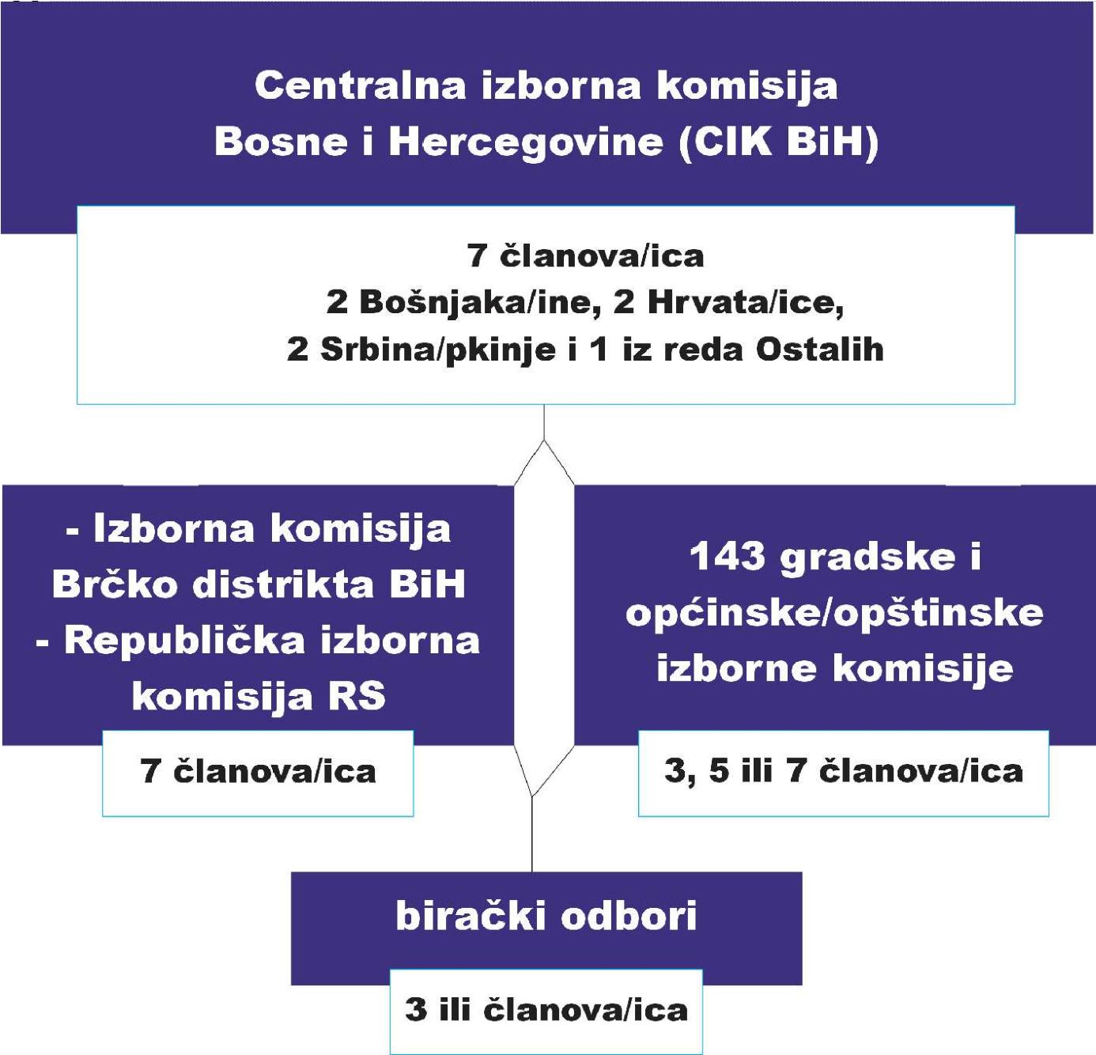

Infographic 1 – Electoral Administration

**The Central Election Commission of BiH (CEC of BiH)** is the institution responsible for organizing, overseeing, and conducting all elections in BiH and plays a key role in the electoral process. The CEC of BiH is responsible for many aspects of the electoral process, from the certification of political parties and candidates to the determination and publication of election results. The CEC ensures the integrity of the voter register, oversees the work of election commissions and polling station committees, and ensures that elections are conducted in accordance with laws and regulations. It also issues regulations on ballot papers, technical equipment, and procedures for the use of electoral technologies. It consists of seven members (two from the Serbian, Croatian, and Bosniak peoples, and one from the "Others" category), who are appointed for a period of seven years. The president of the CEC is elected from among the members, where each member, on a rotational basis, takes over the presidency for a period of 21 months, ensuring equality in the representation of the constituent peoples in decision-making bodies. The administrative-technical and professional tasks of the CEC are carried out by the Secretariat, headed by the Secretary General.

Although due to amendments to the Election Law of BiH, the CEC of BiH found itself in a new situation with additional responsibilities, a tight timeline, and limited capacity expansion, it successfully conducted the 2024 Local Elections from a technical and organizational perspective. From the announcement of the 2024 Local Elections until the publication of this report, the CEC held 96 sessions[1] which were streamed live via the official CEC YouTube channel, providing the public with regular insight into the activities and work of the commission. A lack of transparency in the CEC’s work is seen in the fact that most issues under consideration by the CEC were discussed among members during informal meetings and at "collegiums," while the CEC sessions mostly served for voting and ratifying decisions. The majority of decisions were made by a two-thirds majority of all members, and most often by consensus. Additionally, the CEC did not publish all decisions on its website, which also negatively impacted the transparency of the commission's work.[2] The "Pod lupom" Coalition insisted on the publication of the Central Voters Register (CVR), which, according to the latest amendments to the Election Law of BiH, should be published on the CEC's website to ensure the accuracy and overall integrity of the CVR.[3] The "Pod lupom" coalition believes that the CVR should be publicly accessible on the CEC website, in accordance with the Law on the Protection of Personal Data of BiH[4]; otherwise, there is a violation of the Election Law of BiH by the CEC, as the public does not have access to the CVR, making it impossible to conduct analysis and audit of the CVR to investigate the potential manipulation of voter registers, all aimed at protecting the integrity of the electoral process in BiH.

After the "Pod lupom" Coalition filed an initiative with the CEC, the CEC Collegium adopted it and decided to simplify the process of accrediting election observers from the "Pod lupom" Coalition so that each election observer would be accredited for all 143 municipalities/cities and receive a single accreditation for observing during the 2024 Local Elections. This is just a small step forward toward more significant reforms in the accreditation process for election observers in the future, which would lead to the elimination of unnecessary bureaucratic steps and facilitate observers' access to polling stations.

**Local Election Commissions (LEC),** which are divided into city election commissions (CEC) and municipal election commissions (MEC), play an important role in the electoral process at the local level with numerous responsibilities, including overseeing the voter register, determining polling stations, appointing members of polling station committees, ensuring the security and distribution of polling material, informing voters, and counting and entering election results. LEC consists of three, five, or seven members depending on the number of voters in the basic constituency (city or municipality), with the possibility of engaging a secretary for administrative and technical tasks. LEC members are appointed by a municipal council or municipal assembly with the CEC BiH approval and through a public announcement following a special procedure. The composition of the LEC must reflect multiethnicity and gender equality.

Monitoring the work of LECs, the "Pod lupom" Coalition recorded that one LEC (Pelagićevo) did not have a full composition for the entire pre-election period. It has been noted that 12 (8.39%) LECs do not respect gender equality in their composition,[5] which relates to discrimination against both genders. The majority of LECs conducted adequate preparations for holding the elections. The "Instructions on the Method of Work and Reporting of the Election Commission of the Basic Constituency in BiH" further specify the functioning of LECs. Among other things, the instructions stipulate the adoption of a Rules of Procedure for the work of a local election commission, which was followed by all LECs in BiH. The instructions also provided that an LEC could appoint a secretary, which 81 LECs (56.64%) decided to do, while 62 LECs (43.36%) did not appoint a secretary, and instead, these tasks were mostly shared among LEC members. The majority of LECs regularly held weekly meetings. Six LECs[6] faced difficulties in their work, particularly due to inadequate working conditions. During the pre-election period, a total of 111 violations of electoral deadlines were observed by LECs, primarily regarding the publication of the number of voters for constituency, the list of polling stations with their locations and the number of voters, as well as the completion of training for polling station committee within the given timeframe.[7].

**Polling station committees (PSC)** are *ad hoc* bodies appointed before each election to directly oversee the work of a polling station, ensuring the correctness and confidentiality of voting, conduct vote counting, and record the results. PSCs consist of three or five members, depending on the number of voters at a polling station, with one member serving as the committee’s president. The president and other members of the polling station committees have deputies.

After the amendments to the Election Law of BiH, the responsibility for appointing polling station committee presidents and their deputies transferred from LECs to the CEC of BiH; however, candidates must not be members of a political party, nor hold positions in political party bodies, associations, or foundations that are organizationally or financially connected to a political party, nor be involved in any political party activities. They must be able to carry out their duties in a politically impartial manner.[8] The "Pod lupom" coalition welcomed the professionalization of PSCs through the appointment of qualified and non-partisan individuals to these positions, although irregularities regarding their formation were noted. This serves as evidence that political parties are reluctant to relinquish control over polling station committees as they infiltrate party personnel and their associates into positions of presidents of polling station committees and their deputies.[9]

# LOCAL ELECTIONS IN BOSNIA AND HERZEGOVINA 2024

# POLITICAL CONTEXT

#### Introduction

Bosnia and Herzegovina (BiH) in 2024 faced a political dynamic marked by systemic corruption, prolonged ethnic divisions, economic challenges, and the electoral process. The main focus of the year was European integration, election integrity, and the political situation.

It can be said that the long-standing *status quo* was changed, primarily due to the accelerated process of European integration, decisions by the High Representative, sanctions against individuals and legal entities undermining security, and legal proceedings against high-ranking state officials for violations of the law.

All of this may offer hope, painting a broader picture for the future, that the lives of citizens will improve due to new opportunities created by EU integration and the narrowing of space for corrupt individuals and groups. At the same time, the current situation remains a challenge in both political and security terms. However, this state of affairs has been endured by citizens for the past 30 years, and it is not a new development.

#### EU integration

In December 2022, the EU officially granted BiH candidate status, and in March 2024, the decision was made to open accession negotiations with BiH. This decision, made eight years after BiH submitted its membership application to the EU, sparked hope among citizens and gave new momentum to reforms. The European Council (the Council) called on the European Commission (the Commission) to prepare a negotiation framework so that the Council could adopt it as soon as all relevant steps from the Commission's recommendations of October 2022 were completed.

Preparations for the accession negotiations have partially continued. The Commission held the first introductory meeting on April 24, 2024, in Brussels to explain the screening process, which is the first step in the accession negotiations. BiH has received material on the EU's legal acquis and began implementing the new Growth Plan for the Western Balkans through four pillars: 1) gradual integration into the EU's single market; 2) regional economic integration; 3) key reforms; and 4) improved financial support.  
  
However, the dynamics of the reforms stalled between April and October 2024 due to political turmoil and preparations for the local elections. By the time this report was concluded (December 2024), BiH had not submitted a reform program that includes key objectives in the areas of business environment and private sector development, green and digital transition, human capital, and the fundamental conditions for EU accession.

BiH must continue decisive actions to finalize reforms in accordance with the EU's legal acquis and European standards and fulfil all relevant steps, including strengthening the integrity of the electoral process.

#### Integrity of elections

The High Representative in BiH made a decision on "technical amendments and supplements" to the Election Law of BiH on March 26, 2024, to increase the integrity of the electoral process. With this decision, 28 recommendations from the Coalition "Pod lupom" for better elections in BiH were fully or partially implemented, including 4 out of 5 priority recommendations that had been advocated to the authorities during the previous eight years of the Coalition's work.

The amendments to the Election Law of BiH resulted in a reform of the lowest level of the electoral administration, i.e., polling station committees, banned premature campaigning, more precise regulation of the abuse of public funds and resources, improved protection of electoral rights, tripled sanctions, as well as the creation of preconditions for introducing new technologies into the electoral process.

The Coalition "Pod lupom" supported the solutions through the amendments to the Election Law of BiH and the implementation of many recommendations from election observers. This decision serves the interest of democracy, is good for citizens, prevents proven electoral fraud and irregularities, and contributes to the integrity of elections in BiH. However, it is disappointing that the improvements to the electoral process, in the interest of citizens, were not made by domestic institutions and politicians elected and funded by the citizens.

Since his appointment in 2021, High Representative Christian Schmidt has used "Bonn powers" more than 20 times, imposing new laws and amending the entity constitution. These interventions have been strongly supported by some and criticized by others in the political life of BiH and the international community, creating the appearance of division among key actors on both sides.

#### Political situation

The nearly constant political crisis in BiH escalated in April 2024 after the decision by the High Representative to amend the Election Law of BiH and the announcement by the authorities in the Republika Srpska that they would adopt an entity election law in response, which would represent a violation of the Constitution of BiH and further undermine the functionality of the state. Such a move by the authorities of Republika Srpska provoked reactions from the international community, including the EU and the Office of the High Representative (OHR), which condemned the attempt to undermine the electoral system at the state level.

High Representative Christian Schmidt threatened to use "Bonn powers" again to annul any decision regarding the adoption of the entity election law. Faced with pressure from the international community and criticism from the opposition within BiH, the authorities of Republika Srpska withdrew the proposed law, thus avoiding direct confrontation with international actors and potentially expanding sanctions. However, the crisis deepened political divisions in the country, further polarizing relations between the entities and political parties, almost halting BiH's trajectory to European integration.

The political context was further burdened by the adoption of the Declaration of the All-Serb Assembly in June 2024, many points of which pose a direct threat to security in the Western Balkans. Additionally, political turmoil surrounding the construction of a gas pipeline in the southern part of the country was an unavoidable topic for the public and media in the Federation of BiH. In a broader context, the wars in Ukraine, Palestine, and Lebanon had an unquestionable impact on the country's position in geopolitical frameworks, and the sentiments of citizens.

#### Instead of a conclusion

The events mentioned have highlighted the weaknesses of the political system in BiH, where the interests of politicians and political parties often outweigh the interests of citizens and damage the functionality of the state. The key issue in the country remains the pervasive, systemic, and political corruption that has trapped society, a society in which politicians and political parties are still far stronger than the institutions. The time ahead will inevitably be a test of the country's democratic capacity and its ability to overcome current challenges.

## BASIC INFORMATION

The Local Elections in Bosnia and Herzegovina were held on October 6, 2024, in accordance with the rule that elections are organized on the first Sunday in October unless that date coincides with a religious holiday. In these elections, citizens elected members of local legislative bodies and executive authorities, thereby directly influencing the functioning of local self-government.  
The elections included the election of 58 municipal councils in the Federation of BiH, 53 municipal assemblies in the Republika Srpska, 21 city councils in the Federation of BiH, 10 city assemblies in the Republika Srpska, and the Assembly of the Brčko District of BiH. At the same time, 111 mayors were elected, along with 31 city mayors and 3,200 councilors.

Guaranteed seats for members of national minorities were provided in 21 municipalities, where 23 candidates were elected. This mechanism ensured the representation of minority communities in Bosnia and Herzegovina.  
The elections were conducted under different electoral systems. The simple majority system was applied for the election of (city) mayors, while the proportional system was used for the election of members of municipal councils, municipal assemblies, city councils, city assemblies, and the Assembly of the Brčko District of BiH.

Due to the devastating floods that affected Bosnia and Herzegovina shortly before the elections, the elections had to be postponed in five municipalities. In the municipalities of Konjic, Fojnica, Kreševo, and Kiseljak, elections were held on October 20, while in Jablanica, elections were organized on November 3. This delayed process allowed citizens affected by the natural disaster to exercise their right to vote in safe conditions.

# MONITORING OF THE PRE-ELECTION PERIOD

# GENERAL INFORMATION

The Local Elections in Bosnia and Herzegovina in 2024 were announced at the 21st session of the CEC of BiH, held on May 8, 2024. The elections were scheduled for 58 municipal councils in the Federation of BiH, 53 municipal assemblies in the Republic of Srpska, 111 mayoral positions in BiH, 21 city councils in the Federation of BiH, 10 city assemblies in the Republic of Srpska, 31 city mayoral positions in BiH, and the Assembly of the Brčko District of BiH. It was determined that the elections would be held on October 6, 2024.[10]

Voter registration in BiH has been passive since 2006, while voters who vote from abroad are required to complete electronic registration before each election. The CEC of BiH is primarily responsible for the integrity of the CVR, which is extracted from the unified citizen registry, so the quality of this process also depends on other actors such as municipalities, cantonal and entity police, as well as the citizens themselves.[11] According to the latest amendments to the Election Law of BiH, the CEC of BiH should ensure public access to the CVR via its website or in another appropriate manner as required by the law. The CEC of BiH did not publish the CVR on its website but provided access at the municipal level through local election commissions from June 8 to July 8.

The Coalition "Pod lupom" believes that the level of public access to the CVR during the pre-election period was insufficient and that the amendments to the Election Law of BiH were not implemented in practice. The Coalition pointed out that citizens still only had access to temporary excerpts and online tools for individual checks, which remained the same as before the legislative amendments, thus rendering the reforms ineffective. Full public access to the CVR would be crucial for citizens to identify irregularities, such as the presence of deceased individuals on the voter registers, multiple registrations at a single address, or registrations of individuals who do not live in BiH, all aimed at improving the accuracy and integrity of the elections in BiH.

For the 2024 Local Elections, the CVR was closed on August 22, with 3,400,204 registered voters, including those registered to vote from abroad. Citizens could register to vote from abroad via the online portal e-Voting until July 23, 2024. The CEC of BiH confirmed 44,788 voters who could vote from outside BiH, while 5,489 applications were rejected, including 168 applications from displaced persons. Voters from abroad were allowed to vote by mail or at 14 diplomatic and consular missions in eight countries.[12]

In accordance with the Election Law of BiH, the CEC BiH certifies political entities[13] for participation in all elections in BiH. After the amendments to the Election Law of BiH, no individual who has been convicted by any international or domestic court for the crime of genocide, crimes against humanity, or war crimes can run for elections or hold any elected, appointed, or other official position.[14] The candidate registration process was from May 9 to May 24 and was two-tiered, first confirming the eligibility of political entities, followed by the submission of candidate lists.[15] The CEC of BiH checked the prescribed criteria for verifying political entities, and a total of 296 political entities were confirmed, including 110 political parties, 58 coalitions, 76 independent candidates, 43 candidates from national minorities, and 9 lists of independent candidates for participation in the elections.

The representation of women in the 2024 Local Elections shows minimal progress compared to previous years. The number of female candidates for mayoral positions remained the same as in 2020, although the percentage is slightly higher due to a smaller overall number of candidates. Of the 386 candidates for (city) mayoral positions, only 29 were women (7.51%). The political entity HDZ BiH had the most female candidates for mayoral positions, while in the municipality of Novo Goražde, two women were nominated for this position, making it the only such case in BiH. According to the CEC BiH data, women make up 42.61% of the total number of candidates for municipal and city assemblies/councils, but they are lead candidates in only 13% of the total 1,591 lists. The political entity Naša stranka led with female lead candidates, with women at the top of every third list. Some constituencies, such as Šekovići that had 14 lists, did not have a single woman as a leading candidate. The negative trend of minimal representation of women in key political positions continued in these elections, confirming established practices in BiH.[16]

The election campaign is defined by the Election Law of BiH and encompasses actions and procedures within a legally limited period (30 days before election day) during which political entities, in a legally prescribed manner, inform voters and the public about their programs and candidates. Amendments to the Election Law of BiH more specifically regulated the misuse of public funds and increased penalties for any violations during the official campaign period. Additionally, the most recent amendments to the law prohibit any form of campaigning, including paid political advertising, from the date of election announcement until the beginning of the election campaign and authorize the CEC of BiH to sanction any form of premature campaigning. The campaign for the 2024 Local Elections in BiH started on September 6 and lasted until October 5, followed by the pre-election silence period until the closure of polling stations on October 7 at 7:00 p.m.

The financing of the election campaign is regulated by the Election Law of BiH and the Law on Financing Political Parties in BiH. Political parties represented in legislative bodies are entitled to annual public funding, which can be used for election campaigns. The law sets limits on contributions from individuals and legal entities and prohibits certain sources of financing. The maximum campaign expenditure is capped at 0.30 BAM per registered voter. Amendments to the Election Law of BiH have introduced stricter penalties for exceeding campaign expenditures. Candidates are required to open a separate bank account for campaign income and expenses no later than the day of registration. Temporary reporting on campaign financing has also been introduced, with candidates submitting interim reports to the CEC three days before the election and final reports within 30 days of the publication of the final results. The CEC of BiH has the authority to monitor the financing of political parties and campaigns and impose penalties in cases of legal violations.

## ASSESSMENT OF THE PRE-ELECTION PERIOD

The assessment of the pre-election period for the 2024 Local Elections by the Coalition "Pod lupom" is that the preparations for the elections were mostly carried out efficiently, with certain shortcomings.

Irregularities and shortcomings in the work of election bodies were recorded, most commonly involving violations of deadlines by local election commissions and inadequate implementation of new provisions in the Election Law of BiH (excerpts from the CVR were not published on the CEC's website, unsanctioned electoral irregularities despite evidence, delays in handling complaints, and sanctions imposed were often not deterrent)

The amendments to the Election Law of BiH yielded results, with a significantly higher number of reports recorded, and more sanctions imposed for electoral irregularities in line with the new electoral rules.

The election campaign appeared calmer, with a greater focus on local issues within the jurisdiction of local government levels.

# IRREGULARITIES IN THE PRE-ELECTION PERIOD

# 

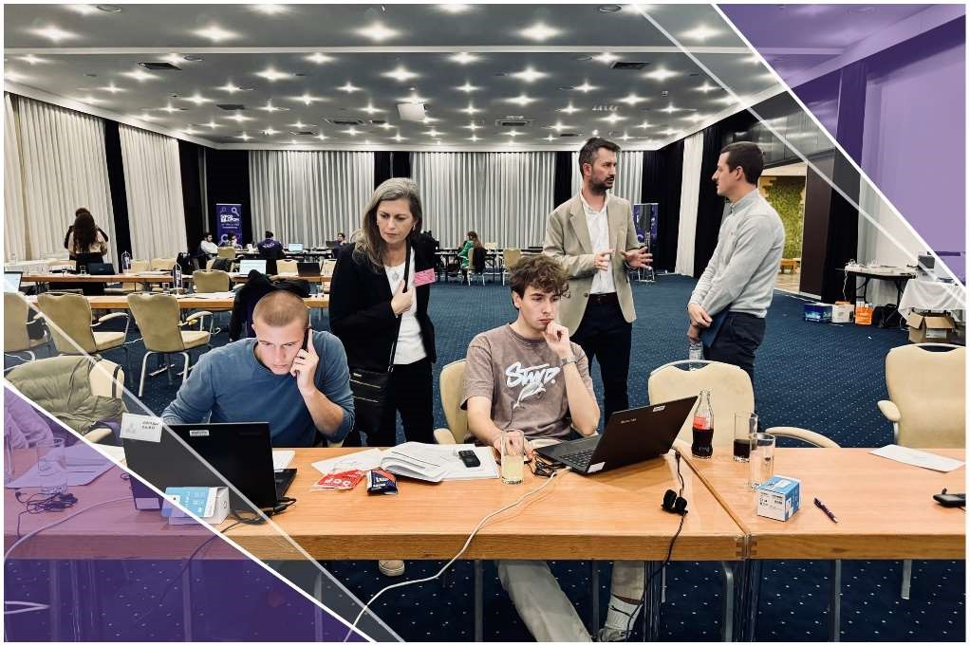

### GENERAL FINDINGS OF OBSERVATIONS

Long-term observation of the 2024 Local Elections in Bosnia and Herzegovina by the Coalition "Pod lupom" began on July 22, 2024. During this period, long-term observers (LTOs) recorded 1,367 irregularities through weekly reports, including 372 cases indicating the misuse of public funds and resources, 323 irregularities related to PSCs, 279 irregularities during the electoral campaign, 126 shortcomings in the work of local election commissions, 115 irregularities in media operations, 48 cases of voter pressure, and 104 cases of other irregularities.

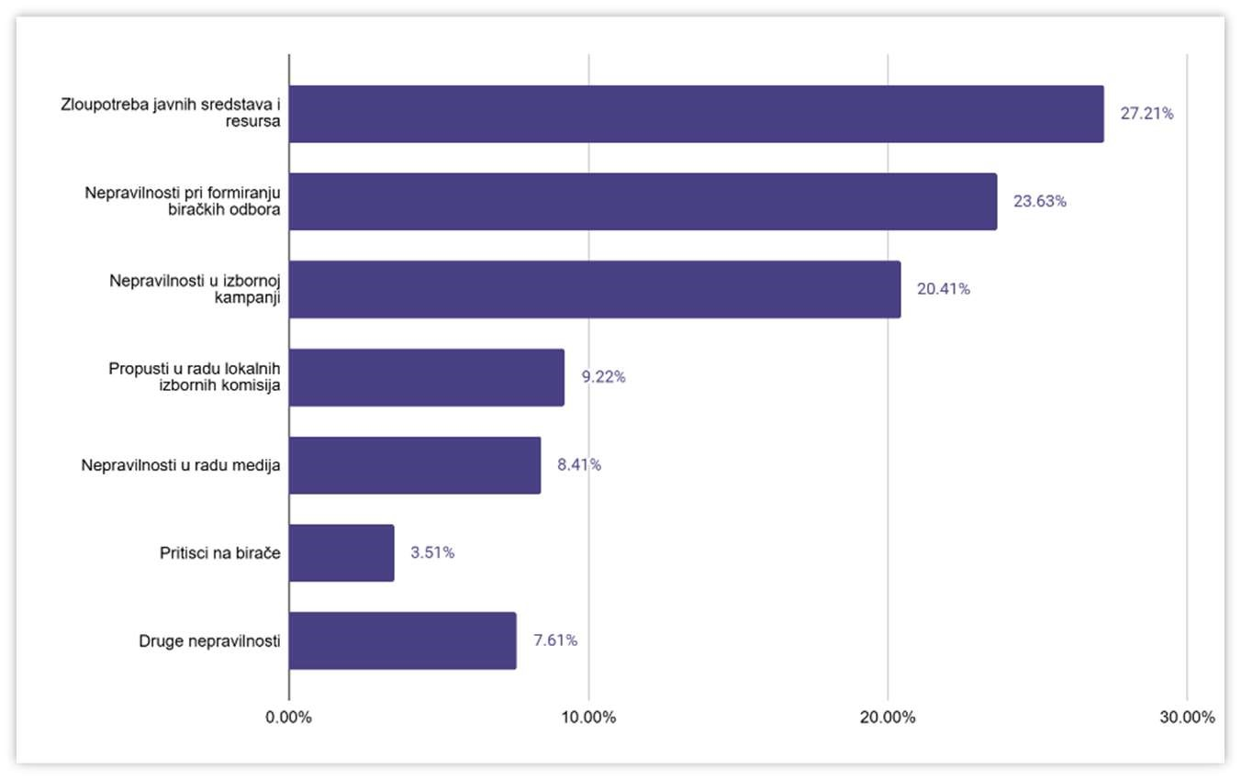

Infographic 2 – Structure of Electoral Irregularities in the Pre-Election Period

Irregularities reported by the LTOs identify 41 political entities as offenders, with the most frequent violations [17] recorded by the following political entities: *SNSD, SDS, SDA, HDZ BiH, SDP, and PDP.[18]*

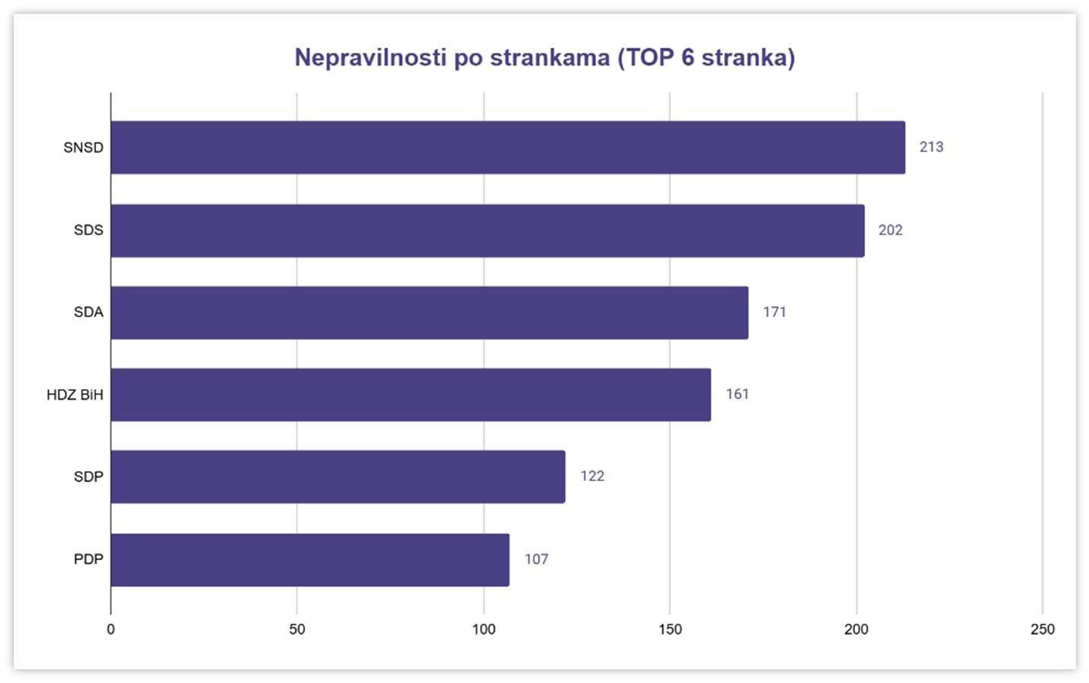

Infographic 3 – Irregularities by Political Parties

### PRESSURE ON VOTERS

During the reporting period, long-term observers (LTOs) recorded a total of 48 instances of pressure on voters, representing a serious violation of electoral integrity and fundamental democratic principles. These pressures commonly manifested through vote-buying, with reports indicating that voters were offered sums ranging from BAM 100 KM to BAM 400 per vote. This practice not only undermines the freedom of choice but also erodes citizens' trust in the regularity of the electoral process, benefiting political entities that employ illicit methods to secure support.

What is particularly concerning is that two severe forms of voter pressure were recorded in the municipalities of Gradiška and Živinice. These cases involved more serious actions that went beyond the typical vote-buying, potentially including threats, blackmail, or abuse of power by certain election actors. Such activities not only endanger the individuals targeted by these pressures but also threaten the entire democratic process in the mentioned communities, raising questions about the legitimacy of the election results.

In response to these irregularities, a criminal charge was filed, seeking institutional action. However, the number of reported cases suggests the need for a more efficient response from relevant authorities, including the judiciary and election commissions. Consistent enforcement of the law, along with educating citizens about their rights and how to protect them, is crucial for preventing similar abuses in the future.

MISUSE OF PUBLIC FUNDS AND RESOURCES

Misuse of public funds and resources refers to any unlawful and unethical use of funds and resources belonging to the state of Bosnia and Herzegovina, its entities, cantons, the Brčko District of BiH, and other units of local government and self-governance. These resources, which should be used exclusively for official and general social purposes, are often exploited by election candidates, political parties, or individuals on electoral lists. Such individuals, who hold public or state positions or are directly elected officials, use available resources to promote their political goals instead of directing them toward the public good. According to this definition, resources include not only movable and immovable assets of public institutions, such as vehicles, equipment, buildings, and other material assets, but also human resources—civil servants and employees engaged in public institutions whose time and work are misused for party or personal interests. This practice undermines equality in the electoral process, breaches public trust, and erodes the principles of transparent and accountable management of public assets.

The misuse of public funds and resources includes:

* Using the position of head of an institution or organization for self-  
   promotion as a candidate and/or promoting the political entity to   
   which they belong through the public promotion of the institution or   
   organization;
* Involving public servants subordinate to the candidate in performing tasks during working hours for the purpose of promoting the candidate or political entities;
* Using the premises of public institutions, organizations, or public companies for pre-election activities unless the same premises are guaranteed to other candidates and political entities under the same conditions;
* Using communication resources, information services, or office equipment of public institutions, organizations, and public companies for election campaigns;
* Using transportation resources owned by state, entity, city, cantonal, or municipal bodies and organizations free of charge or at reduced rates for campaign activities;
* Promoting political entities or candidates at public events or ceremonies funded by public institutions or public companies;
* Collecting signatures or conducting election campaigns by individuals holding electoral office or public servants during official activities or events organized by a public institution, public body, or public company;
* Using public funds and resources for the direct or indirect purchase of voter support during election campaigns, including, among other things, providing one-time financial or non-financial assistance to citizens or specific groups, except when such assistance is planned as   
  part of regular budget subsidies.

During the reporting period, LTOs recorded 372 cases indicating the misuse of public funds and resources, including: 80 cases of using public funds to purchase direct or indirect voter support, 51 cases of public promotion of candidates through the public promotion of institutions, organizations, or public companies, 41 cases of candidate promotion at public events and ceremonies, 19 cases of using the premises and resources of institutions, organizations, or public companies for pre-election activities, 10 cases of involving public servants during working hours for candidate promotion, and 171 cases of other misuses of public funds, mostly related to the intensification of public works during the pre-election period.

|  |  |  |
| --- | --- | --- |
| **MISUSE OF PUBLIC FUNDS AND RESOURCES** |  | **372** |
| Use of public funds for purchasing direct or indirect voter support | 80 | 21.50% |
| Public promotion of candidates through public promotion of authorities, institutions, or public enterprises | 51 | 13.70% |
| Promotion of candidates at public events and manifestations | 41 | 11.02% |
| Use of facilities and resources of authorities, institutions, or public enterprises for election activities | 19 | 5.10% |
| Involvement of civil servants during working hours for the purpose of promoting candidates | 10 | 2.68% |
| Other cases of misuse of public funds (e.g., intensification of public works, visits by officials, etc.) | 171 | 45.96% |

Table 1 – Misuse of Public Funds and Resources

### IRREGULARITIES RELATED TO POLLING STATION COMMITTEES

Between August 22 and October 22, 2024, the "Pod Lupom" Coalition conducted monitoring of the formation of polling station committees. Ten monitors were engaged, analyzing **500** polling stations and investigating **3,175** individuals (501 presidents and deputy presidents of polling station committees and 2,674 members and deputy members of PSCs). The monitoring was carried out in accordance with the currently applicable legal regulations and the latest amendments to the Election Law of Bosnia and Herzegovina, which significantly altered the "functioning" of polling station committees—one of the weakest links in the electoral process in BiH.

In July 2022, the High Representative in BiH issued a Decision amending the Election Law of BiH, which, among other provisions:

● Prohibited the abuse of the legal right to participate in the work of   
 the polling station committee by fictitious representation;

● Prohibited false representation on behalf of any political entity to   
 favor another political entity, with sanctions prescribed for

violations of the law in this regard.

In June 2024, the High Representative in BiH issued another Decision amending the Election Law of BiH, which, among other changes, specified:

* That no individual who currently stands as a candidate or has been a candidate for any level of government in the most recent general or local elections can be appointed as a member of the polling station committee or election commission, except for the Central Election Commission of BiH;
* That the president of a polling station committee and their deputy cannot be members of a political party, hold a position in political party bodies, associations, or foundations organizationally or financially linked to a political party, nor engage in any activities related to political parties. They must also be able to perform their duties in a politically impartial manner;
* That for the local election cycle, the positions of members and alternate members of polling station committee for each of the basic constituencies will be filled based on proposals from political entities represented in the directly elected bodies of local self-government units from the relevant basic constituency in the previous election cycle.

During the monitoring of the formation of polling station committee, Pod lupom identified **247** electoral irregularities related to the appointment of presidents/deputy presidents of PSCs , the appointment of members/deputy members of PSCs, and trading of positions within polling station committees (fictitious representation).

|  |  |  |  |
| --- | --- | --- | --- |
| **Irregularity** | ***Irregularities in the appointment of the chairman/deputy chairman of the polling station committee*** | ***Irregularities in the appointment of members/alternate members of polling station committee*** | ***Trading of seats on polling station committees***  *(fictitious representation)* |
| **No.**  **of cases** | **158** | **71** | ***18*** |
| **Basis** | ***Connection with political parties*** | ***current candidate or was a candidate for any level of government in the last general and most recent local elections***  *(65 cases)*  ***member of the highest executive-political body of a political party***  *(4 cases)*    ***member of the executive body of government***  *(1 case)*  ***ban on the candidacy***  *(1 case)* | ***ban on fictitious representation in the name of a political party with the aim of favoring another political party for a position in the polling station committee.*** |

Table 2 – Irregularities in Forming PSCs

During the monitoring process, **51** political entities were identified as likely failing to comply with the provisions of the Election Law of Bosnia and Herzegovina related to the formation of PSCs. More than half of all irregularities in the formation of polling station committees involved five political entities: **SDS** (21.07%), **HDZ BiH** (14.56%), **SDA** (9.96%), **SNSD** (9.57%), and **SP** (4.59%).

During the reporting period, LTOs recorded 323 irregularities related to PSCs, including: 172 instances of suspicion or complaints regarding the PSC presidents and their deputies being linked to political entities, 36 cases of evidence of unlawful trading of positions within PSC, 15 cases where the LECs failed to publish the list of names of appointed PSC members along with their political affiliations, and 100 other irregularities concerning PSCs.

|  |  |  |
| --- | --- | --- |
| **IRREGULARITIES RELATED TO POLLING STATION COMMITTEES** | **323** | |
| False representation of candidates for the president/deputy president of PSC | 172 | 53.25% |
| There is knowledge of illegal trading of positions in PSC. | 36 | 11.14% |
| LEC did not publish the list of names and surnames of appointed members of all PSCs with their political party affiliation. | 15 | 4.64% |
| Other irregularities related to PSC | 100 | 30.95% |

Table 3 – Irregularities related to PSCs

### IRREGULARITIES IN THE ELECTION CAMPAIGN

Monitoring of election campaign activities was conducted to observe compliance with legal regulations and ensure the transparency of the electoral process. The premature election campaign, prohibited by law from May 8 to September 6, 2024, included a ban on advertising through media, social networks, and public spaces, except for lawful official events held by political entities that did not have the character of a campaign. The official start of the election campaign on September 6 allowed political entities to conduct activities in accordance with the law, such as public gatherings, distribution of promotional materials, and presenting their programs to voters. However, the law prohibited placing materials on public or religious buildings, using hate speech, or exploiting children for political purposes.

During the campaign, observers paid special attention to pressure on voters, which constituted a serious electoral irregularity. This pressure included threats, coercion, bribery, and exploitation of citizens' economic circumstances to influence their voting behavior. The most common forms of pressure included persuading voters to vote against their will, forcing them to join a political party, distributing propaganda materials, requiring attendance at political rallies, offering gifts or promises of employment, and threatening employment termination or other sanctions. These activities undermined voters' free will and the integrity of the electoral process, seriously threatening fundamental democratic principles.

The election silence, which began on the morning of October 5, provided voters an opportunity to make decisions without additional influence and based solely on the available information. During this period, organizing rallies, advertising, and other activities that could affect voters were prohibited, including disrupting the electoral process or using loudspeakers near polling stations.

In the pre-election period, LTOs recorded 279 instances of irregularities in the election campaign, including 143 cases of paid advertising, 99 cases of premature campaigning, 29 cases of distribution and placement of pre-election materials, and 8 cases of discrimination of any kind for pre-election purposes.

|  |  |  |
| --- | --- | --- |
| **PREMATURE ELECTION CAMPAIGN** |  | **279** |
| Cases of paid advertising | 143 | 51.25% |
| Cases of premature election campaign | 99 | 35.48% |
| Cases of distribution and placement of election material | 29 | 10,39% |
| Cases of using discrimination on any grounds for election purposes | 8 | 2.86% |

Table 4 – Premature Election Campaign

### SHORTCOMINGS IN THE WORK OF LOCAL ELECTION COMMISSIONS

Local election commissions play a key role in organizing elections, including the designation of polling stations and the appointment of PSCs. Polling stations were designated by August 2, 2024,[19] and none were located in facilities that could compromise the regularity or impartiality of the electoral process, such as religious buildings, government offices, political party premises, or locations associated with abuse. The final list of polling stations was published by September 21,[20] ensuring transparency and timely information for citizens.

The process of assigning positions in PSCs began with a draw of political entities, which was completed on August 7, 2024.[21] After that, local election commissions appointed members of PSCs by August 22. [22] Training for the appointed members took place from August 26 to September 26, with occasional extensions until October 4 in special cases.[23] During the training, members of the PSCs were familiarized with the rules and procedures to ensure the legality and efficiency of their work on Election Day.

During the pre-election period, LTOs recorded 126 irregularities[24]24 related to the shortcomings in the work of LECs. It was noted that LECs violated election deadlines in 111 cases, 12 LECs did not adhere to gender equality in their membership (Brod, Fojnica, Glamoč, Istočna Ilidža, Kozarska Dubica, Livno, Novi Grad Sarajevo, Oštra Luka, Pelagićevo, Prnjavor, Srebrenik, and Zvornik), in 2 cases LEC centers for the voter register were not accessible to citizens (Ključ and Živinice), and 1 LEC had an incomplete composition (Pelagićevo). Regarding violations of election deadlines by LECs, a total of 111 violations were recorded, of which: 5 related to the preliminary designation of polling stations, 3 related to the draw of political entities for party members of PSCa, 10 related to the appointment of party members to PSCs, 33 related to the publication of the number of voters for their constituency, i.e., city or municipality, 32 related to the publication of the list of polling station locations with the locations and number of voters, and 28 related to the completion of training for all members of the PSCs.

|  |  |
| --- | --- |
| **LEC did not preliminarily determine the polling stations by August 2, 2024** | |
| *DRVAR, GRADIŠKA, TRNOVO (FBIH), TRNOVO (RS), ŽIVINICE* | **5** |
| **LEC did not conduct the draw for political parties' members of the PSCs by August 7, 2024.** | |
| *BUGOJNO, KALINOVIK, PELAGIĆEVO* | **3** |
| **LEC did not make a decision on the appointment of party members to PSCs by Aug 22, 2024** | |
| *BROD, KALINOVIK, KLJUČ, KOZARSKA DUBICA, LIVNO, LJUBUŠKI, NOVI*  *GRAD, ORAŠJE, PRIJEDOR, TEŠANJ* | **10** |
| **LEC did not publish the number of voters for its electoral unit by Aug 22, 2024** | |
| *BANOVIĆI, BOSANSKI PETROVAC, ČAPLJINA, CENTAR SARAJEVO, DOBOJ ISTOK, DOBRETIĆI, FOČA (FBIH), GLAMOČ, GRADIŠKA, HADŽIĆI, ILIDŽA, ISTOČNA ILIDŽA, JAJCE, JEZERO, KLADANJ, KLJUČ, LAKTAŠI, LIVNO, LJUBUŠKI, MILIĆI, MRKONJIĆ GRAD, NOVI GRAD SARAJEVO, NOVO SARAJEVO, OLOVO, OSMACI, PETROVAC, RUDO, ŠIPOVO, SRBAC, TEŠANJ, TUZLA, VIŠEGRAD, ŽIVINICE* | **33** |
| **LEC did not publish the final list of polling stations with locations and the number of voters by Sept 21, 2024** | |
| *BOSANSKI PETROVAC, BOSANSKO GRAHOVO, CENTAR SARAJEVO, DOBOJ ISTOK, DOBOJ JUG, DRVAR, GRADIŠKA, HAN PIJESAK, ILIDŽA, ISTOČNA ILIDŽA, ISTOČNI STARI GRAD, KLJUČ, KOSTAJNICA, KOZARSKA DUBICA, KRUPA NA UNI, LIVNO, MAGLAJ, NOVI GRAD, NOVI GRAD SARAJEVO, NOVI TRAVNIK, NOVO SARAJEVO, PETROVO, PRNJAVOR, RUDO, ŠAMAC, ŠEKOVIĆI, TREBINJE, VELIKA KLADUŠA, ZAVIDOVIĆI, ŽEPČE, ŽIVINICE, ZVORNIK* | **32** |
| **LEC did not complete the training of all PSC members by Sept 26,2024** | |
| *BANJA LUKA, BOSANSKI PETROVAC, BOSANSKO GRAHOVO, DERVENTA,*  *DOBOJ ISTOK, DOBOJ JUG, DONJI VAKUF, GLAMOČ, GRADAČAC, ISTOČNA ILIDŽA, ISTOČNO NOVO SARAJEVO, JAJCE, KALINOVIK, KNEŽEVO, KOTOR VAROŠ, MILIĆI, MRKONJIĆ GRAD, NOVI GRAD SARAJEVO, NOVO SARAJEVO, PETROVO, PRNJAVOR, ŠAMAC, ŠEKOVIĆI, ŠIPOVO, SRBAC, TEŠANJ, TESLIĆ, TRNOVO (FBIH)* | **28** |

Table 5 - Violation of Electoral Deadlines by LECs

### IRREGULARITIES IN THE WORK OF THE MEDIA

The media in Bosnia and Herzegovina play a crucial role in informing the public during the electoral process, and their actions must comply with professional standards, the journalistic code of ethics, and democratic principles. However, during the pre-election period, numerous irregularities in the media's work were recorded, undermining the transparency and integrity of the elections. Biased reporting, discrimination in political ads, the spread of misinformation, and the exploitation of children in political advertising were the most serious violations. The media are obligated to operate impartially and professionally, but they often face accusations of favoring certain political options, which undermines public trust in free and fair elections.

According to the long-term observers, 115 irregularities in the media's work were recorded. Of these, 53 cases related to biased media reporting in favor of a single political option, while in 39 municipalities, websites that reported on the elections were found not to have transparent information about ownership.

Additionally, 14 reports on officials mentioned their candidacy or party affiliation, directly violating the rules of impartial media reporting. Five cases of fake news broadcasting further damaged trust in the electoral process, while three ads contained discriminatory messages, and one involved the exploitation of children, which is particularly concerning.

These data highlight the need for stronger regulation and increased oversight of media reporting during elections. Media ownership transparency, responsible reporting, and the elimination of all forms of pressure on journalists are key to preserving democratic principles. Properly informing voters contributes to free and fair elections, while irregularities in the media's work can seriously undermine the integrity of the electoral process and public trust in democracy.

|  |  |  |
| --- | --- | --- |
| **IRREGULARITIES IN THE WORK OF THE MEDIA** | **115** | |
| Media report bias, favoring one political option | 53 | 46.08% |
| Municipalities where portals that report on elections lack transparent ownership information | 39 | 33.91% |
| Media, when reporting on officials, mention their candidacy and party affiliation | 14 | 12.17% |
| Media broadcast fake news that could jeopardize the integrity of the elections | 5 | 4.34% |
| Media broadcast political advertising that includes the exploitation of children | 3 | 2.60% |
| Media broadcast political advertising that includes any form of discrimination | 1 | 0.86% |

Table 6 – Irregularities in the Work of the Media

### OTHER IRREGULARITIES

During the reporting period, long-term observers recorded 104 other electoral irregularities that threatened the integrity of the electoral process and violated citizens' democratic rights. Among the most frequent violations, 36 cases of exploiting children for electoral purposes by political entities stand out, constituting a serious violation of ethical and legal norms. Such practices not only endanger children's rights but also send a worrying message about the abuse of power for political purposes. Additionally, pressures on the media (7 cases) and civil society organizations (5 cases) related to electoral activities were recorded, further complicating the work of key actors in ensuring transparency and adherence to the law.

Irregularities were also noted in the work of the CEC BiH and LECs, where citizens were denied professional and timely information in two instances. These situations undermine public trust in institutions that should ensure transparency and equality in the electoral process. A case of restricting freedom of speech and assembly was also recorded, which directly violates fundamental democratic rights. These cases highlight a broader issue of the lack of respect for rights and freedoms during the electoral period, undermining confidence in the electoral process.

The "Pod lupom" Coalition was contacted by a distressed citizen from Mostar following the publication of the candidate lists for the 2024 Local Elections in Bosnia and Herzegovina. Her identity had been stolen and used to place her on the candidate list of a local political entity without her knowledge. After visiting the local police station, where she was advised to report the incident to the "Pod lupom" Coalition, she did so. The Coalition’s legal team provided her with legal assistance to report the identity theft to the CEC of BiH, the City Election Commission, and to provide a statement at the police station. According to available information, the investigation in this case was still ongoing at the time of the completion of this report. This is not the first instance of citizens being placed on political party candidate lists without their knowledge, representing a serious violation of their guaranteed rights and freedoms, as well as a criminal offense.

In addition to these specific irregularities, 53 cases of other electoral frauds and violations were recorded, including various forms of manipulation that threaten the integrity of the elections. These cases involve activities such as voter list manipulation, resource misuse, and attempts to influence voter preferences. All these irregularities highlight the need for stricter control and sanctioning of violations, as well as additional efforts to educate citizens and strengthen oversight bodies to preserve the integrity and credibility of the electoral process.

|  |  |  |
| --- | --- | --- |
| **OTHER IRREGULARITIES** |  | **104** |
| Cases of child exploitation for electoral purposes by political entities | 36 | 34,61% |
| Media exposed to pressures related to the elections | 7 | 6,73% |
| Civil society organizations exposed to pressures that can be linked to the elections | 5 | 4,80% |
| CVR/LEC does not provide information professionally to citizens | 2 | 1,92% |
| Restriction of the freedom of assembly, opinion, or speech | 1 | 0,96% |
| Other irregularities and fraud | 53 | 50,96% |

Table 7 – Other Electoral Irregularities

## MONITORING THE SOCIAL MEDIA OF POLITICAL ENTITIES

The "Pod lupom" Coalition conducted social media content monitoring of political entities from May 15, 2024 (after the announcement of the Local Elections) to October 13, 2024 (seven days after the election day on October 6).

The monitoring focused on Facebook, one of the most widely used social media platforms in BiH. Five monitors tracked content on the official Facebook pages of **19** political entities[25]. Considering that these are official party profiles that publish general content, for more comprehensive social media content monitoring, the official Facebook pages of party leaders from the sample were also monitored. Additionally, as this monitoring occurred before the 2024 Local Elections, the content of Facebook pages of party branches in major BiH cities, where the parties are most active, was also monitored. To ensure the representativeness of the results, in addition to parliamentary parties, the sample also included some additional parties and Facebook pages (new parties or influential individuals within existing parties). In total, **80** official Facebook pages were monitored, with **9,663** posts analyzed prior to the 2024 Local Elections.

The social media monitoring revealed that during the 2024 Local Elections, the following 10 political entities were the most active on social media: **SNSD** (20.6%), **SDP** (8.6%), **Naša stranka** (8.4%), **Za pravdu i red – list of Nebojša Vukanović** (7.9%), **SDA** (7.7%), **PDP** (7.1%), **HDZ BiH** (5.9%), **NiP** (5.5%), **DF** (5.3%), and **US** (4.4%).

Monitors assessed that the majority of posts on political entities' social media as **neutral** (57.97%), followed by **negative** (25.55%) and **positive** (16.47%). On the other hand, citizens did not comment on 53.22% of the posts, left positive comments on 25.75%, negative comments on 11.18%, and neutral comments on 9.83%. The most relevant content of citizens' comments generally included **support for the party** (22.08%), **discrediting the party or candidate** (3.44%), or possible **hate speech** (3.04%).

The most frequently recorded irregularities included: **manipulation of information** (25.5%) – mostly spins, covert advertising, manipulation of facts, biased reporting, and conspiracy theories; **premature campaigning** (15.21%) – mostly unpaid, and to a lesser extent, paid; followed by **indicia of misuse of public funds and resources** (4.23%) – mostly related to the intensification of public works, one-time forms of assistance, and visits from political representatives; **suspicions of hate speech** (3.69%) – mostly ethnic intolerance, extremist ideologies, religious intolerance, and hate speech towards the LGBT community; **pressure on voters** (2.97%); and **gender-based violence** (0.73%) – mostly spreading accusations, belittling intellect, and sporadic rumors.

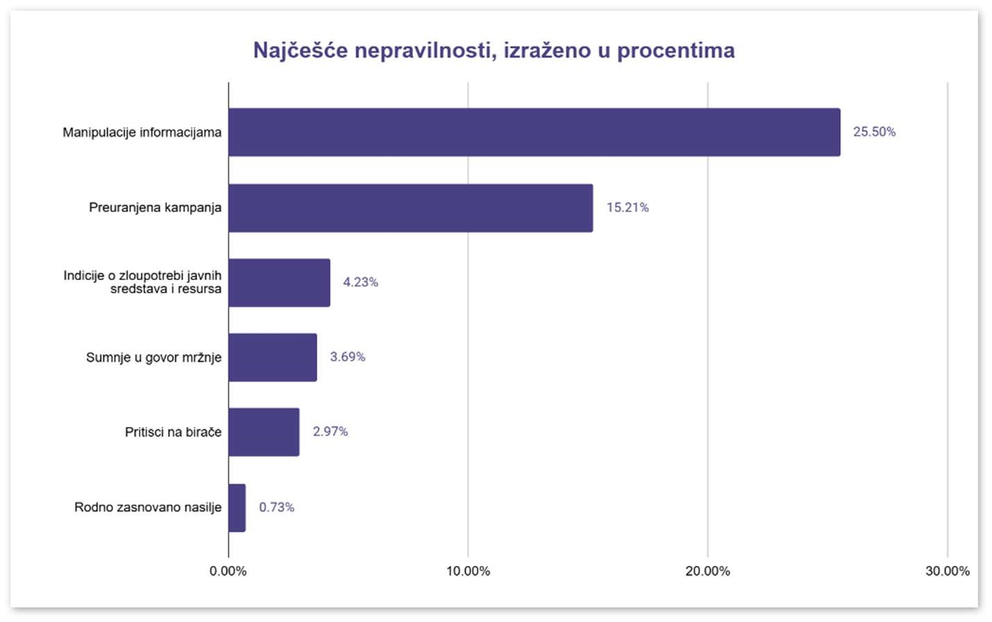

Infographic 4 – Monitoring Social Media

The top 5 parties with the highest number of all the mentioned recorded irregularities are:

1. **SNSD** (43.93%)
2. **PDP** (15.12%)

#### 3. Naša stranka (9.7%)

1. **SDA** (8.46%)
2. **DF** (4.63%)

Almost a third of the content (29.31%) in the five-month monitoring of social media was published during the official election campaign period. As much as 66.9% of the published content did not relate to the presentation of the party's program, while 21.1% of the content had an undefined or vague program, and only a small percentage (12%) clearly presented a program. Furthermore, the data show that 10.6% of the published content during this period can be characterized as an attempt to belittle or discredit a political opponent in the election.

On social media of political entities, 18.5% of the published content was shared from a media outlet. In nearly half of cases (49.1%), media content was used to promote a party or candidate; in 11.1% of cases, the content was used to discredit another party or candidate, and in a small number of cases (0.4%), it was used to attack the media itself. The most frequently shared content by political entities came from the following five media outlets: **RTRS** (35.6%), **ATVBL** (10.5%), **KLIX** (6%), **VRBASMEDIA.COM** (4.7%), and **BNTV** (2.1%).

## MONITORING OF ELECTION CAMPAIGN

The "Pod lupom" Coalition engaged **41** monitors for the 2024 Local Elections to observe the election campaign from September 6 to October 5, 2024, with the aim of documenting all forms of electoral irregularities at the campaign rallies of political parties and violations of the Election Law of BiH. This was done to address these issues and report them to the relevant institutions (CEC of BiH).

The "Pod lupom" Coalition monitored a total of **379** pre-election rallies of political parties across BiH. The same number of rallies (179) was observed in both the Federation of BiH and the Republika of Srpska, while 21 pre-election rallies were held in the Brčko District of BiH.

These 379 observed pre-election rallies were held in 87 municipalities/cities in Bosnia and Herzegovina (44 in FBiH, 42 in RS, and BD BiH). Additionally, when it comes to political entities whose rallies were monitored, the Coalition’s monitors observed 33 rallies of political parties, 27 rallies of political party coalitions, 10 rallies of other political entities, 6 rallies of independent candidates, 5 mayoral candidate debates, 1 rally of a list of independent candidates, and 5 other rallies.

Although there is a general belief that political entities do not address local issues in local elections, the findings of the "Pod lupom" Coalition after monitoring political rallies reveal that **89.9%** of the rallies did indeed discuss local topics.

The most frequent topics discussed at the rallies were[26]:

1. **Local roads and infrastructure** (66.2%)
2. **Construction and spatial planning** (50.1%)
3. **Support for vulnerable groups** (46%)
4. **Culture and sports** (40.3%)
5. **Water supply and sewage systems** (39.2%)
6. **Local-level education** (38.7%)
7. **Health care and health centers** (34.3%)
8. **Security in local communities** (27.8%)
9. **Cleanliness and waste removal** (23.4%)
10. **Public lighting** (19.7%)
11. **Parking** (14%).

However, it is important to compare these findings with online space. While political entities communicated directly with voters about focusing on local issues, the monitoring of social media by the "Pod lupom" Coalition showed that **66.9%** of the posted content did not relate to presenting the party's program, and **21.1%** of the content lacked specificity or concrete details about the program.

At election rallies where the party’s program was less presented, and where there was less focus on local issues, political entities focused on discrediting political opponents. The emphasis was not on local issues affecting citizens, but rather on topics relevant to the political entities representing certain cantonal, entity-level, and state-level issues, with a strong focus on ethnic issues.

#### 

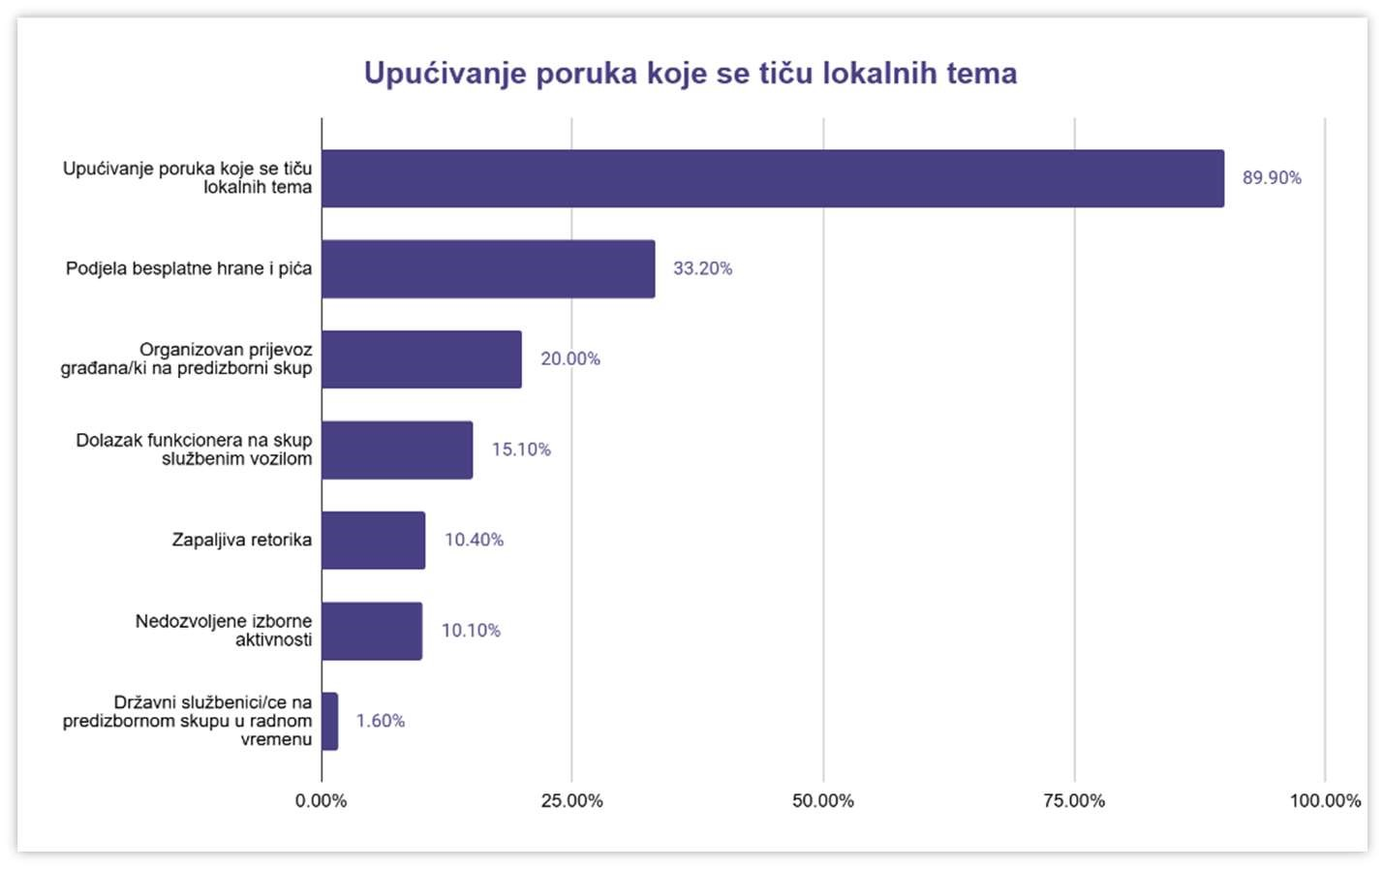

Infographic 5 – Monitoring the Election Campaign

As regards documented violations of electoral rules or provisions of the BiH Election Law, the most common violations included the free distribution of food and drinks, the organized transportation of citizens from other local communities to attend pre-election rallies, the arrival of officials at rallies using official vehicles, inflammatory rhetoric targeting political opponents and certain ethnic issues, and other prohibited electoral activities such as the removal of election materials from opposing political entities, the exploitation of children for political purposes, pressure on voters, and instances of hate speech at some political party pre-election rallies.

# MONITORING OF THE ELECTION DAY

## GENERAL INFORMATION

Election day in Bosnia and Herzegovina represents the peak of democratic participation, during which citizens exercise their right to vote for representatives at various levels of government. The process begins in the early morning hours when members of PSCs arrive at polling stations to prepare everything needed for voting. This includes setting up ballot boxes, preparing ballots, and organizing the voting space to ensure the secrecy of the vote. Before opening the polling stations, it is checked whether all materials are accounted for and in proper condition. Once everything is arranged, the polling stations officially open at 7 a.m. and remain available to citizens until 7 p.m.

Throughout the day, voters come to the polling stations with valid identification documents[27] to exercise their right to vote. After verifying their identity and confirming they are registered at that polling station, voters receive their ballots. Voting takes place under strictly controlled conditions, with the voter entering the voting booth to cast their vote in secret. The voting booths are positioned facing the members of PSC to minimize the risks of photographing ballots and voting irregularities, while respecting the secrecy of the vote. After marking their choice on the ballot, the voter places the ballot into the ballot box, completing the voting process. Smaller queues may form at some polling stations, but the PSC members ensure that the process runs as efficiently as possible and in accordance with the rules. Following amendments to the Election Law of BiH, new election technologies were used as a pilot project at 458 (8.5%) polling stations across 23 constituencies[28] during the 2024 Local Elections. The technologies tested included: electronic voter identification, ballot scanning, result transmission, and video surveillance.

The entire voting process is monitored by observers representing political parties, non-governmental organizations, and international institutions. Their role is to ensure the regularity and transparency of the elections, observing all stages from the setup and opening of polling stations to voting and vote counting. Observers have the right to point out any irregularities, further ensuring the public's trust in the electoral process. The presence of observers contributes to a sense of security for voters while allowing for the documentation of potential issues or violations of rules.

After the polling stations close at 7 p.m., the members of PSCs begin the vote counting process. Each ballot is carefully examined to determine whether it is valid, and then the votes are counted. This process requires focus and precision, as the results are entered into official forms that are later submitted to the relevant authorities[29] for further processing. Observers are present during the counting process to ensure transparency and prevent any possibility of manipulation. Preliminary election results are usually published on the same evening after the polling stations close. These results provide political actors, the media, and citizens with an initial insight into the outcome of the vote, although the final results are confirmed only after thorough processing of all data and consideration of any complaints or objections.

The Coalition for Free and Fair Elections "Pod lupom" engaged **829[30]** citizen, non-partisan election day observers for the 2024 Local Elections, who monitored the entire electoral process at polling stations (setting up and opening polling stations, voting process, closing polling stations, counting votes, and packaging election materials). "Pod lupom" observers also monitored the implementation of pilot projects introducing new technologies at selected polling stations, as well as voter turnout during the 2024 Local Elections. A new innovative manual for election day observers was created, along with publicly available video training. The observation mission covered 14.3% of the total number of polling stations in the country (one in every seven regular polling stations).

## ASSESSMENT OF ELECTION DAY

The assessment of the Election Day of the 2024 Local Elections by the Coalition "Pod lupom" is that the election day proceeded according to electoral rules at the majority of polling stations.

The processes of setting up and opening polling stations, closing polling stations, and packaging election materials went smoothly without significant deviations from previous electoral cycles.

The voting process at regular polling stations where new technologies were not piloted was rated worse compared to previous elections, with a significant increase in cases of family voting, misuse of assistance during voting, and voting without proper voter identification. Observers reported more complaints about being unable to observe the voting process unimpeded (at 7.4% of polling stations) and filed nearly four times as many complaints about the voting process compared to previous elections (at 13.4% of polling stations).

The vote counting process at polling stations without electronic identification and scanners was less effective in previous elections, with the possibility of influencing election results at 3.8% of observed polling stations.

The Coalition "Pod lupom" evaluates the piloting of new technologies as successfully implemented at 97.9% of the observed polling stations. The voting process at polling stations where voter identification was carried out using electronic devices and voting was done through ballot scanners was better compared to regular polling stations.

The recorded cases of violations of electoral rules, as well as isolated incidents, require serious analysis and preventive measures in the future.

## ACCESS OF OBSERVERS TO POLLING STATIONS AND VIOLATIONS OF OBSERVERS' RIGHTS

Observers had uninterrupted access to the majority of polling stations they were assigned to for the 2024 Local Elections. Sporadic cases of access issues were recorded, but they were promptly resolved.

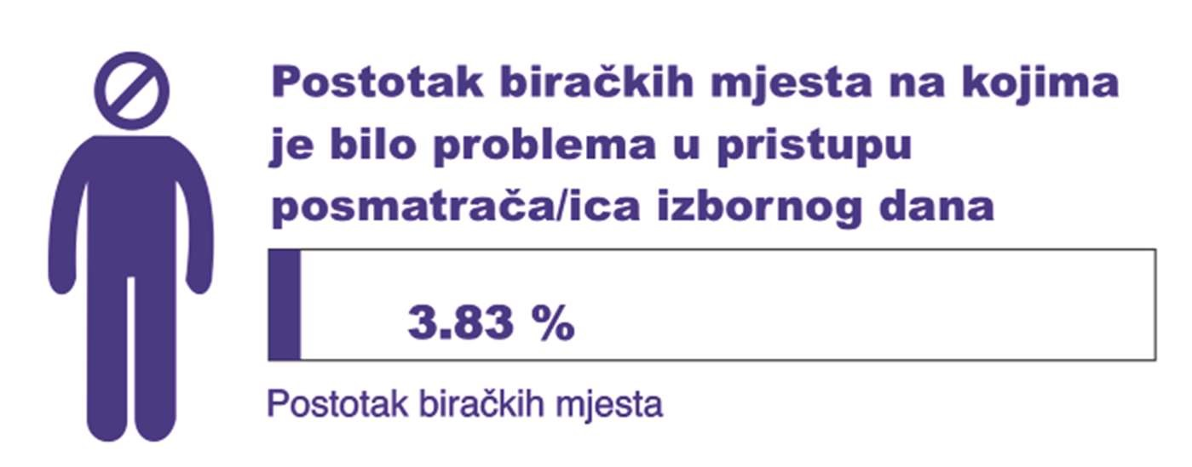

Infographic 6 – Observer Access to Polling Stations

Unfortunately, from one election cycle to the next, the CEC of BiH or local election commissions repeatedly fail to provide the PSCs with the list of observers. As a result, Pod lupom observers face challenges accessing polling stations due to procedural shortcomings. This issue occurred again during the 2024 Local Elections in **Ilidža, Olovo, Vogošća, Kalesija, Trebinje, Prijedor, and Banja Luka.** Despite the "Pod lupom" Coalition consistently raising concerns about this matter, it has persisted for a decade, undermining the integrity of election observation missions.

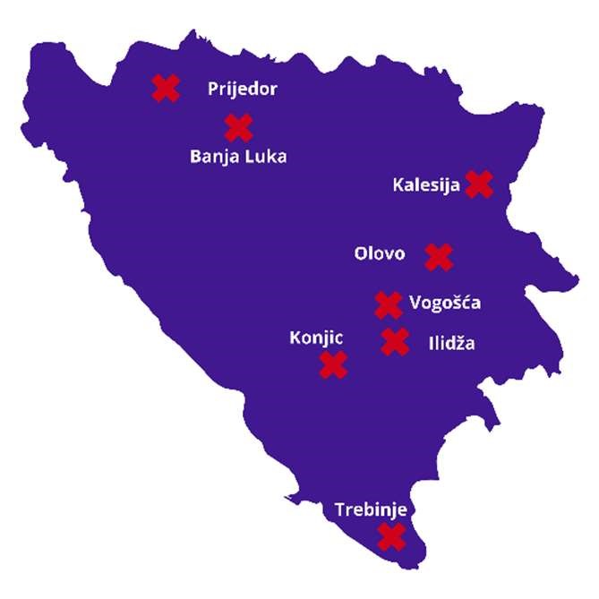

Infographic 7 – Challenges in Access to Polling Stations

During the postponed elections in **Konjic**, at one polling station (127A005), an observer was denied access to the counting of received ballots before the opening of the polling station, with the explanation that "this is not the practice here." The "Pod lupom" Coalition warns PSCs that they are not authorized to conduct processes at the polling station based on their own practices and rules, and that they must operate strictly in accordance with the Election Law of BiH, which permits observers to effectively monitor the electoral process, including the counting of received ballots, and in accordance with the Regulation on the Implementation of Elections in BiH established by the CEC of BiH. It is positive that the observer was granted access following an intervention with the City Election Commission.

## ORGANIZATION AND OPENING OF POLLING STATIONS

#### Organization of polling stations

At 1.81% of polling stations, within a 50-meter radius of the polling station location, there were signs or posters of political entities, religious symbols, or markings that could have discriminatory meanings.

It is estimated that 21.98% of polling stations were not accessible for people with disabilities who use wheelchairs or other aids. However, the data indicate an improvement in the organization of polling stations in this regard. When the Coalition first monitored the accessibility of polling stations for people with disabilities in 2014, 30% of polling stations were deemed inaccessible.  
  
The average number of voting booths per polling station is 2.41.

2.62% of polling stations did not display a list of all PSC members with the names of the political entities they represented, which is a violation of the law.

#### Opening of polling stations

The majority of polling stations opened on time. However, 21.77% of polling stations experienced a slight delay of up to 15 minutes, while 1.81% opened with a delay exceeding 15 minutes.

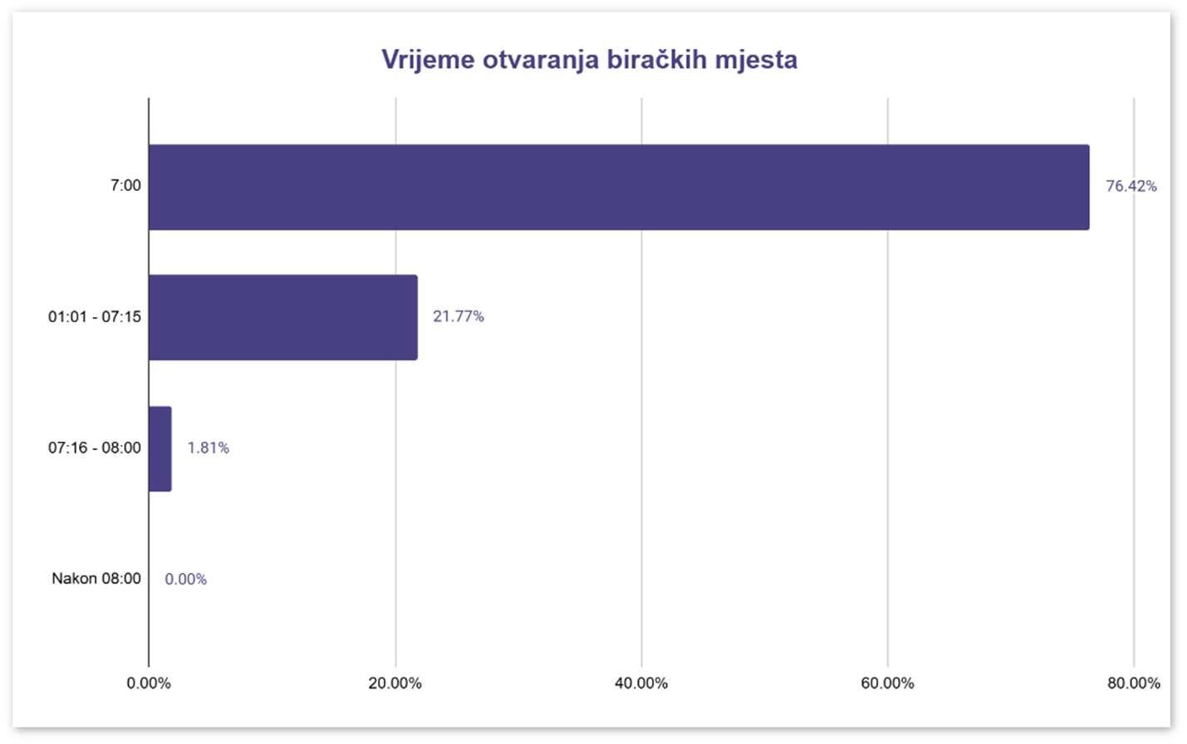

Infographic 8 – Polling Station Opening Time

#### Irregularities and shortcomings

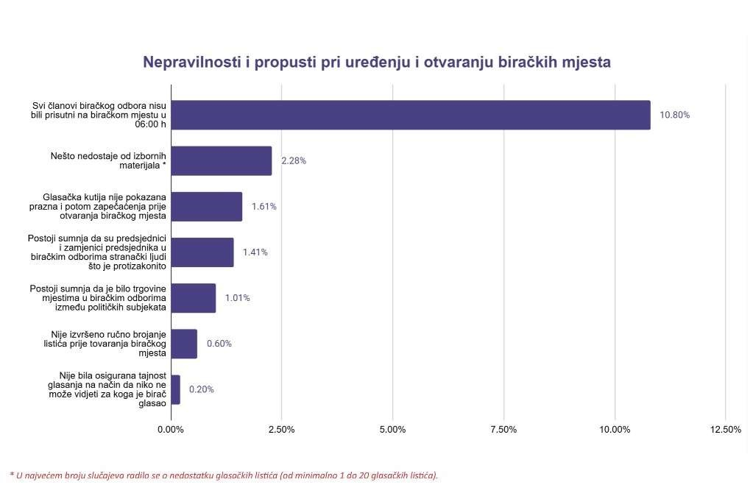

Infographic 9 – Irregularities and Shortcomings in Polling Station Setup and Opening

In terms of gender equality among chairpersons of PSCs, slightly more than half were male, specifically 51.21%.  
  
The average number of voters registered in the CVR per polling station is 635.

For the 2024 Local Elections, the average number of all observers per polling station was 4.21, with a total of 2,069 observers present at the observed polling stations.

## VOTING PROCESS

Recorded irregularities and shortcomings in the voting process indicate long-standing challenges in ensuring the consistent application of electoral rules. While significant improvements to electoral regulations were adopted and implemented for the first time in these elections, certain electoral irregularities and shortcomings remain "traditional" issues, and if frequent, they may impact the election results.

The voting process was marked by various types of irregularities and shortcomings. The most common issues included cases of family voting, voters being turned away from polling stations because they were not listed in the Voter Register, and the use of voting assistance without the required evidence. A notable concern involved individuals assisting multiple voters, as well as instances of ballot photographing. Additional issues included obstruction of observers, voting without proper verification of identification documents, breaches of voting secrecy, and indications of organized voter transportation.

At some polling stations, there were instances of overt persuasion to vote for specific political entities, pressure on voters, and the presence of unauthorized individuals disrupting the voting process. Observers filed complaints at 13.4% of the observed polling stations.

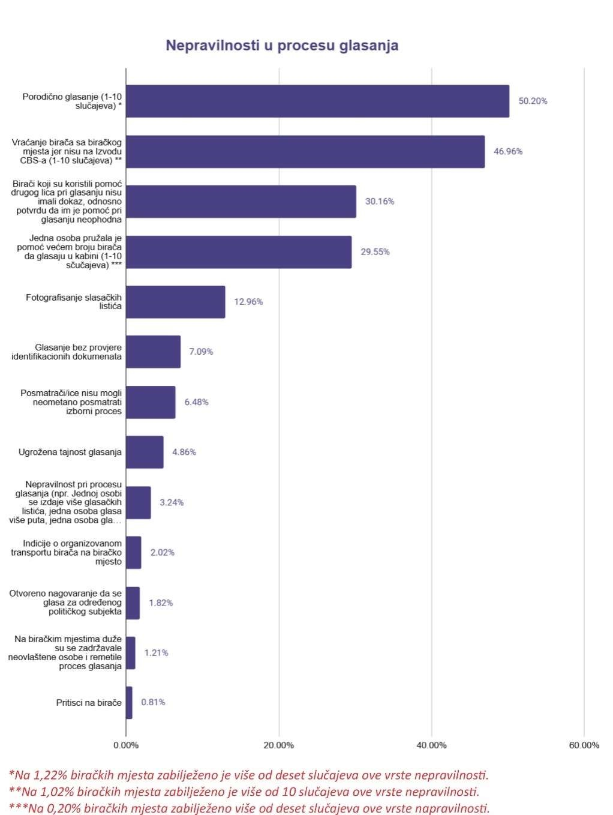

Infographic 10 – Irregularities in the Voting Process

## CLOSING OF POLLING STATIONS

The closing of polling stations proceeded similarly to previous elections, with no significant differences observed. Most polling stations closed on time. A slight delay of up to 15 minutes occurred at 11.02% of polling stations, while 0.84% of polling stations closed between 7:16 PM and 8:00 PM. At 1.06% of polling stations, not all members of the PSC were present at the time of closing.

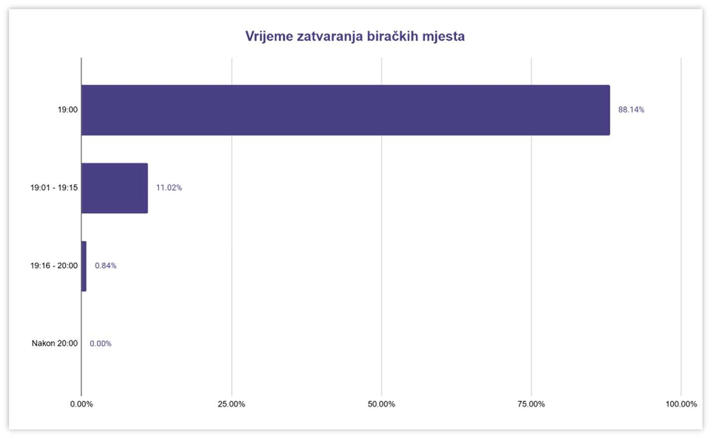

Infographic 11 – Polling Station Closing Time

The majority of voters who were at or in front of the polling station at 7:00 PM were allowed to vote, except at 4.03% of polling stations. At 1.91% of polling stations, entry was permitted after the official closing time.

## COUNTING OF VOTES

The process of counting the votes mostly adhered to electoral regulations though certain shortcomings and irregularities were observed. The most common issues included instances where unused and damaged ballots, along with pencils (not red, as required), were not properly packed into envelopes and stored in protective bags. Additionally, there were situations where stamps or pencils were found on the counting table. It was also noted that some ballots were missing the required stamp and the signature of a PSC member. Observers at certain polling stations faced challenges in monitoring the vote-counting process without obstruction. Furthermore, there were suspicions of votes being added to ballots and irregularities in declaring ballots invalid at some polling stations, A total of 64 complaints were filed concerning the vote-counting process, including 30 complaints regarding the counting of votes for mayors/chairs at 20 polling stations, and 34 complaints about the counting of votes for the council/assembly at 20 polling stations.

#### Irregularities and shortcomings

|  |  |  |
| --- | --- | --- |
| **Irregularity/Shortcoming** | **Counting votes for**  **(city) mayor**  **(% BM)** | **Counting votes for Council/**  **Assembly**  **(% BM)** |
| **Unused and damaged ballots, along with pencils (not red, as required), were not packed into envelopes and stored in the protective bag.** | **4.34%** | **3.60%** |
| **Ballots from the box were missing the required stamp and the signature of the PSC member.** | **4.12%** | **2.54%** |
| **After the ballot box was opened, a stamp or pencil was found on the table where votes were being counted.** | **3.90%** | **3.18%** |
| **Observers were unable to monitor the vote counting process without interruptions.** | **1.30%** | **1.27%** |
| **Invalid ballots were not declared invalid in accordance with the CEC regulations.** | **0.43%** | **0%** |
| **Suspicions arose that votes were added to the ballots during the vote- counting process.** | **0.43%** | **0.64%** |

Table 8 – Irregularities and Shortcomings in Vote Counting

## PACKING OF POLLING MATERIAL

Irregularities in the packing of election material were observed at 2.38% of polling stations. At 0.43% of polling stations, not all members of the polling board signed the ballot count form and the forms with the aggregate results. At 1.73% of polling stations, the yellow copies of the forms with the aggregate results were not clearly visible, while at 21% of polling stations, they were visible but illegible. Observers from the Coalition "Pod lupom" reported feeling certain pressures during their observation of election day after the election material had been packed at 2.38% of polling stations.

## TURNOUT

The Coalition "Pod lupom" monitored voter turnout during the 2024 Local Elections. The turnout was recorded at **47.1%** (with a margin of error of +/- 1.26% at a 0.95 confidence interval), representing a **2.9% decrease** compared to the previous Local Elections in 2020 and the General Elections in 2022.

Several factors may have influenced the lower turnout:

* The integrity of the Central Voter Register (CVR) has been compromised, and the CVR is not publicly available, even as the number of registered voters continues to rise.
* At 303 polling stations where electronic voter identification was tested, political entities were unable to manipulate the voter list and turnout figures.
* The integrity of the Central Voter Register (CVR) has been compromised, and the CVR is not publicly available, while the number of registered voters continues to rise.
* At 303 polling stations where electronic voter identification was tested, political entities could not manipulate the voter list and turnout.

The Coalition "Pod lupom" also monitored voter turnout during the postponed 2024 Local Elections in Fojnica, Kiseljak, Konjic, and Kreševo, held on October 20, 2024, as well as in Jablanica, held on November 3, 2024.

The recorded turnout for the postponed elections in Fojnica, Kiseljak, Konjic, and Kreševo was **51.1%** (with a margin of error of +/- 2.63% at a 0.95 confidence interval), which is **4% higher** than the turnout for the regular elections.  
In Jablanica, the turnout for the postponed elections was significantly higher at **67.4%** (with a margin of error of +/- 2.6% at a 0.95 confidence interval).

***Voter turnout in local elections in Bosnia and Herzegovina through election cycles:***

Voter turnout in local elections in Bosnia and Herzegovina has shown a declining trend across election cycles, according to official data from the CEC. The highest turnout was recorded in **2000,** at **65.4%,** while the lowest turnout occurred in **2004,** at **46.8%.** Despite some fluctuations, the long-term trend points to a decline in voter participation in local elections.

It is also important to highlight that the questionable integrity of the Central Voter Register (CVR), where the number of registered voters has been steadily increasing, may contribute to the declining percentage of voter turnout. While the total number of voters participating in elections across the cycles has remained relatively stable (1.6 – 1.8 million voters), the official (percentage) turnout in Bosnia and Herzegovina has decreased. This creates a paradox where the number of voters increases, but the percentage turnout declines.

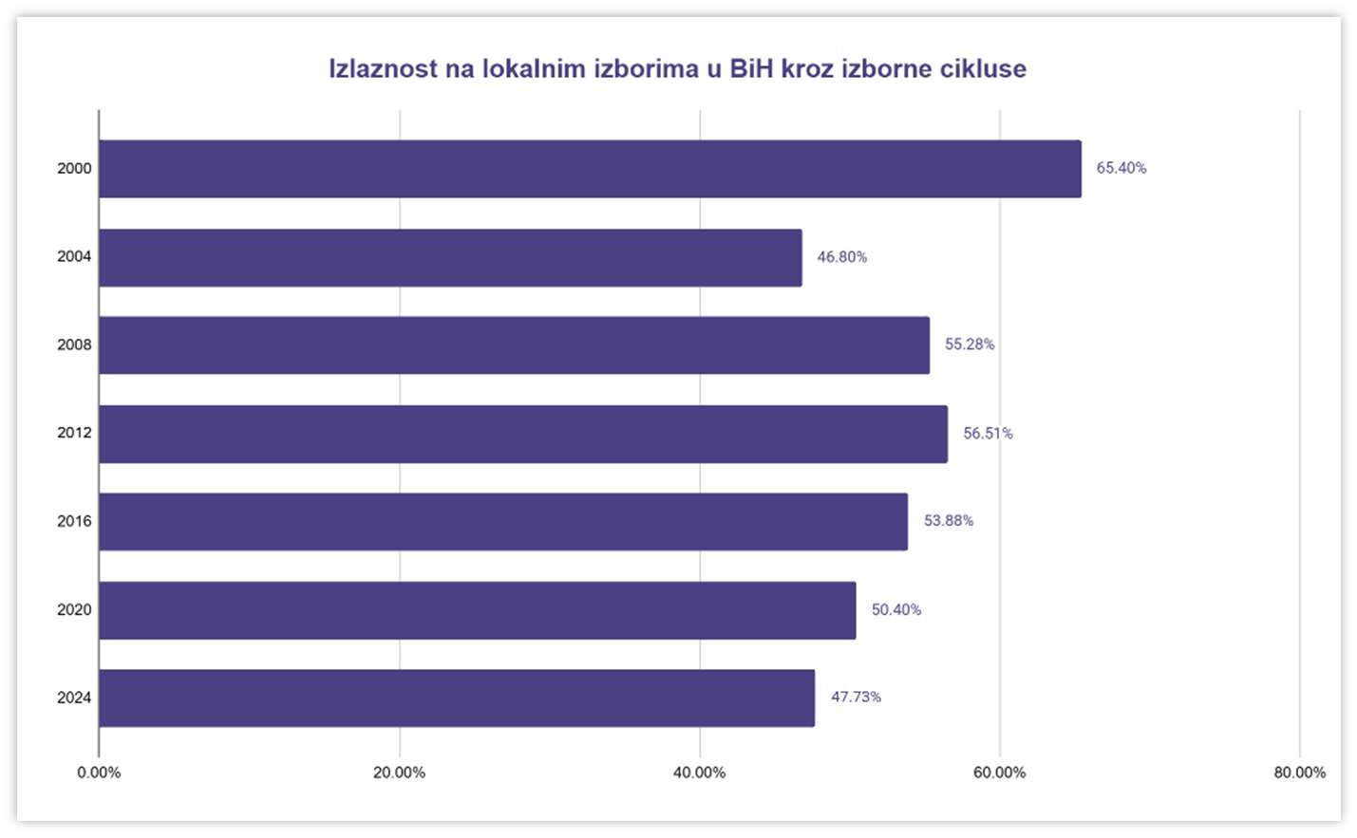

Infographic 12 – Voter Turnout in Local Elections in BiH through Election Cycles

## CRITICAL SITUATIONS ON ELECTION DAY

On Election Day, the Coalition "Pod lupom" received reports from its observers regarding **149** critical situations. This term refers to violations of procedures and election rules, significant technical errors in the functioning of election administration at all levels, or incidents at polling stations. In cooperation with the election administration, all critical situations were successfully resolved during Election Day and night.

The number of critical situations showed a slight increase compared to the 2022 General Elections. These include instances of obstructing observation, lack of polling material, and irregularities during the voting process such as family voting, abuse of voting assistance, photographing ballots, improper sealing of ballots, issuing more ballots than necessary, shortcomings in the work of PSCs, and breaches of the secrecy of the vote. Particularly concerning are the recorded cases of illegal pressure on voters.

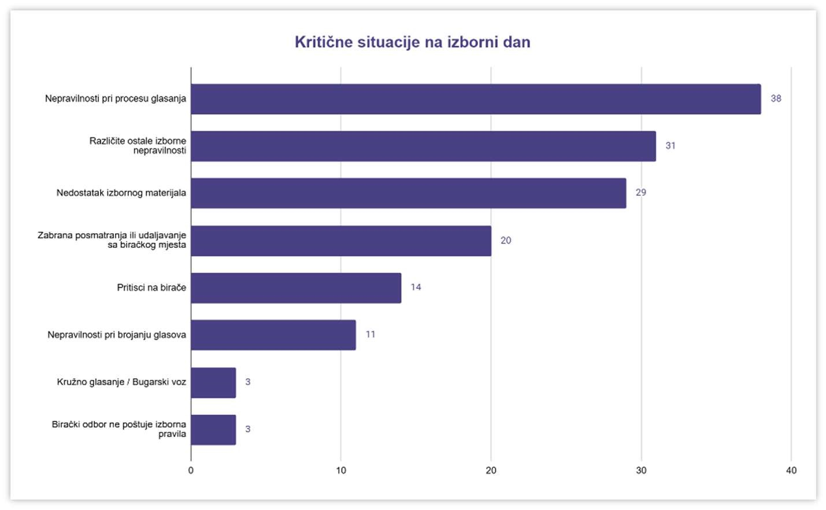

Infographic 13 – Critical Situations on Election Day

Based on the recorded violations of election rules, 74 complaints were documented in the Record o work of PSC.

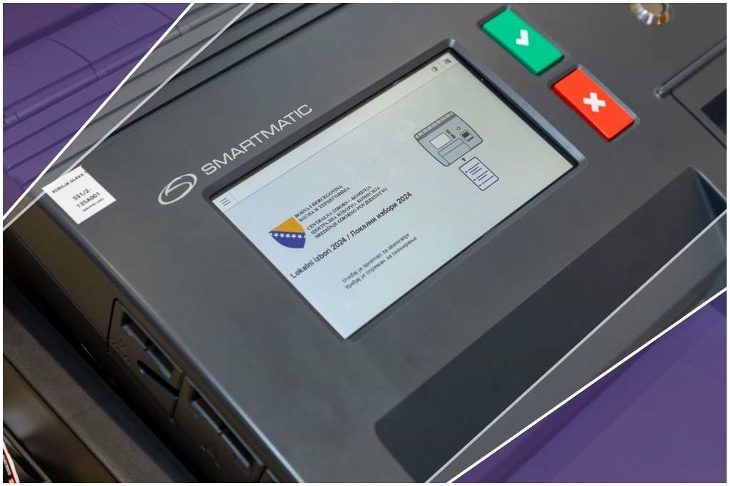

# NEW TECHNOLOGIES IN THE 2024 LOCAL ELECTIONS

On the day of the 2024 Local Elections, four pilot projects introducing new technologies were implemented at 458 polling stations across 24 basic constituencies:

|  |  |
| --- | --- |
| **VOTER AUTHENTICATION AND TRANSMISSION OF RESULTS**  ***Support:***  ***European Union*** | **Voter authentication** is the process of confirming a voter’s identity at the polling station, which is conducted after verifying a personal identification document and involves comparing the voter’s fingerprint biometric data with the records in the IDDEEA database.  **Transmission of results** involves delivering the election results from the polling station to the Central Election Commission (CIK) via an online application. This process takes place after the manual counting of votes. |
| **165 POLLING STATIONS**  **11 basic constituencies** | **Stari Grad Sarajevo** (46), **Domaljevac Šamac** (7), **Bijeljina** (28), **Doboj** (17), **Goražde** (7), **Gradiška** (14), **Sanski Most** (8), **Srebrenica** (7), **Tešanj** (9), **Trebinje** (8) and **Zvornik** (14) |

Table 9 – Voter Authentication and Result Transmission Pilot

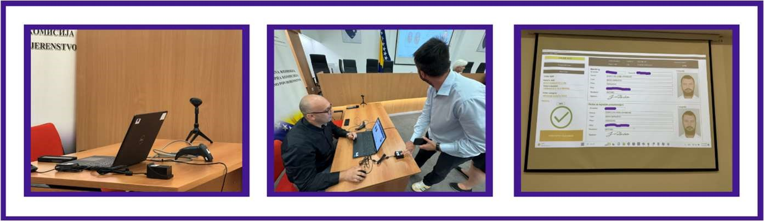

*Equipment for Voter Authentication and the Transmission of Results*

|  |  |
| --- | --- |
| **OPTICAL SCANNERS AND AUTOMATED COUNTING OF VOTING RESULTS**  ***Support: USAID*** | **The use of optical scanners** at polling stations involves inserting ballots into a ballot box equipped with an optical scanner that automatically counts the votes and enables the direct transmission of results. The automatically counted voting results are electronically sent to the CEC after the polling stations close. |
| **145 POLLING STATIONS**  **7 basic constituencies** | **Novi Grad** (11), **Prijedor** (25), **Tuzla** (32), **Visoko**  (11), **Vogošća** (48), **Stolac** (9), **Mostar** (9) |

Table 10 – Optical Scanners and Automated Vote Counting Pilot

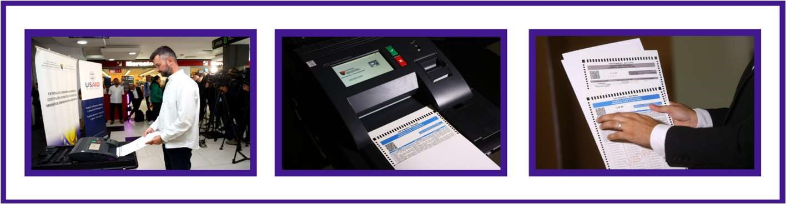

*Equipment for Optical Scanners and Automated Vote Counting*

|  |  |
| --- | --- |
| **BIOMETRIC VOTER IDENTIFICATION AND AUTHENTICATION**    ***Support: OSCE*** | **Biometric Voter Identification and Authentication** involve confirming a voter’s identity at a polling station, after identification through a personal document. The process includes comparing the voter’s fingerprint biometric data using an identification device integrated with biometric data or checking it in real-time against the IDDEEA records. |
| **138 POLLING STATIONS**  **1 basic constituency** | **The Brcko District of Bosnia and Herzegovina**  (138) |

Table 11 – Biometric Voter Identification and Authentication

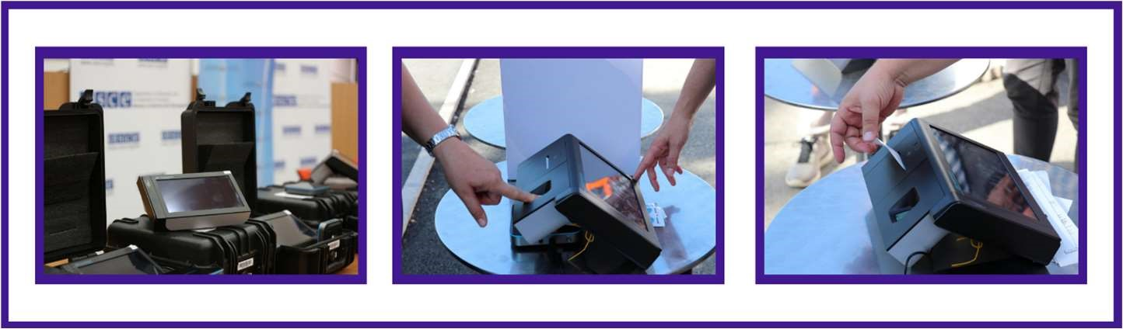

*Equipment for biometric identification and voter authentication*

|  |  |
| --- | --- |
| **VIDEO SURVEILLANCE AT POLLING STATIONS**    ***CEC BiH*** | Video surveillance is a system that monitors polling stations and/or rooms designated for counting ballots, with the capability for local storage of video recordings, while ensuring that the secrecy of voting is not compromised. |
| **10 POLLING STATIONS**  **5 basic constituencies** | **Zenica** (2), **Centar Sarajevo** (2), **Banja Luka** (2), **East Novo Sarajevo** (2), **Vlasenica** (2) |

Table 12 – Video Surveillance Pilot at Polling Stations

On Election Day, the "Pod lupom" Coalition monitored the implementation of voter authentication and the transmission of results, optical scanners and automatic ballot counting, and biometric identification and voter authentication. Out of 448 polling stations where these new electoral technologies were implemented, the "Pod lupom" Coalition deployed its observers at 298 polling stations (66.5%).

The "Pod lupom" Coalition assessed that the piloting of new technologies was successfully carried out at 97.9% of polling stations. At only 2.1% of polling stations, the use of the new technology was discontinued, and the previous voting method was reinstated.

#### Opening of Polling Stations and the Implementation of New Technologies

At the polling stations where new technology was piloted, the opening was delayed compared to regular polling stations (5.6% of pilot polling stations vs. 2% of regular polling stations).

In the first few hours after the polling stations opened, equipment was functioning properly at almost all polling stations, and the voting process proceeded smoothly. Exceptions included one polling station in Doboj where the electronic voter identification system was not working, but this issue was later fixed, and two polling stations in Tuzla where the optical scanners for ballots were not functioning, and voting continued without the equipment. At almost all polling stations, the new technology being piloted was properly installed and prepared for use. An exception was 1.3% of polling stations.  
  
Additionally, at almost all polling stations, an operator for the new technologies was present. Along with PSC members, they were required to arrive one hour before the polling station opened to test and set up the new technology. The exception was 1.3% of polling stations.  
  
What needs further improvement is voter education on voting with new technologies, as instructions explaining how to use the piloted technology were not displayed at 12.9% of polling stations.

#### New Technologies and Voting Process

The voting process at polling stations where voter identification was done via electronic devices and voting was done via ballot scanners was more effective compared to regular polling stations. The number of polling stations where improper voter identification occurred was almost half as low at pilot polling stations compared to regular ones, and the number of cases of voting abuses was lower by a fifth.

At most polling stations, the voting process using new technologies proceeded without interruption. Observers on the ground also provided their assessment of the issues voters encountered when using the new technologies, noting that at a smaller number of polling stations, the process was slower or there were interruptions in operation.

At locations where scanners were used, scanning both ballots from the moment of access to the scanner until the end of the process took an average of **44.9** seconds.

At locations where electronic identification was applied, an average of 11 voters (3.4%) were unsuccessfully identified out of an average turnout of 322 voters.

#### Final Processes at the Polling Station

As regards the closing of polling stations, significantly more delays were recorded at pilot polling stations (8.3% of pilot polling stations compared to 0.9% of regular polling stations).

The vote counting process at polling stations without electronic identification and scanners was less efficient compared to previous elections. There were no significant irregularities in the process of packing polling material compared to previous elections, or between pilot polling stations and regular polling stations.  
  
At most polling stations, the electronic transfer of results was successfully carried out. However, at 11.8% of polling stations, there were issues with the electronic transfer of results.

Where scanners were used, the average duration of the transfer of results for both levels of government was **92.6** seconds.

At 9.1% of polling stations, the chairperson of the PSC did not inform all present that the electronic transfer of voting results was carried out using new technology. At 11.9% of polling stations, the new technology being piloted was not turned off or disabled for further use. At 3.7% of polling stations, the new technology that was being piloted was turned on again after being turned off following the closing of the polling station.

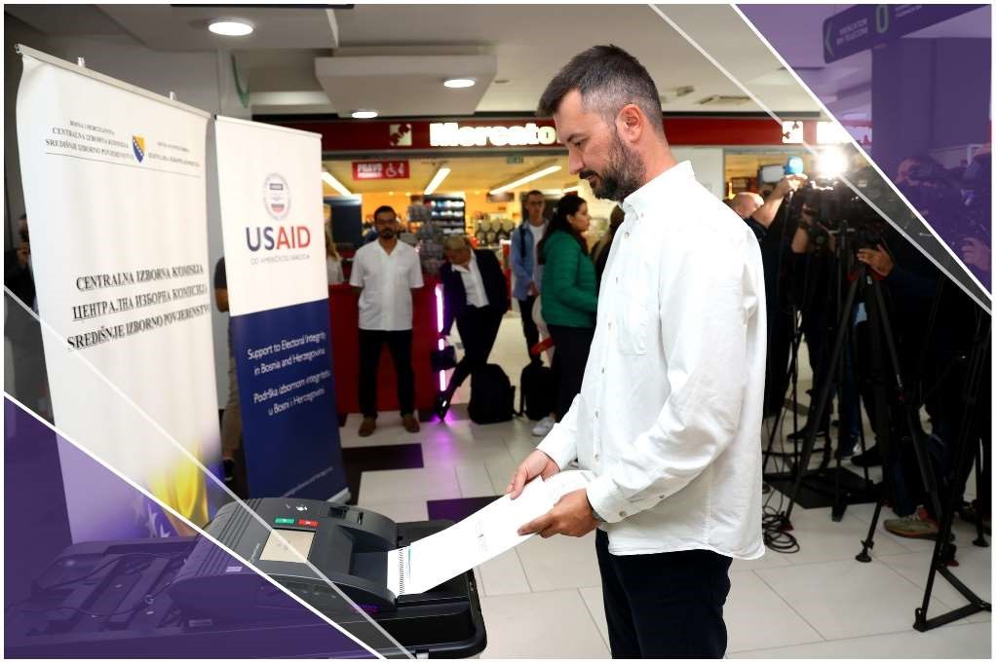

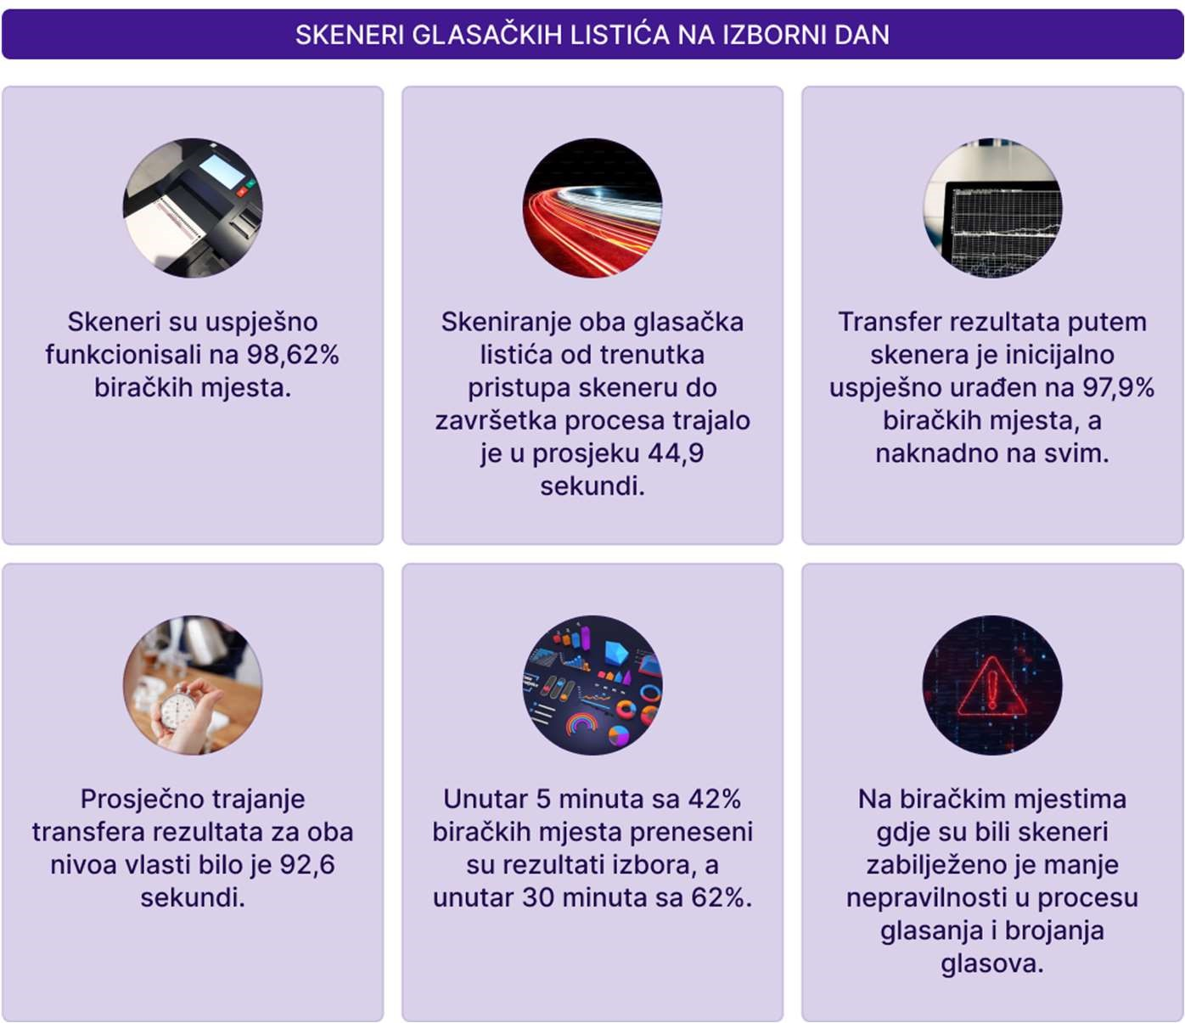

Infographic 14 – Key Findings of the Optical Scanners and Automated Vote Counting Pilot Monitoring

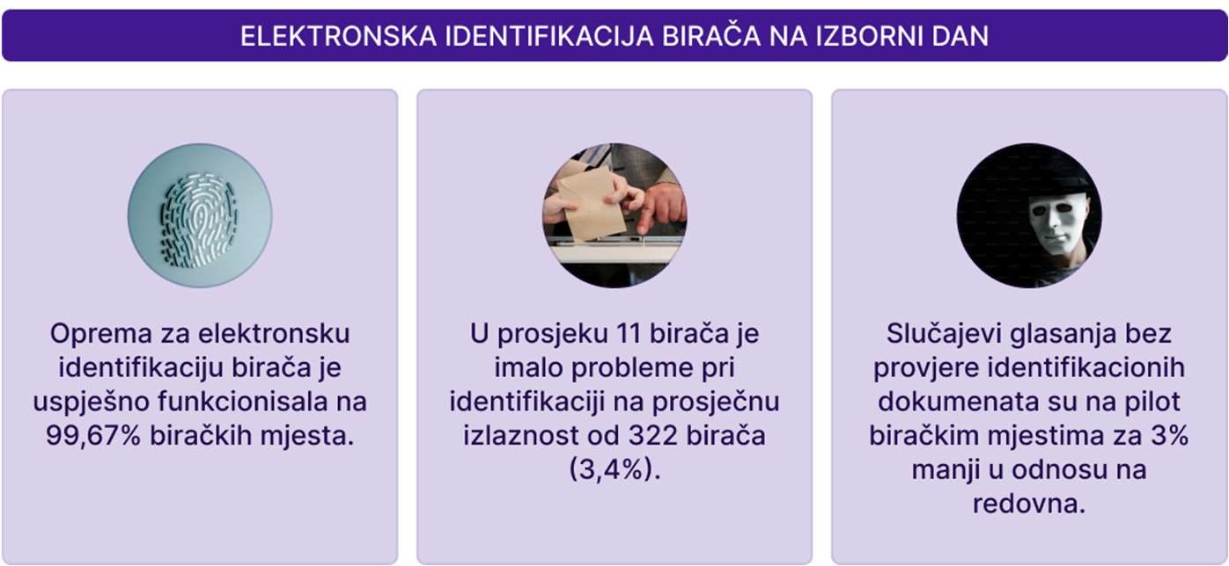

Infographic 15 – Key Findings of the Biometric Voter Identification and Authentication Pilot and Results Transmission Monitoring

# MONITORING OF THE POST-ELECTION PERIOD

## GENERAL INFORMATION

The deadline for constituting municipal and city assemblies or councils is 30 days from the date of the announcement of the final election results. This period ensures the timely establishment of legislative bodies for local self-governance and their functioning in accordance with electoral legislation.

Mandates for municipal councils, municipal assemblies, city councils, and city assemblies are allocated based on a proportional representation system, applying rules on the minimum percentage of votes required. Political parties, coalitions, independent candidates, or lists of independent candidates certified by the CEC of BiH participate in the distribution of mandates based on the number of votes won.

The electoral threshold for political entities is 3%, while the intra-party threshold for candidates on semi-open lists in local elections is 10%. Candidates on the list who receive less than 10% of the votes at the municipal level participate in the allocation of remaining mandates according to their order on the list. In the event of identical results, the mandate is assigned through a draw. If a candidate loses their mandate, it is transferred to the next candidate on the same list.

The number of members in municipal councils or assemblies varies depending on the number of registered voters in the municipality. In municipalities with fewer than 8,000 voters, councils have between 11 and 17 members. For municipalities with 8,000 to 20,000 voters, the number of members ranges from 17 to 25, while municipalities with more than 20,000 voters have councils with 25 to 31 members.

Members of a city council or city assembly are elected by the municipal councils or assemblies that constitute the city. Mandates are distributed proportionally based on the order of candidates on the lists. The mayor and the president of the city council or city assembly are elected in accordance with the law and the city statute, ensuring compliance with regulations and transparency in the election of local leadership.

The mandate of municipal councils, municipal assemblies, city councils, and city assemblies is four years. Within 15 days of the constitution of a municipal council or municipal assembly, members of the city council or city assembly are elected, enabling the timely formation of local self-governance bodies.

When appointing leaders in administrative bodies at the municipal, cantonal, or city level, attention is given to the composition of the population in the respective community. This rule ensures equal representation of all peoples and respect for fundamental democratic principles, further strengthening citizens' trust in the elected authorities.

Monitoring the post-election period is crucial for preserving the integrity of the electoral process. The CEC of BiH is responsible for determining the results of both direct and indirect elections after the legal deadlines for filing complaints and appeals have expired, and once the decisions become final. All decisions are made based on electoral rules and other relevant regulations.

## RECOUNTING OF VOTES

The recounting of votes plays a crucial role in eliminating doubts about the accuracy of the initial vote count, especially in cases of valid complaints indicating possible electoral fraud or technical errors. The “Pod Lupom” Coalition actively monitored the recounting process, attending nearly all instances of vote recounts.

During the process of determining election results, due to numerous observed, reported, and confirmed irregularities related to the results from polling stations, the CEC of BiH issued orders for the recounting of ballots or the opening of ballot bags to address other irregularities at a total of 186 polling stations.

The CEC of BiH also received requests for recounts from the “Pod Lupom” Coalition for a total of 15 electoral units. All requests were denied, as they were assessed to have been submitted by unauthorized entities.

The Coalition’s observers were present at nearly all locations where recounts were conducted, ensuring transparency and adherence to legal procedures. Specific guidelines were provided to observers regarding the technical aspects of the recount and the documentation of results.

The “Pod Lupom” Coalition maintained continuous communication with the Main Counting Center (MCC), reporting on progress and any potential irregularities in the process. During this period, technical issues such as delays in the delivery of election materials were documented and promptly communicated to the relevant authorities.

The following irregularities were observed:

* During the recount, a ballot was found to be missing a stamp (the ballot was declared invalid).
* During the recount, a ballot was found to be missing both a signature and a stamp (the ballot was declared invalid).

After each cycle of vote recounts, observers submitted reports detailing their observations, any identified irregularities, and recommendations for improving the process in the future. Observers were also granted access to all relevant records and reports on the recount, which were later submitted to the “Pod Lupom” Coalition.

In this election cycle, the CEC of BiH adopted a significantly more proactive approach in ordering various actions, including those initiated ex officio. However, it is important to note that the process of determining results has undermined public trust due to numerous observed irregularities and discrepancies between polling station results and those established at the MCC.

Regarding new technologies, during the process of determining election results, the CEC of BiH ordered a verification count of ballots through manual recounting at 33 polling stations where new technologies had been implemented, due to observed and reported discrepancies in polling station results. The discrepancies primarily involved individual votes for candidates or invalid ballots.

The overall experience with the process of determining results was further hindered by the fact that a report on the operations of the Main Counting Center, including all identified irregularities, has not yet been made available to the public.

In the secondary jurisdiction, concerning appeals against decisions by local election commissions, the number of proceedings conducted by the CEC remains unknown. For the first time after an election, the CEC did not provide the “Pod Lupom” Coalition with statistics on complaints received, stating that this data will only be processed and made available in a report planned for publication in April 2025.

## DETERMINATION OF ELECTION RESULTS

The Election Law of Bosnia and Herzegovina defines the deadlines for determining election results, while the regulations of the Central Election Commission (CEC) specify the sequence for determining results, public notification, and the manner of publishing and confirming results. The BiH CEC is required to confirm the final election results within 30 days of election day, as a general rule. Exceptionally, confirmation of the results may be delayed by up to 15 days.

After the recount of votes, the BiH CEC confirmed the final election results. The verification process included data checks, such as votes from abroad, postal votes, and invalid ballots.

Pod lupom’s observers reported several technical errors in data processing that could have potentially affected the final results. Additionally, a significant number of invalid ballots were recorded again, raising doubts among citizens and requiring further scrutiny.

The results of the 2024 Local Elections were confirmed at the 100th session held on November 5, 2024, thus meeting the legally prescribed deadline.

Holding the 110th session also ensured that the CEC met the deadline for confirming the results of delayed elections in Fojnica, Jablanica, Kiseljak, Konjic, and Kreševo as well as the results for the cities and municipalities of Bihać, Čapljina, Doboj, Foča, Gacko, Prozor-Rama, and Mostar, which were based on requests for recounts.

The CEC ensured transparency of the election results through its website, and the Pod lupom Coalition regularly monitored the published information, providing insights into the procedures and reports on vote counting. However, election results are never available upon request in a format that allows for additional data processing and analysis, which fails to meet the standards of open data in elections.

# PROTECTION OF ELECTORAL RIGHT

## GENERAL INFORMATION

The protection of electoral rights is ensured by election commissions, including local election commissions and the CEC, as well as the Appellate Division of the Court of Bosnia and Herzegovina. The legal framework governing complaints, objections, appeals, and requests related to the electoral process is clearly defined by the Election Law and other accompanying regulations, such as the Law on Administrative Procedure of Bosnia and Herzegovina and the CEC’s guidelines.

Election commissions protect electoral rights ex officio, based on their findings or complaints submitted by authorized individuals. According to the provisions of the Election Law, these authorized individuals are voters or political entities. A voter, as interpreted by the CEC, can lodge a complaint only when their personal electoral rights are violated. "Pod lupom” views this is as a highly restrictive interpretation as it prevents citizens, associations, and other interested parties in the electoral process from officially lodging complaints, even when their electoral rights are directly violated, or they have knowledge of serious irregularities at polling stations where they are not voting. Furthermore, regarding political entities, complaints can only be submitted by the entity, not by individual candidates without the support of their political entity.

In other words, under the Law, voters and political entities have the right to file complaints regarding the electoral process, while ex officio action is taken in cases of identified irregularities.

Although this segment has been improved through decisions by the High Representative (such as extending the deadline for filing complaints and imposing stricter sanctions), the Coalition “Pod lupom” believes that the scope of individuals authorized to submit complaints should be expanded. The current framework, based on the CEC’s restrictive interpretation, limits the ability of citizens and organizations to intervene promptly when their rights are violated.

## COMPLAINTS, OBJECTIONS, AND APPEALS ON ELECTORAL PROCESS

According to publicly available information on the CEC BiH website, as of the conclusion of this report (December 2024), the CEC BiH has received 1,480 objections and appeals regarding the electoral process for the 2024 Local Elections in BiH. This is almost four times more than for the 2022 General Elections. This could indicate that citizens are better able to recognize electoral irregularities, as well as a gradual restoration of citizens' trust in elections in BiH, which is one of the key goals of the "Pod lupom" Coalition. Additionally, the CEC has finally protected the identity of the complainants after public reactions and media reports. This is especially important to encourage citizens to submit complaints to the CEC regarding identified electoral irregularities, and to prevent potential consequences for the complainants in the form of pressure and possible retaliation by political entities and their responsible persons at the local level.

For the first time after some elections, the CEC BiH did not provide the requested data on the number and structure of received objections and appeals to the Coalition, claiming that this data will only be available and presented in the report planned for April 2025. According to available data on the CEC BiH website, by the conclusion of this report, 986 cases (two-thirds of the received objections and appeals) have been resolved or are still being processed.

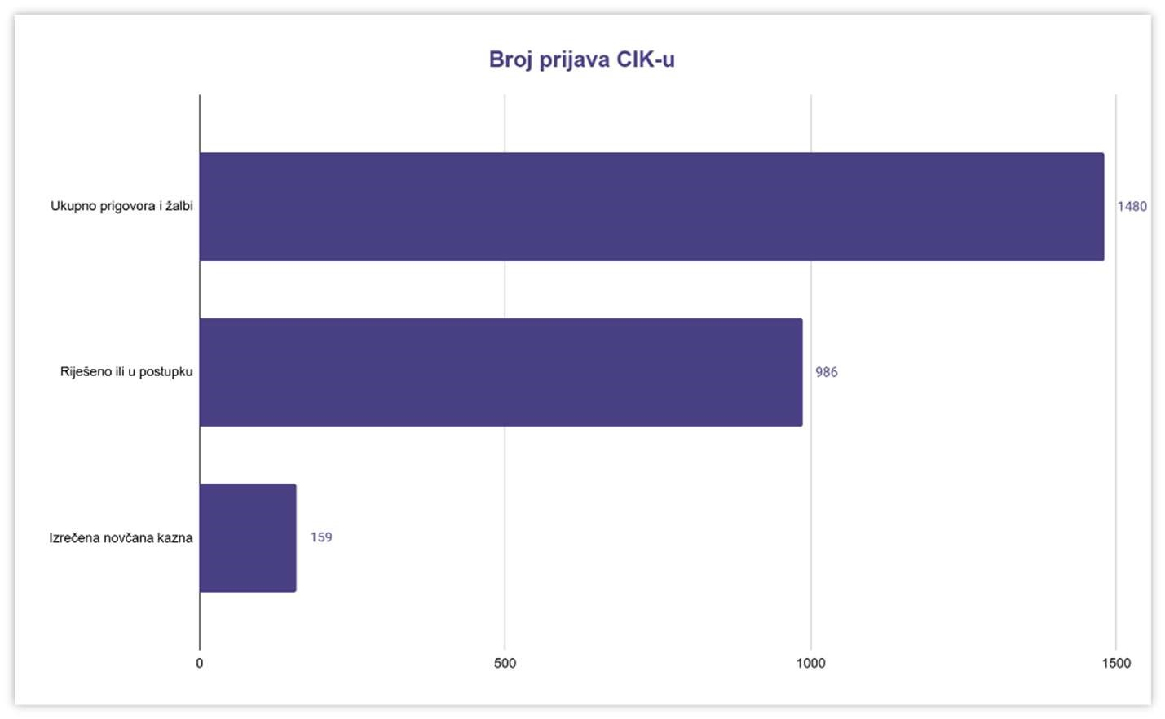

Infographic 16 – Number of Reports to the CEC

The most received objections and appeals were related to premature campaigning (603), misuse of public funds and resources (367), violation of the election silence (151), and paid campaigning during the period when it was prohibited (145).

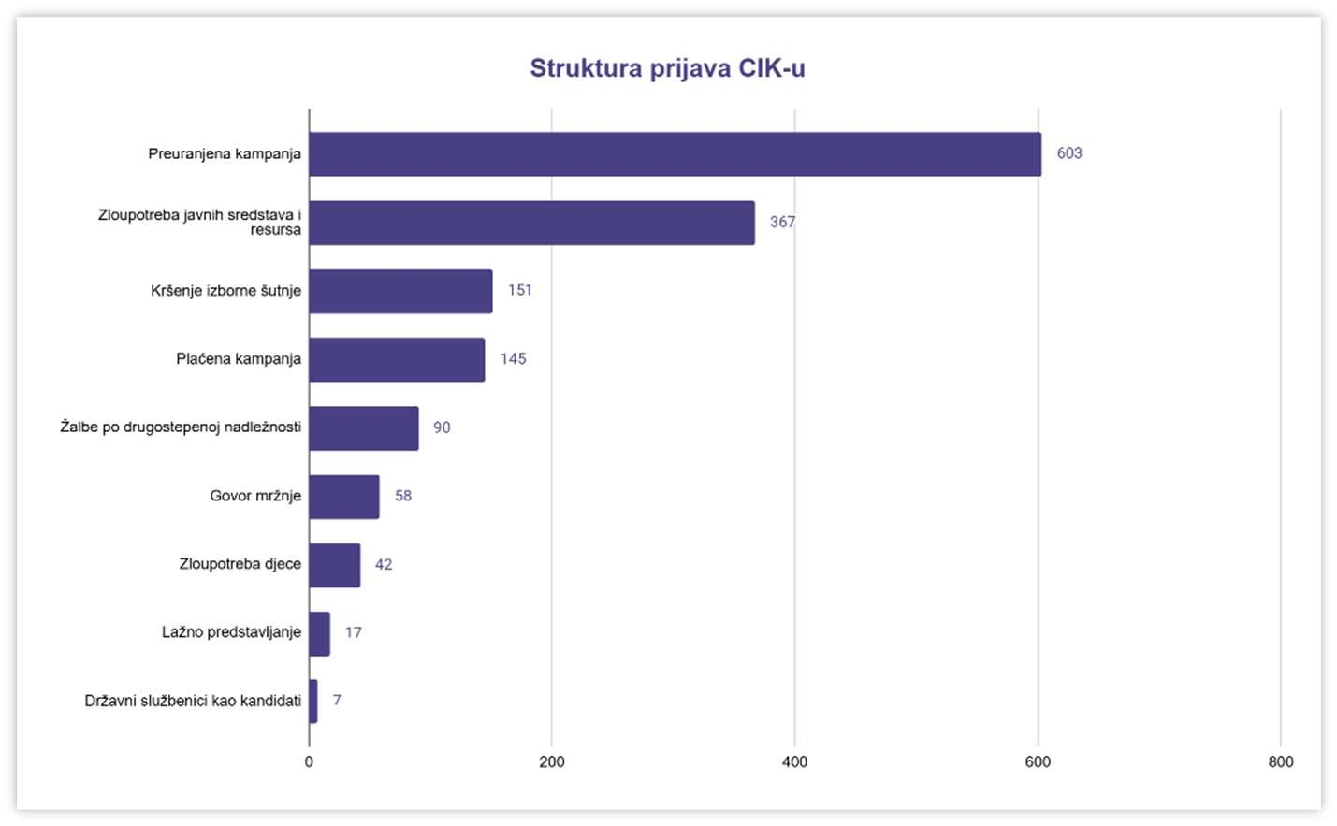

Infographic 17 – Structure of Reports to the CEC

Based on the received objections and appeals, the CEC BiH imposed fines in only 159 cases. This means that only one in ten complaints to the CEC results in a monetary penalty for violators of electoral rules. A total of 859,500 BAM in fines were imposed.

The minimum possible penalty prescribed by law for political entities is 3,000 BAM, while the average fine imposed by the CEC in previous cases was 5,405 BAM. By the time this report was concluded, only one penalty of the maximum amount of 30,000 BAM was imposed on the political entity HSP BiH, and one of 15,000 BAM on PDP candidate Vlado Sladoj, both due to the use of hate speech. The imposition of low, almost minimal sanctions is especially controversial in the case of political entities that repeatedly violate electoral rules. According to the "Pod lupom" Coalition’s analysis from August, two-thirds of all complaints and even 80% of all fines[31] were related to 10 political parties that continuously violate electoral rules. Some repeat offenders could have been sanctioned with amounts up to 12 times higher than those prescribed by the Electoral Law of BiH.

The "Pod lupom" Coalition believes that the CEC BiH did not timely consider all objections and appeals regarding the electoral process, that in some obvious cases with clear evidence, it accepted excuses and justifications from political entities and officials as a basis for not imposing penalties, and that the amounts of the fines imposed were low and lacked a deterrent effect. In this regard, it is necessary to improve the processing of electoral irregularity complaints (remarks, objections, appeals, initiatives, citizen reports, and other submissions), establish a system for prioritizing actions (e.g., potential influence on the electoral process, severity of the violation, priority according to the electoral activity calendar, chronological order upon receipt), and specify sanctioning practices (especially that repeat offenders are penalized progressively and with the strictest penalties). Furthermore, the review of objections and appeals regarding the electoral process should be digitalized, all cases should be displayed in real-time upon receipt, and all decisions related to the complaints should be made publicly available. This can be achieved by further strengthening the human and technical capacities of the Legal Department of the Central Election Commission of BiH.

## COMPLAINTS BY THE POD LUPOM COALITION

As in previous election cycles, the "Pod lupom" Coalition reported all observed irregularities to the competent authorities, primarily the CEC of BiH. A total of 442 complaints about electoral irregularities were sent to the CEC of BiH, 388 of which were submitted before Election Day in the form of initiatives for initiating proceedings ex officio, and 54 on Election Day as initiatives or information.

The largest number of complaints about electoral irregularities before Election Day related to paid campaigns during the period when this was prohibited (143), abuses in the formation of PSCs (104), premature campaigning (89), violation of the election silence (14), misuse of public funds and resources (6), and other irregularities (32).

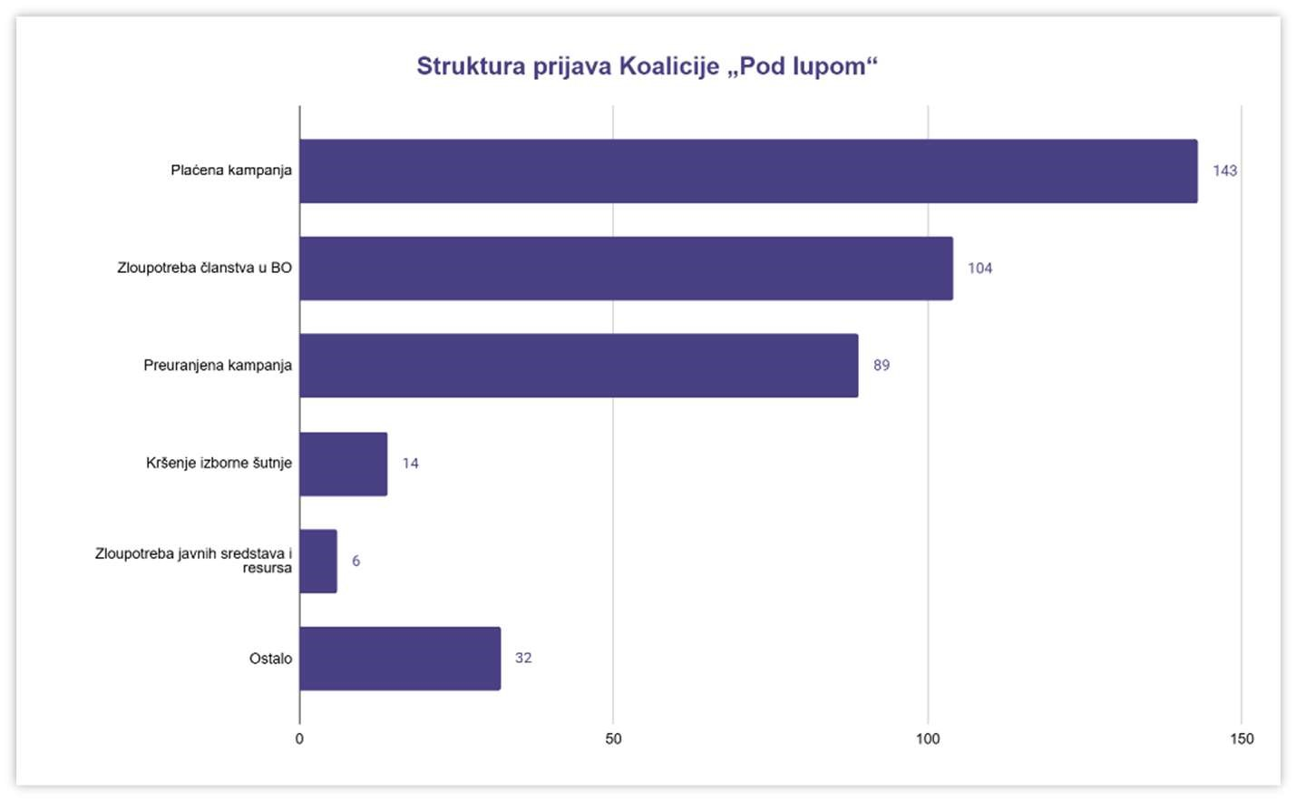

Infographic 18 – Structure of Reports by the Pod lupom Coalition

Based on the complaints from the "Pod lupom" Coalition, the CEC of BiH had imposed 87 sanctions by the time this report was concluded. This included 34 financial penalties (21.4% of the total number of financial sanctions) amounting to a total of 158,500 BAM (18.4% of the total financial penalties), and 53 decisions removing 59 individuals from membership in PSCs.

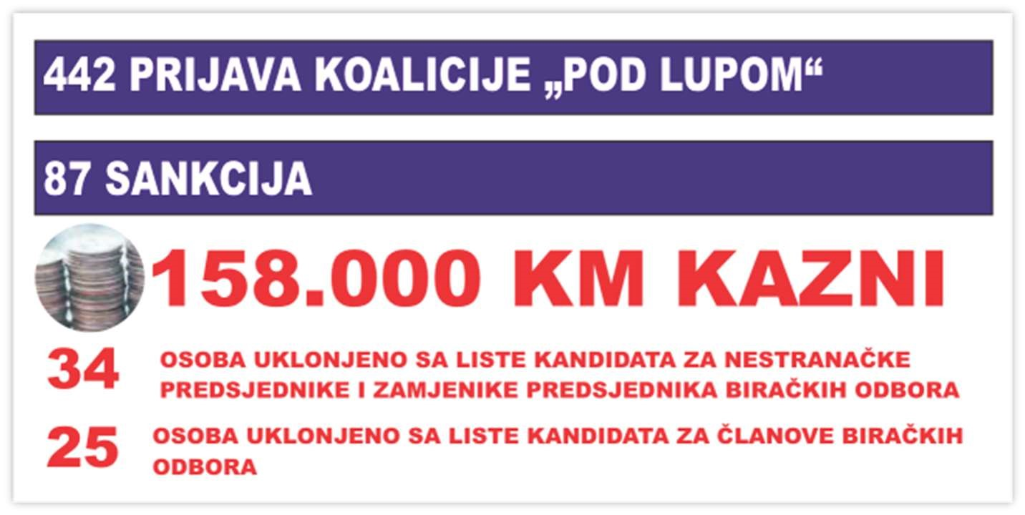

Infographic 19 – Sanctions based on complaints by Pod lupom“

The "Pod lupom" Coalition also submitted six requests for a recount of votes for a total of 442 polling stations due to narrow differences in the results for (city) mayors in 12 municipalities and cities in BiH, discrepancies between the results recorded at the polling stations (the so-called yellow copies) and those published on the CEC BiH website, as well as identified electoral irregularities that could have influenced the election outcome. Additionally, a recount of mail-in ballots was requested in Dobretići, Bosansko Grahovo, and Tomislavgrad due to the significant share of postal votes in the electorate/ballots from regular polling stations, which could have impacted the outcome in races for municipal/city councils. The CEC BiH rejected all requests for recounts from the "Pod lupom" Coalition as unauthorized, but based on the requests, it acted ex officio in several cases and ordered a recount of votes.

Of the total 442 initiatives submitted to the CEC, 271 still have not been considered, even though some initiatives were submitted in July (five months before the completion of this report). This once again highlights the untimeliness in processing complaints and issues in the CEC BiH's handling of the matter.

## REPORTS BY CITIZENS

The "Pod lupom" Coalition regularly encouraged citizens to report any irregularities and suspicions about the electoral process, whether they concerned electoral manipulations, abuses, pressure on voters, or other forms of electoral corruption, through a free SOS phone line, an online form on the website, and social media.

During the election period, the "Pod lupom" Coalition took various steps to ensure the protection of the electoral rights of all citizens. These activities included legal assistance, counseling, and timely intervention in cases where voters' rights were endangered. Complaints were processed by the Coalition's Legal Team, and all relevant complaints were forwarded to the CEC or other competent institutions for further action.

More than 20,000 citizens of BiH used various educational tools provided by the "Pod lupom" Coalition regarding elections in BiH during the two-month period. The publicly available video training for election day observers was viewed more than 13,000 times on the Coalition's YouTube channel (link: <https://shorturl.at/jqXrZ>), the election quiz was played over 9,000 times (link: <https://shorturl.at/deaxr>), and over 300 positive or negative experiences from citizens about the elections were received through the platform "My Electoral Experience," which were displayed on the election experience map (link: <https://shorturl.at/vO3Vh>).

On Election Day, 154 complaints were received from citizens. The largest number of complaints related to violations of the election silence (28), pressure on voters (20), positive experiences on election day (13), overcrowding at polling stations (13), irregularities in the work of PSCs (12), violations of voting secrecy (9), parallel voter lists (7), verification of electoral rules (7), manipulations with polling material (6), and vote buying (6).

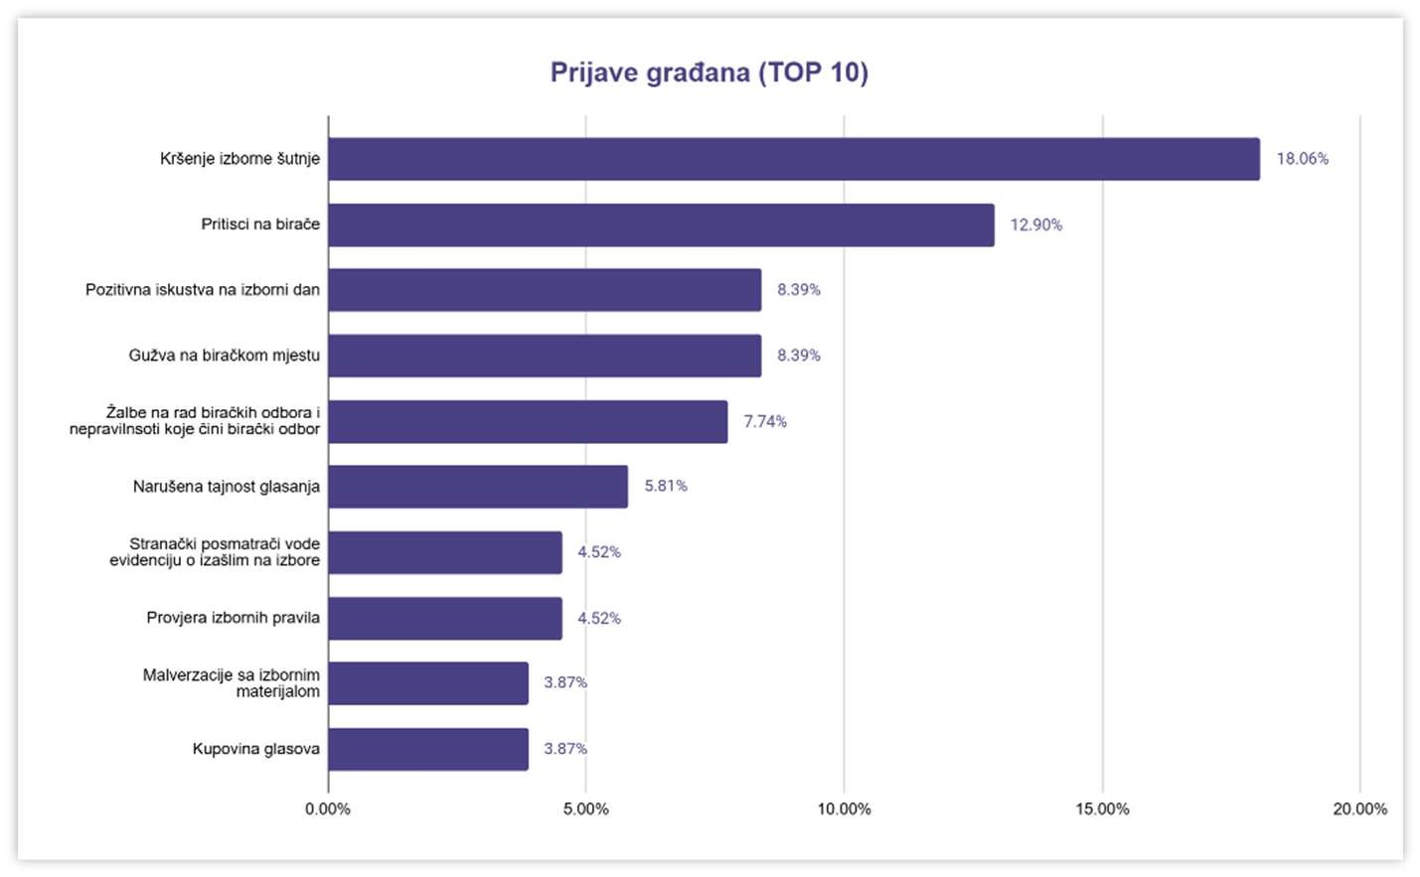

Infographic 20 – Citizen Reports to the Pod lupom Coalition

# ELECTORAL FORENSICS

Electoral forensics is the process of analyzing, investigating, and evaluating electoral processes to ensure their integrity, reliability, and compliance with legal regulations. This discipline uses various techniques to identify and detect potential irregularities, manipulations, or fraud during elections. The goals of this type of research and analysis are to prevent electoral irregularities, improve transparency, provide evidence for resolving electoral disputes, and protect the electoral will of the voters.

The Pod lupom Coalition monitors and analyzes the values of various indicators to identify potential statistically relevant deviations and occurrences that may indicate electoral fraud. Below are some interesting findings from such analyses.

## DATA OPENNESS

Openness of electoral data is a key element of a democratic society. The data collected and held by public institutions must be public. By sharing this data, institutions confirm their commitment to being transparent in their work, and citizens, civil society organizations, and all interested parties, by using public data, have the opportunity to hold institutions accountable. Regarding the openness of electoral data, this means that such data can be freely and easily used, processed, reused, and distributed among the broader public.

Open electoral data are timely, detailed, freely available on the internet, suitable for analysis, non-exclusive and non-discriminatory, free to use, and permanently available.

By respecting the principles of open electoral data throughout all phases of the electoral process—from announcing elections to confirming final results, and even after the official election period—the accountability of institutions is strengthened, and the opportunities for manipulations are reduced. The following is an explanation of the basic principles of open electoral data and their application by the electoral administration in Bosnia and Herzegovina.

|  |
| --- |
| **Timeliness** |
| Although the CEC BiH provides timely information in certain areas - most often about ongoing activities defined by the electoral calendar, and information for voters on how to vote or check their polling place - additional efforts are needed to ensure the timely availability of all data in all stages of the electoral process. In some cases, due to untimely availability of even basic decisions, the electoral administration almost jeopardizes the independent observation mission of the "Pod lupom" Coalition, from decisions on the accreditation of observers, timely distribution of accreditations, late allocation of polling stations or changes in allocation, to the absence of documents on the outcome of complaints and appeals regarding irregularities in the electoral process, and during times when certain analyses are being conducted and when it is most needed. |

|  |
| --- |
| **Level of Detail** |
| The election administration still cannot be praised for the availability of detailed public information. Some documents, such as the Regulations on Election Procedures or the Annual Report on Election Implementation, provide more detail abouts specific parts of the election process. On the other hand, press releases are brief, election statistics documents are inconsistent and limited, and even unavailable for some election cycles. Official responses to inquiries from the "Pod lupom" Coalition for more information on a particular topic are often generic and insufficient for any further analysis. |

|  |
| --- |
| **Free accessibility on the internet** |
| Most basic election data is freely available on the internet; however, this data is often limited, which is why the "Pod lupom" Coalition is forced to submit written requests to the Central Election Commission for more information. Although the data requested in writing are also free, there remains an issue with the level of detail in the information received in the responses received. |

|  |
| --- |
| **Suitability for analysis** |
| Unfortunately, most publicly available data are not suitable for analysis. In most cases, these are scanned printed versions of documents that are available online. Although election results are publicly available, they cannot be easily exported or processed. One of the recommendations for adhering to the principle of open election data is to make the data available in a processable format (e.g., Excel) allowing for easier interpretation and analysis by interested parties, and to ensure that the complete data can be downloaded with just "one click." |

|  |
| --- |
| **Permanently accessible** |
| The basic election data published on the CEC website are usually permanently available; however, one of the challenges is that older data can be harder to find, and there have been instances of previously publicly available documents such as the outcomes of complaints from previous election cycles, were removed. |

|  |
| --- |
| **Non-exclusive and Non-discriminatory** |
| One of the key issues in this segment is the public accessibility of the Central Voter Register (CVR). Currently, even political entities can obtain extracts from the voter register, but despite the law requiring the CVR to be public, it is not accessible to non-governmental organizations that would conduct analysis or independent audits of the CVR. This effectively creates a form of exclusivity of publicly available information for one social group while denying it to another, thus violating the principle of non-exclusivity and non-discrimination. |

|  |
| --- |
| **Free to use** |
| In the past, all data requested from the election administration has been free of charge. Considering that this is not the practice for some other public institutions and public enterprises, this represents a positive aspect in adhering to the principle of open electoral data, despite the limitations in other areas of data openness. |

## SIGNIFICANT STATISTICAL DEVIATIONS

The "Pod lupom" Coalition monitored the structure of the electorate for the 2024 Local Elections in Bosnia and Herzegovina. Official and publicly available data indicate a significant increase in the number of voters in certain basic constituencies, i.e., municipalities and cities in Bosnia and Herzegovina. The largest increase in the number of voters in the 2024 Local Elections compared to the 2022 General Elections was recorded in the Brčko District of Bosnia and Herzegovina (18%), East Drvar (14.5%), Sanski Most (7.1%), Kalinovik (7%), and the Trnovo RS (6.9%). While these figures, by themselves, do not prove electoral irregularities, the sudden increase in the number of voters compared to the previous election cycle may suggest potential electoral manipulation, such as targeted voter re-registration or an increase in the number of voters who de facto do not reside in that municipality/city. In the case of certain municipalities with a very small population (e.g., East Drvar), a small increase in the number of voters by just a few people can represent a significant percentage deviation, which should be taken into account. Also, in the case of the Brčko District of Bosnia and Herzegovina, the increase may be related to the obligation to choose a voting option for the general elections, which is not the case for local elections.

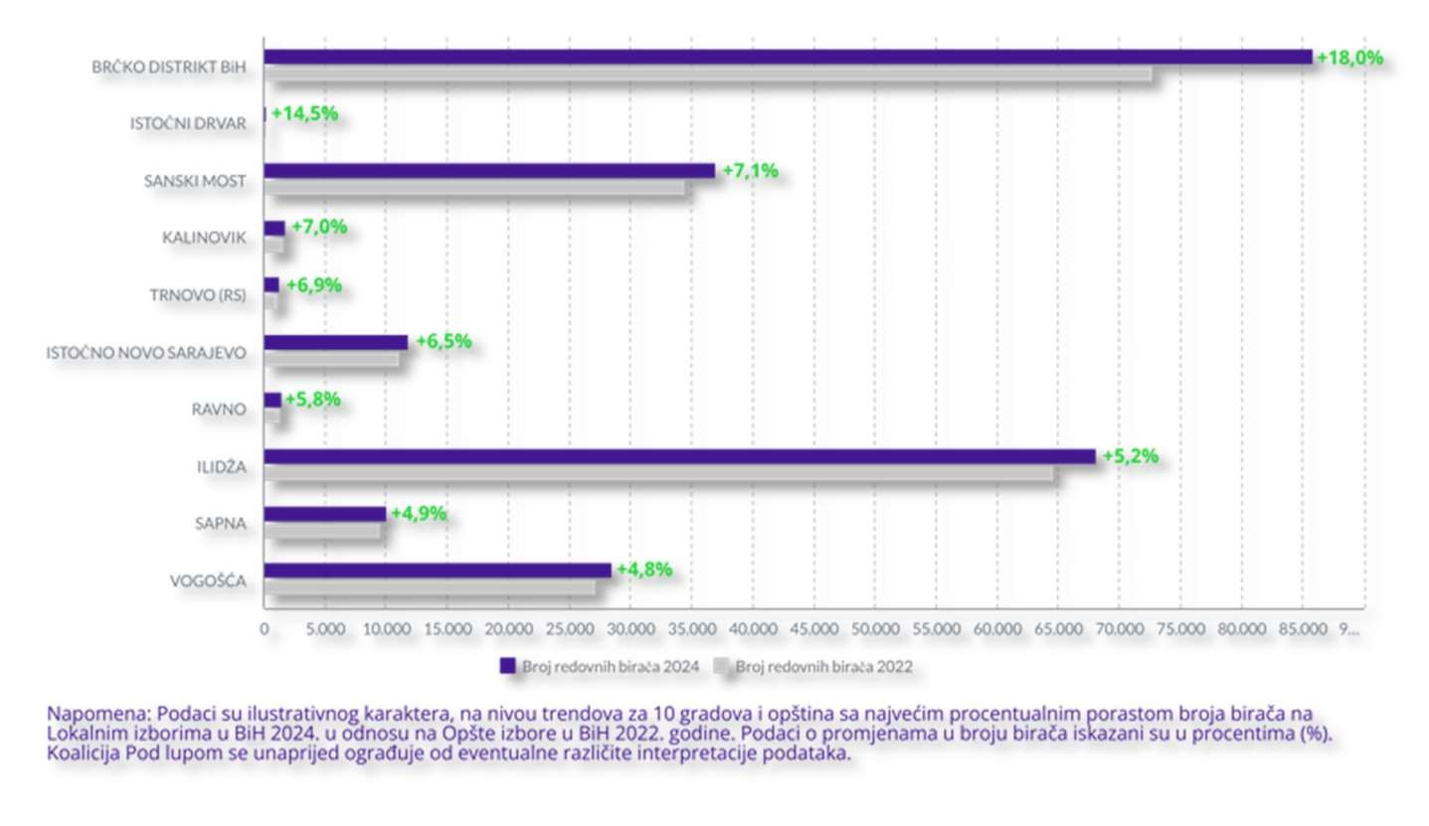

Infographic 21 – Ten Municipalities/Cities with the Highest Increase in Voter Numbers

A data point that may be indicative is the proportion of the electorate voting by mail within the total electorate, and consequently, in the number of voters who exercised their right to vote. Although the Election Law of Bosnia and Herzegovina allows voting by mail, statistically significant deviations in municipalities and cities regarding the proportion of such voters in the electorate are an indication of vote manipulation via mail with the aim of influencing the election outcome. The best example of this is the municipality of Dobretići, where one-fifth of the electorate consists of voters who can vote by mail. After processing the results, the proportion of mail-in votes in the total number of votes (i.e., those who actually voted) rises to half of those who voted. Thus, in this election, out of 690 valid ballots, as many as 352 were mail-in votes (51%), meaning that voters who de facto do not reside in Dobretići made up the majority of those who voted in the election. Considering the history of proven election fraud related to mail-in voting, this not only could affect the election result but could also determine the outcome of the election. The long-standing position of the "Pod lupom" Coalition is that anyone who de facto does not have residence (according to the law, residing with the intention of living permanently there) in a municipality/city should not have the right to vote in local elections where local authorities are elected. This is the case in many developed democratic countries and is the practice at the level of the European Union.

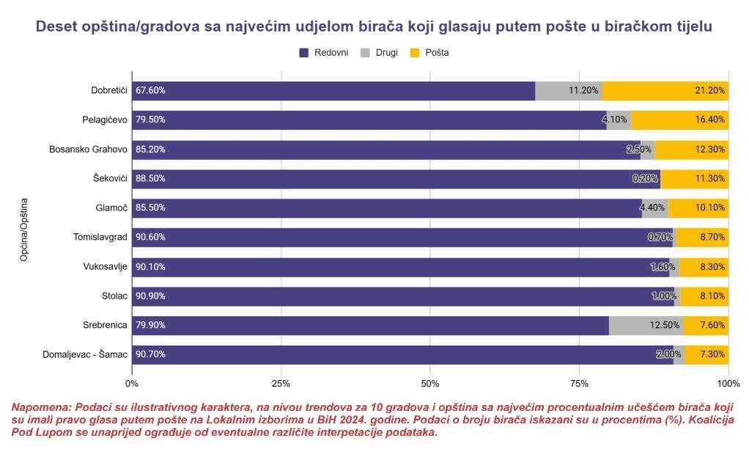

Infographic 22 – Ten Municipalities/Cities with the Highest Proportion of Voters Voting by mail

The "Pod lupom" Coalition, through post-election analysis of voter turnout data and the number of invalid ballots per polling station, found that 3.8% of polling stations had a turnout greater than 75%, which could suggest electoral fraud – voting on behalf of someone else who did not go to the polls through the misuse of unused ballots. Additionally, 8.3% of polling stations recorded more than 10% invalid ballots for council/assembly elections, which could indicate electoral fraud – intentional invalidation or cancellation of votes for political opponents by members of PSCs or operators entering election results. It is important to note that the average percentage of invalid ballots in EU member states is 1.5-2%, and that in Bosnia and Herzegovina, abnormal values of invalid ballots persist from one election cycle to the next. The "Pod lupom" Coalition has used some of these data as the basis for requests for recounts of ballots and believes that, in the future, the CEC should, based on similar analyses and indications, automatically order recounts of ballots ex officio to eliminate doubts about any irregularities.

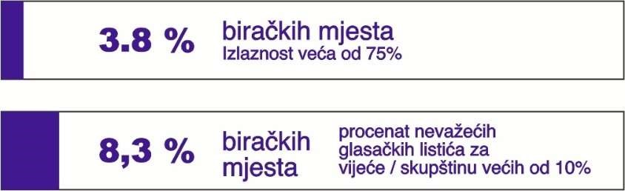

Infographic 23 – Percentage of Polling Stations with High Voter Turnout and a Large Number of Invalid Ballots

## INTERESTING TRENDS

The „Pod lupom“ Coalition conducted a post-election analysis and comparison of the election results from 2020, 2022, and 2024. This was done to identify trends in election results by political parties across election cycles.

In 142 positions, citizens directly elected (mayors) of cities/municipalities, while the mayors of the Brčko District of BiH, Mostar, and Sarajevo are appointed after the election by the indirectly elected councils/assemblies of these local communities. Out of 142 elected (mayoral) positions, only 27 saw a change in leadership compared to the Local Elections of 2020 (different individuals or candidates from different political parties were elected). The same individuals kept a total of 92 positions, while the change involved 23 individuals within the same political party who won the mayoral mandate both in the previous and this local election cycles. Out of the total 142 (mayoral) positions, only 7 were won by women (4.9%). This, along with the appointments to decision-making positions after elections, which are often seen as electoral spoils and represent an open form of systemic corruption, reflects the actual relationship between political entities and the participation of women in politics in BiH.

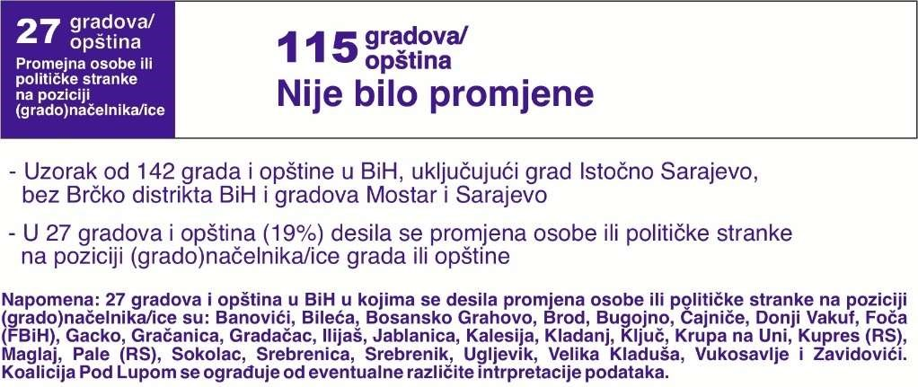

Infographic 24 – Number of Municipalities/Cities with Changes in the Person or Political Party Holding the Mayor Position

If we take a closer look at the actual election results, it is noticeable that some political parties gained more voter support, some stagnated, and others lost a significant number of votes.

The 10 political parties with the most mayoral mandates over the last two local election cycles saw the following changes in the number of mayoral positions won compared to the previous local elections: SDA (+5), NiP (+2), SBiH (+1), and SNSD (+1) recorded an increase. HDZ BiH and PDP saw stagnation, while SDS (-4), independent candidates (-2), as well as SDP BiH (-1) and PDA (-1) experienced losses.

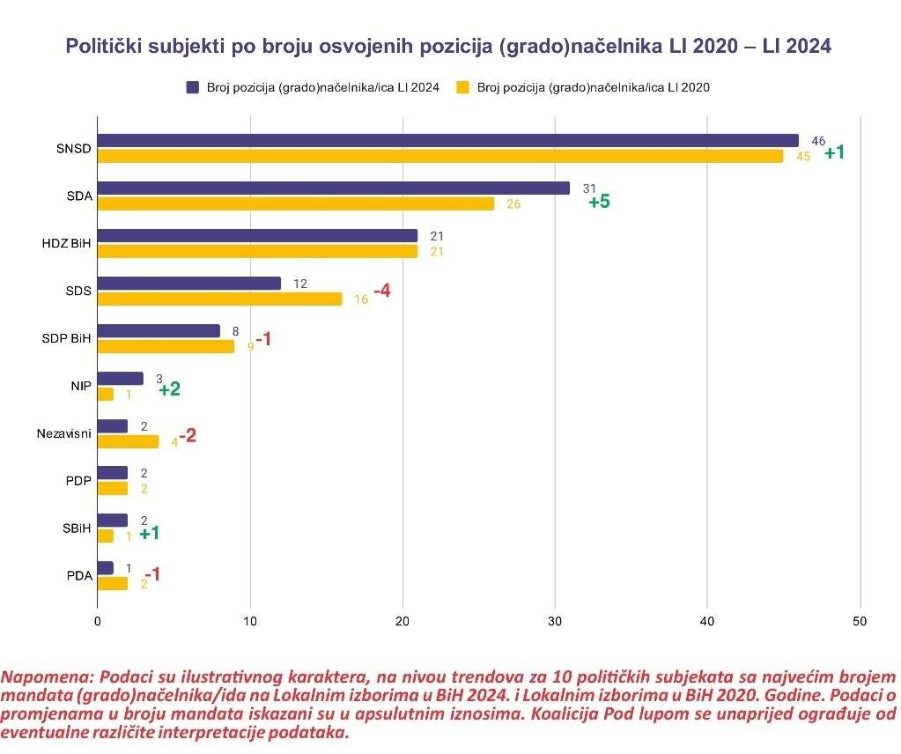

Infographic 25 – Political Entities by Number of Mayoral Positions Won LE 2020 – LE 2024

When comparing the number of votes won in the most recent 2022 General Elections and he 2024 Local Elections, clear trends emerge in the support given to the 20 political parties with the highest number of votes in the 2024 Local Elections.

The largest increase in the number of votes was recorded by SDA (+47.8 thousand votes), SBiH (+25 thousand votes), and Narodni Front (+18.2 thousand votes), with the latter being a new political entity that did not exist in 2022. The largest decrease in the number of votes was recorded by DF (-69 thousand votes), PDP (-27.2 thousand votes), NES (-20 thousand votes), Naša Stranka (-18.8 thousand votes), HDZ BiH (-14.7 thousand votes), and SDS (-11.8 thousand votes). Other political parties in the top 20 with the most votes generally saw changes within the range of +/- 5 thousand votes.

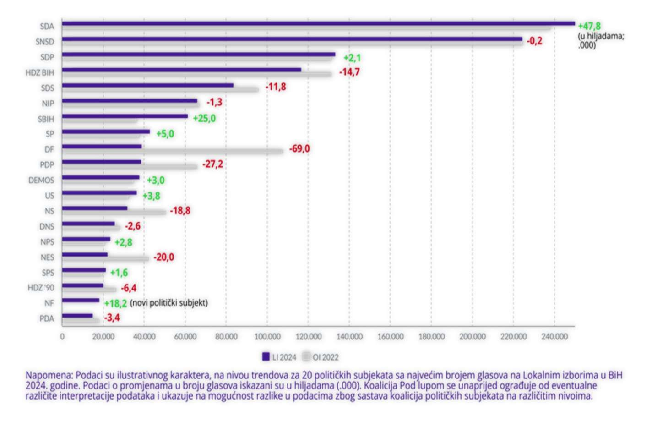

Infographic 26 – Political entities by the number of votes won GE 2022 – GE 2024

The source of the election results data is the CEC website. The data are for illustrative purposes, showing trends by political parties with the highest number of votes. Data on changes in the number of mandates are presented in absolute terms, while data on changes in the number of votes are presented in thousands (.000). The Coalition "Pod lupom" disclaims any responsibility for potential different interpretations of the data and points out the possibility of discrepancies due to the composition of political coalitions at different levels.

# METHODOLOGY OF LONG-TERM ELECTION MONITORING

The Pod lupom Coalition monitored the entire electoral process in Bosnia and Herzegovina for the 2024 Local Elections, covering all phases of the election process from the announcement of the elections, through Election Day, to the publication of the final confirmed election results. For this purpose, long-term monitoring of the elections was conducted three months before the Election Day, short-term monitoring on Election Day, and post-election monitoring.

Long-term monitoring of the elections was carried out from July 23 to October 16, 2024. This type of election observation provides continuous monitoring of the entire electoral process, offering a comprehensive picture that covers as broad a spectrum of election-related activities as possible, not just Election Day itself. The Coalition conducted long-term monitoring of the 2024 Local Elections in collaboration with 49 civil society organizations, informal groups, and activists from across Bosnia and Herzegovina, as well as 54 long-term observers covering all 143 basic constituencies in the country (municipalities, cities, and Brčko District). Long-term observers monitored the work and sessions of all municipal/city election commissions in BiH, activities outlined in the election calendar, compliance with election deadlines, electoral irregularities, and media coverage. They reported weekly and sent a total of 1,716 regular reports on key observation findings. In addition, the long-term observers of the Coalition "Pod lupom" held 1,213 meetings with various actors in the electoral process (election administration, political entities, institutions, police departments, civil society organizations, media, and others) to provide the most objective assessment of the electoral process in BiH. Reports from long-term observers constitute a key component of this final report.

Short-term election observation on Election Day was conducted using a methodology of representative sampling of polling stations and observation of additional polling stations where new election technologies were piloted. On Election Day, Pod lupom engaged 776 observers at polling stations across the country (including postponed elections in five municipalities and cities), 53 observers in mobile teams, and 60 operators in the Call Center. Nearly 100,000 data entries on the quality of election implementation were processed on Election Day via the observer reporting system from polling stations and an advanced database.

In the post-election period, the Coalition’s team worked on processing all observation findings, monitoring the repeated vote counts at the level of basic constituencies and the Main Counting Center, and protecting electoral rights (including submitting requests for re-counting ballots). An additional 21 observers were engaged for the repeated vote counts and 8 observers at the Main Counting Center. The Coalition also monitored the work of the BiH CEC by observing sessions online.

# ABOUT US

**About the Pod lupom Coalition**

The Coalition Pod lupom is an informal coalition of civil society organizations in Bosnia and Herzegovina, currently consisting of 49 member organizations. The Coalition is dedicated to monitoring and improving electoral processes in BiH.

Since its establishment in 2014, the Pod lupom Coalition has observed over 20 different elections in Bosnia and Herzegovina at various levels of government, including regular, early, and repeated elections.[32] Over 16,000 citizen, non-partisan observers have been engaged in all these elections. To date, the Coalition has directly worked with over 150,000 citizens, including over 60,000 young people. So far, a total of 54 Coalition’s recommendations have been partially or fully implemented in electoral rules, leading to direct improvements in the electoral process. According to a public opinion survey from August 2024, the Coalition is one of the most trusted actors in the electoral process among citizens and ranks among the five most recognized civil society actors in BiH.

In addition to election observation and advocating for improvements of the electoral process in all its segments, Pod lupom is involved in research and analysis, organizing public events and expert discussions on election topics, educating citizens – particularly young first-time voters – and developing member organizations.

**The Pod lupom Coalition and the 2024 Local Elections in Numbers**

In the Local Elections in Bosnia and Herzegovina held on October 6, 2024, the Coalition "Pod lupom":

* Engaged 829 citizen, non-partisan election day observers
* Covered 776 regular polling stations (every seventh regular polling station in the country)
* Engaged 60 operators in the Call Center
* Received and processed nearly 100,000 data points regarding the quality of the election process
* Recorded 149 critical situations on Election Day
* Engaged 54 long-term observers who held 1,213 meetings with various election process stakeholders
* Recorded 1,367 electoral irregularities during the pre-election period
* Submitted 442 reports of electoral irregularities to the competent authorities, resulting in 87 sanctions totaling 158,500 BAM
* Trained over 1,000 citizens and 100 international observers on election day observation
* Organized 12 press conferences and issued 23 press releases
* Recorded 963 press reports about its activities
* Enabled 20,000 citizens to use various educational tools provided by the Coalition "Pod lupom" regarding elections in BiH

# APPENDICES

Infographic 1 – Electoral Administration  
Infographic 2 – Structure of Electoral Irregularities in the Pre-election Period  
Infographic 3 – Irregularities by Political Parties  
Infographic 4 – Monitoring Social Media  
Infographic 5 – Monitoring the Electoral Campaign  
Infographic 6 – Observer Access to Polling Stations  
Infographic 7 – Challenges in Access to Polling Stations  
Infographic 8 – Polling Station Opening Time  
Infographic 9 – Irregularities and Failures in Polling Station Setup and Opening  
Infographic 10 – Irregularities in the Voting Process  
Infographic 11 – Polling Station Closing Time  
Infographic 12 – Voter Turnout in Local Elections in BiH through Electoral Cycles  
Infographic 13 – Critical Situations on Election Day  
Infographic 14 – Key Findings of the Optical Scanners and Automatic Vote Counting Pilot Monitoring  
Infographic 15 – Key Findings of the Biometric Voter Identification and Authentication Pilot and Result Transmission Monitoring  
Infographic 16 – Number of Reports to the CEC  
Infographic 17 – Structure of Reports to the CEC  
Infographic 18 – Structure of Reports from the Pod lupom Coalition   
Infographic 19 – Sanctions Based on Reports from the Pod lupom Coalition   
Infographic 20 – Citizen Reports to the Pod lupom Coalition  
Infographic 21 – Ten Municipalities/Cities with the Highest Increase in Voter Numbers  
Infographic 22 – Ten Municipalities/Cities with the Highest Proportion of Voters Voting by Mail  
Infographic 23 – Percentage of Polling Stations with High Turnout and Invalid Ballots  
Infographic 24 – Number of Municipalities/Cities with Changes in the Person or Political Party Holding the (Mayoral) Position  
Infographic 25 – Political Parties by Number of (Mayor) Positions Won LE 2020 – LE 2024  
Infographic 26 – Political Parties by Number of Votes Won GE 2022 – GE 2024

Table 1 – Misuse of Public Funds and Resources  
Table 2 – Irregularities in Forming Election Commissions  
Table 3 – Irregularities Related to Election Commissions  
Table 4 – Premature Electoral Campaign  
Table 5 – Violation of Electoral Deadlines by Local Election Commissions  
Table 6 – Irregularities in the Work of the Media   
Table 7 – Other Electoral Irregularities  
Table 8 – Irregularities and Shortcomings in Vote Counting  
Table 9 – Voter Authentication and Result Transmission Pilot  
Table 10 – Optical Scanners and Automatic Vote Counting Pilot  
Table 11 – Biometric Voter Identification and Authentication Pilot  
Table 12 – Video Surveillance Pilot at Polling Stations

1. The 2024 Local Elections in Bosnia and Herzegovina were announced at the 21st session of the CEC held on May 8, 2024, while the final 117th session was held on December 9, 2024.
2. Statement of Preliminary Findings and Conclusions of the International Observation Mission of the OSCE Office for Democratic Institutions and Human Rights (ODIHR), link:  
   <https://www.osce.org/odihr/elections/bih/577660>, p. 7
3. The Election Law of Bosnia and Herzegovina ("Official Gazette of BiH," nos. 23/2001, 7/2002, 9/2002, 20/2002, 25/2002 – corr., 4/2004, 20/2004, 25/2005, 77/2005, 11/2006, 24/2006, 33/2008, 37/2008, 32/2010, 48/2011 – Constitutional Court decision, 63/2011 – Constitutional Court decision, 18/2013, 7/2014, 31/2016, 54/2017 – Constitutional Court decision, 41/2020, 38/2022, 51/2022, 67/2022, 24/2024, and 24/2024 – correction), Article 3.1, paragraph (2).
4. The Law on Personal Data Protection of Bosnia and Herzegovina ("Official Gazette of BiH," nos. 49/06, 76/11, and 89/11).
5. Brod, Fojnica, Glamoč, Istočna Ilidža, Kozarska Dubica, Livno, Novi Grad Sarajevo, Oštra

   Luka, Pelagićevo, Prnjavor, Srebrenik and Zvornik
6. Bijeljina, Gradiška, Livno, Novi Travnik, Ugljevik and Žepče
7. For more details, see the section "Shortcomings in the Work of Local Election Commissions," p.
8. The Election Law of Bosnia and Herzegovina ("Official Gazette of BiH," nos. 23/2001, 7/2002, 9/2002, 20/2002, 25/2002 – correction, 4/2004, 20/2004, 25/2005, 77/2005, 11/2006, 24/2006, 33/2008, 37/2008, 32/2010, 48/2011 – Constitutional Court decision, 63/2011 – Constitutional Court decision, 18/2013, 7/2014, 31/2016, 54/2017 – Constitutional Court decision, 41/2020, 38/2022, 51/2022, 67/2022, 24/2024, and 24/2024 – correction), Article 2.19, paragraph (2).
9. For more details, see the section "Irregularities Related to PSCs," p. ___.
10. Decision on the Announcement and Holding of the 2024 Local Elections.
11. “The responsibility for reporting deceased citizens to the municipality lies with the family of the deceased, who must present a printed extract from the death register to the competent authorities. According to the Law on Permanent and Temporary Residence of Citizens of BiH, registration and de-registration of residence are the responsibility of the citizens themselves.", Statement of Preliminary Findings and Conclusions OSCE Office for Democratic Institutions and Human Rights (ODIHR), link: https://www.osce.org/odihr/elections/bih/577660, p. 10
12. Voting was enabled in Serbia, Germany, Austria, Denmark, the Netherlands, Slovenia, Sweden, and Belgium at the following diplomatic and consular missions: the Embassy of BiH in Belgrade, Berlin, Vienna, Copenhagen, The Hague, Ljubljana, Stockholm, and Brussels, the General Consulates of BiH in Munich, Frankfurt, and Stuttgart, the Honorary Consulates in Graz and Salzburg, and the Honorary Consulate of BiH for Upper Austria.
13. “Political entity" refers to a political party, independent candidate, coalition, or list of independent candidates, certified for participation in the elections in accordance with the Election Law of BiH.
14. Election Law of BiH, Article __
15. After the amendments to the Election Law of BiH, the registration of political subjects was conducted in electronic form through a special online platform, e-Elections.
16. Tirović, Belma: “Zastupljenost žena na Lokalnim izborima 2024. Godine” (Istinomjer.ba),

    link: https://istinomjer.ba/zastupljenost-zena-na-lokalnim-izborima-2024-godine/
17. Top 6 political entities by the number of electoral irregularities are responsible for 70 % of all documented electoral irregularities
18. Other political entities are: BH Zeleni, Čapljina u Srcu, DEMOS, DF, DNS, HDS, HDZ 1990, HRS, HSP, HSS, Koalicija za Mostar, Krug, Laburistička stranka, Naprijed, Narodni front, Naša stranka, NDP, NES, Nezavisna lista Doboj, NiP, NPS, PDA, Prva SDS, Prva stranka, Republička stranka Srpske, Savez mladih snaga, SD BiH, Snaga naroda, SNS FBiH, SP, SPS, Stranka Život, Svojim putem, SZBiH, Ujedinjena Srpska
19. The local election commissions that did not carry out the preliminary designation of polling stations by August 2, 2024, are: Drvar, Gradiška, Trnovo (FBiH), Trnovo (RS), and Živinice.
20. The local election commissions that did not publish the final list of polling stations with locations and the number of voters by September 21, 2024, are: Bosanski Petrovac, Bosansko Grahovo, Centar Sarajevo, Doboj Istok, Doboj Jug, Drvar, Gradiška, Han Pijesak, Ilidža, Istočna Ilidža, Istočni Stari Grad, Ključ, Kostajnica, Kozarska Dubica, Krupa na Uni, Livno, Maglaj, Novi Grad, Novi Grad Sarajevo, Novi Travnik, Novo Sarajevo, Petrovo, Prnjavor, Rudo, Šamac, Šekovići, Trebinje, Velika Kladuša, Zavidovići, Žepče, Živinice, and Zvornik.
21. The local election commissions that did not conduct the draw for political subjects for the party members of PSCs by August 22, 2024, are: Bugojno, Kalinovik, and Pelagićevo.
22. The local election commissions that did not make a decision on the appointment of party members to the PSCs by August 22, 2024, are: Brod, Kalinovik, Ključ, Kozarska Dubica, Livno, Ljubuški, Novi Grad, Orašje, Prijedor, and Tešanj
23. The local election commissions that did not conduct training for polling board members by September 26, 2024, are: Banja Luka, Bosanski Petrovac, Bosansko Grahovo, Derventa, Doboj Istok, Doboj Jug, Donji Vakuf, Glamoč, Gradačac, Istočna Ilidža, Istočno Novo Sarajevo, Jajce, Kalinovik, Kneževo, Kotor Varoš, Milići, Mrkonjić Grad, Novi Grad Sarajevo, Novo Sarajevo, Petrovo, Prnjavor, Šamac, Šekovići, Šipovo, Srbac, Tešanj, Teslić, and Trnovo (FBiH)
24. Irregularities related to the shortcomings in the work of local election commissions in all categories, except for violations of election deadlines, refer to the last weekly LTO report for the period of September 22–29, 2024.
25. SDA, SNSD, SDP, HDZ BiH, DF BiH, NiP, Naša stranka, NES, SDS, PDP, Za pravdu i red – Nebojš Vukanović’s list, Za nove generacije, Ujedinjena Srpska, HRS, DNS, BH-KF, Naprijed BiH, HDZ 1990 and Narodni front – Jelena Trivić.
26. Numerous topics are presented at campaign rallies, and the monitors of political gatherings had the opportunity to select multiple topics discussed at the rally when reporting.
27. ID card, passport or driver’s license
28. Banja Luka, Bijeljina, Brčko District of BiH, Centar Sarajevo, Doboj, Domaljevac-Šamac, Gradiška, Eastern New Sarajevo, Novi Grad, Mostar, Prijedor, Sanski Most, Srebrenica, Old Town Sarajevo, Stolac, Tešanj, Tuzla, Trebinje, Visoko, Vlasenica, Vogošća, Zenica, and Zvornik; Decision on the designation of polling stations for the implementation of pilot projects for the 2024 Local Elections from August 16, 2024.
29. Local election commission and the Central Election Commission of BiH
30. For the regular Local Elections 2024 held on October 6, 2024, 789 observers were engaged (739 at polling stations and 50 in mobile teams). For the postponed Local Elections 2024 in Fojnica, Kiseljak, Konjic, and Kreševo, held on October 20, 2024, 32 election day observers were engaged, and for the postponed elections in Jablanica, held on November 3, 2024, 8 Election Day observers were engaged.

    .
31. Data from the Pod lupom analysis of August 2024.
32. General Elections (2014, 2018, 2022). Local Elections (2016, 2020, City of Mostar, 2024). Snap elections (Domaljevac-Šamac, East Drvar, Stanari, Kalesija, Živinice, Fojnica, Milići, Trnovo, Glamoč, Doboj, Bosansko Grahovo, Bosanski Petrovac, Bužim, Kakanj, Ribnik, Foča, Prijedor, Bihać, Srebrenik, Tuzla, Bratunac, Vogošća). Repeat elections (Stolac, Doboj, Srebrenica). Mayoral Recall Election (Lukavac).