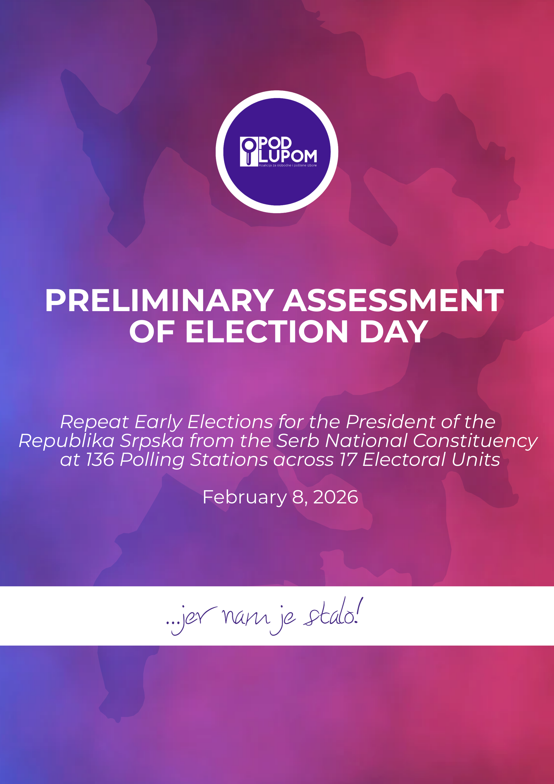

Contents

Preliminary Assessment of Election Day 2
Results of the Repeated Early Elections for President of Republika Srpska from among the Serb people 3
Voter Turnout in the Repeated Early Election for President of Republika Srpska 3
Chronological Overview of Election Day (Extended Observation Results) 5
Challenges in implementing the election observation mission and coverage of polling stations on election day 5
Access of Observers to Polling Stations 6
Opening and Arrangement of Polling Stations 6
Voting Process 7
Closing of Polling Stations 10
Vote Counting 10
Packaging of Election Material 11
Acknowledgements 11

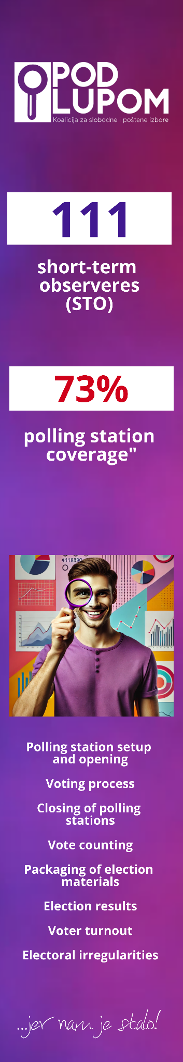

Preliminary Assessment of Election Day

The preliminary assessment of election day by the Coalition “Pod lupom” for the Repeat Early Elections indicates that, based solely on the methodology of direct observation at polling stations, the electoral process largely proceeded in accordance with the applicable legal rules and prescribed procedures. However, certain deviations were recorded at individual polling stations, which, in isolated cases, may have affected the voting results at those specific locations.
Additionally, observer access during these elections was hindered by decisions of the CEC BiH, as well as on the ground due to arbitrary interpretations of procedures and rules by the election administration. This represents a step back from the democratic standards and electoral practices achieved in previous cycles.
At the same time, the overall picture of election day cannot be viewed solely through findings at polling stations. A significant number of indications of electoral irregularities were recorded outside the scope of direct observation, including pressure on voters around polling stations, the maintenance of parallel lists of voters who cast ballots, indications of partisan-formed polling boards with politically affiliated chairpersons, and possible vote buying. The scale and frequency of these cases raise justified doubts regarding the full regularity of election day. In this context, even with formal compliance at most polling stations, the potential impact of irregularities on voter choice cannot be entirely ruled out.
The preliminary assessment of election day confirms that:
- Electoral technologies in the form of electronic voter identification and ballot scanners must be applied at all polling stations, which would prevent the electoral irregularities that prompted these repeat elections;
- Police and prosecutors must urgently investigate and prosecute all forms of unlawful pressure on voters to ensure that election results reflect the true will of citizens;
- Election administration must be freed from any political influence in accordance with the law; and
- The implementation of independent election observation must be encouraged by institutions, with observers’ access to polling stations facilitated.

Results of the Repeated Early Elections for President of Republika Srpska from among the Serb people

The Coalition “Pod lupom” monitored the results of the Repeat Early Elections for the President of Republika Srpska from the Serb ethnic constituency. The data include the number of votes for each candidate based on the polling stations where “Pod lupom” observers were deployed. These findings serve as a preliminary confirmation of the official election results.
Candidate Siniša Karan received 69.03% of the votes, candidate Branko Blanuša 30.17%, and the remaining candidates collectively received 0.8% of the votes.
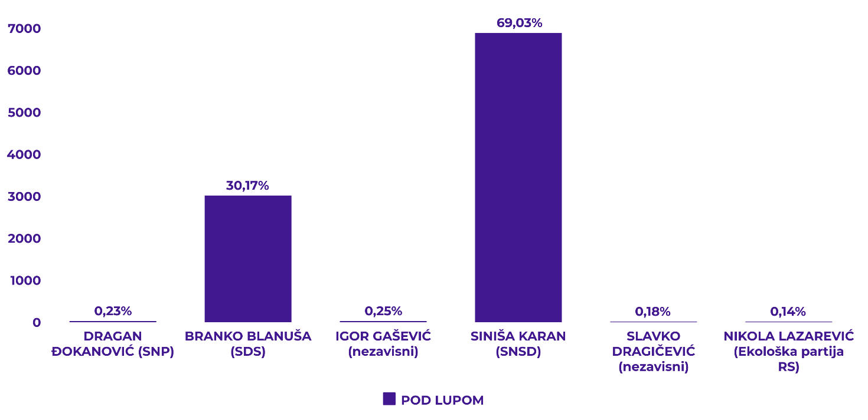

Voter Turnout in the Repeated Early Election for President of Republika Srpska

The Coalition “Pod lupom” monitored voter turnout throughout election day, providing independent data on citizen participation. Turnout data are published at three key time intervals: 11:00 a.m., 3:00 p.m., and 7:00 p.m., corresponding to the same intervals at which the CEC BiH releases official voter turnout information. This approach allows for an independent and timely verification of turnout, with the possibility of comparison to official CEC data.
At polling stations where “Pod lupom” observers were present, recorded turnout in the Repeat Early Elections by 7:00 p.m. was 49.6%, compared to the CEC BiH official figure of 49.51%.
For comparison, turnout at the previous General Elections 2022 in Republika Srpska by 7:00 p.m. was 53%, while at the Early Elections held on 23 November 2025, at polling stations where repeat elections were conducted, turnout was 46.3%.

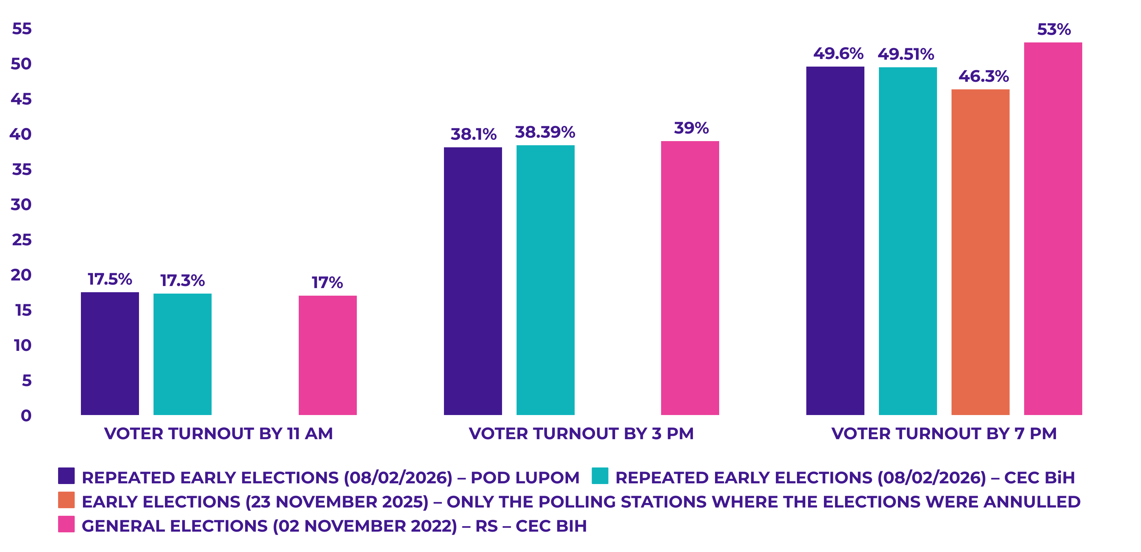
Turnout was 3.4% lower than at the previous General Elections, and 3.3% higher compared to turnout at the Early Elections at these polling stations.
Below is an overview of voter turnout by municipalities and cities where the repeat early elections were held, with a comparative presentation alongside the Early Elections held on 23 November 2025.
Municipality/City | Early Elections | Repeated Elections | Difference
Osmaci | 37.11% | 54.05% | 16.94%
Milići | 44.08% | 52.15% | 8.07%
Banja Luka | 28.60% | 35.62% | 7.02%
Bratunac | 38.18% | 45.04% | 6.86%
Doboj | 51.43% | 58.15% | 6.72%
Prijedor | 51.97% | 57.62% | 5.65%
Rudo | 24.39% | 29.32% | 4.92%
Brčko distrikt BiH | 37.79% | 40.55% | 2.76%
Gacko | 61.30% | 63.91% | 2.61%
Nevesinje | 54.01% | 56.18% | 2.17%
Laktaši | 52.93% | 54.46% | 1.53%
Zvornik | 43.38% | 44.01% | 0.63%
Bileća | 60.49% | 58.33% | -2.16%
Vlasenica | 53.23% | 48.50% | -4.73%
Ugljevik | 61.54% | 54.29% | -7.24%
Stanari | 47.73% | 30.91% | -16.82%
Lopare | 83.01% | 43.46% | -39.55%
Izlaznost | 46.30% | 49.60% | 3.30%

Chronological Overview of Election Day (Extended Observation Results)

The Coalition “Pod lupom” presents below a more detailed overview of the findings from election day observation, based on a significantly larger dataset than the reports released on the day of the elections. Unlike the initial information published during the election day and night, the following provides a systematic, chronological account of all key phases of election process monitoring.
The overview includes key findings related to observer access to polling stations, the preparation and opening of polling stations, the voting process, the closing of polling stations, the counting of votes, and the determination of election results. Each of these phases has been documented in detail, allowing for the identification of irregularities, deviations from legal and procedural standards, and an assessment of the overall compliance of the electoral process with applicable rules.

Challenges in implementing the election observation mission and coverage of polling stations on election day

The observation mission of the Coalition for Free and Fair Elections “Pod lupom” on election day was conducted under partially specific and challenging conditions, which significantly affected the scope and organization of monitoring the electoral process. Although the Coalition “Pod lupom” had planned for full coverage of polling stations with civic, non-partisan observers in a timely manner, such coverage was not possible due to the decision of the Central Election Commission of Bosnia and Herzegovina (CEC BiH) to deny the request for accreditation of additional observers.
It is important to note that the Election Law of Bosnia and Herzegovina does not impose restrictions regarding the accreditation of new observers in the context of repeat elections. Furthermore, in previous practice—including repeat elections in Doboj, Srebrenica, and Stolac—the CEC BiH allowed the accreditation of additional observers without obstacles. The absence of such a practice in the current electoral cycle indicates inconsistent application of rules and deviation from previously established standards, negatively affecting the integrity of the electoral process.
Although the Coalition “Pod lupom” had a sufficient number of already-accredited observers at the entity level, the CEC decision had a direct and significant impact on the organization of the observation mission. This particularly affected operational and logistical aspects, including increased costs, more complex field deployment planning, and reduced flexibility in observer allocation. This approach led to an illogical and unsustainable situation in which observers could not be deployed to polling stations in the communities where they live, while at the same time their deployment from distant communities was permitted.
As a result, the coverage of polling stations by civic, non-partisan observers on election day was 73%, with 111 observers deployed to 99 polling stations out of 136 where repeat elections took place.
Full coverage was not achieved in the following electoral units:
- Zvornik: 57% coverage (30 polling stations covered)
- Laktaši: 67% coverage (16 polling stations covered)
- Doboj: 81% coverage (25 polling stations covered)
In all other electoral units where elections were repeated, 100% of polling stations were covered.
Although this level of coverage allows for relevant insight into the course of the electoral process, it simultaneously represents a limitation in terms of fully monitoring the process at all polling stations.
Despite these challenges, the observation mission of the Coalition “Pod lupom” was conducted professionally, responsibly, and in accordance with election observation rules. However, experiences from this and previous electoral cycles clearly indicate the need for consistent application and simplification of rules regarding observer accreditation, rather than the opposite, to enable improvements in the electoral process in the context of election observation in the future.

Access of Observers to Polling Stations

The majority of independent, non-partisan observers had unobstructed and timely access to polling stations, without any barriers to their work, such as prohibitions on observation that had occurred in the past.
Isolated Access Issues Identified
The Coalition “Pod lupom” recorded that in Zvornik, observers were not able to access polling stations freely due to procedural issues. Polling boards required observers, in addition to their accreditation, to present a separate accreditation decision to gain access—something that had not been required previously.
Additionally, throughout the day, one observer experienced pressure at the polling station where they were assigned to monitor the electoral process.
On a positive note, at the majority of polling stations, legal rules regarding election day observers were respected. Unobstructed access for independent observers is a fundamental prerequisite for credible election observation. Only under such conditions can an observation mission be conducted in full capacity and ensure there are no doubts about the regularity of the electoral process during the opening of polling stations.

Opening and Arrangement of Polling Stations

Observation of the opening and preparation of polling stations represents the first phase of election day, which the Coalition “Pod lupom” systematically monitored. During this phase, data were collected on the timely opening of polling stations, the presence and composition of polling boards, the availability and completeness of electoral materials, as well as compliance with prescribed procedures for preparing polling stations for voting.

Polling Station Opening Time
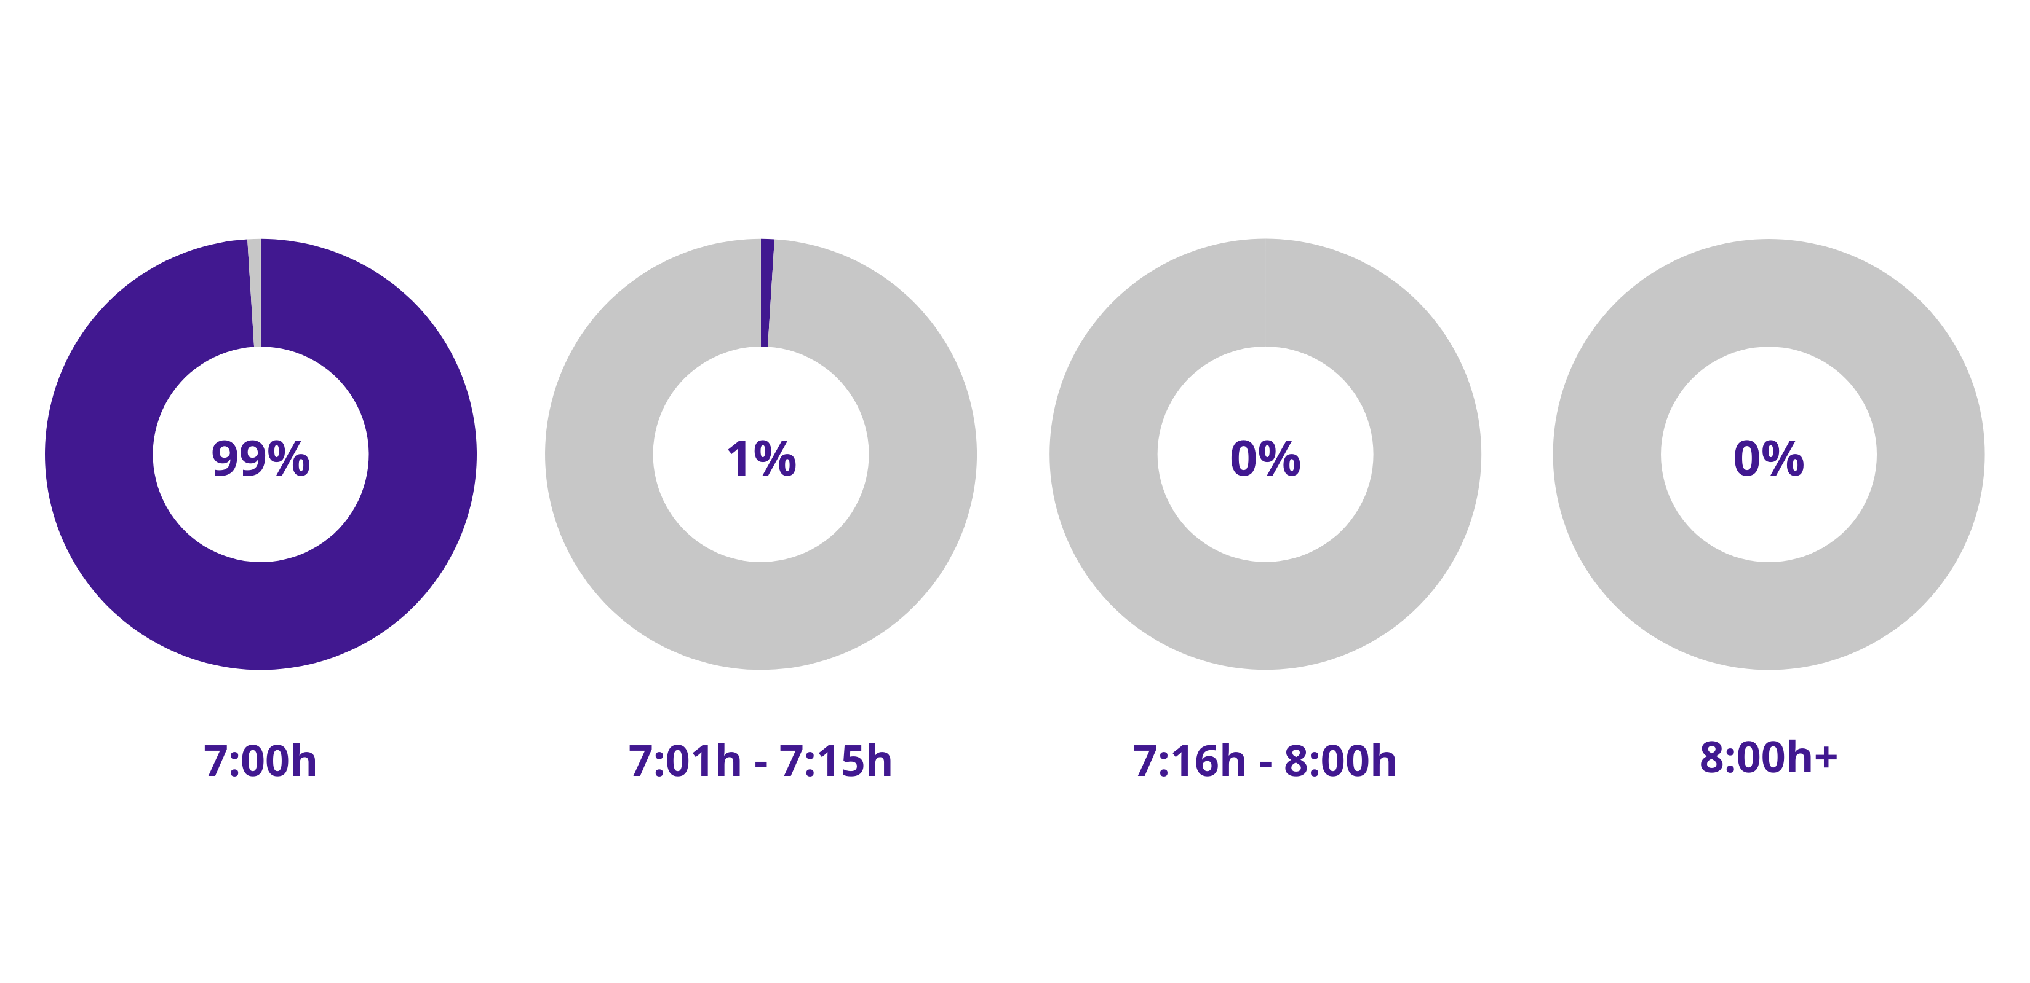The majority of polling stations were opened on time without significant delays. 99% of observed polling stations were opened precisely at 7:00 a.m., while 1% were opened between 7:01 a.m. and 7:15 a.m.
The Coalition “Pod lupom” recorded isolated cases of procedural lapses or non-compliance with legal requirements. Below is an overview of key statistical indicators collected during the observation of the opening and preparation of polling stations:
- An estimated 14.3% of polling stations were not accessible for persons with disabilities using wheelchairs or other aids.
- At 3.1% of polling stations, there were suspicions that polling station chairpersons and their deputies were affiliated with political parties, which is illegal.
- At 2% of polling stations, not all members of the polling board were present at the polling station at 6:00 a.m.
Additionally, the Coalition “Pod lupom” monitored the gender of polling station chairpersons and recorded that 63.3% of chairpersons were male and 36.7% female. The appointment of over one-third of chairpersons as women indicates that legal provisions on gender equality are partially applied. However, men still constitute a significant majority, meaning gender representation is not yet fully balanced. This highlights room for further improvement in achieving practical gender equality.

Voting Process

The voting process represents the next critical phase of election day, which the Coalition “Pod lupom” monitored through direct observation at polling stations. During this period, observers tracked compliance with legal and procedural rules, including the proper issuance and recording of ballots, potential cases of multiple voting or voting on behalf of others, and other types of irregularities and lapses, such as family voting, unlawful assistance to voters, pressure on voters, presence of unauthorized persons at or near the polling station, breaches of ballot secrecy, photographing ballots, and similar issues.
Serious Election Irregularities Recorded by “Pod lupom”
Indications of Partisan Polling Station Chairpersons
The Coalition “Pod lupom” recorded 21 cases in which there were indications that polling station chairpersons were affiliated with political parties, which is illegal. Such irregularities are unacceptable because a partisan-controlled polling board can significantly influence election results, which is why clear legal restrictions exist. “Pod lupom” collected evidence throughout the day regarding these indications to submit to the competent authorities.
Above-Average Turnout in Doboj
At five polling stations in Doboj, above-average turnout (70%+) was recorded, which deviates significantly from expected voting patterns. At one of these polling stations, situations were observed in which, on average, one voter cast a ballot every minute during a specific time interval (e.g., from 7:00 to 11:00). This pace of voting, considering the physical and procedural limitations of the voting process, indicates potential irregularities and requires further investigation.
Particularly concerning is the fact that at one polling station, multiple types of electoral irregularities occurred simultaneously, potentially affecting the legality of the electoral process and the results at that polling station. Therefore, the Coalition “Pod lupom” filed a formal complaint regarding polling station 038B044, Pridjel Donji.
Parallel Voter Records in Doboj and Laktaši
In the Doboj and Laktaši areas, information was recorded regarding the maintenance of parallel lists of voters who had cast their ballots at or near polling stations. This represents a subtle but potentially dangerous form of pressure on voters. Such practices involve the unlawful recording of voter identities or turnout outside official electoral procedures, with the aim of subsequent monitoring and control of voting behavior. While not directly related to the act of voting itself, maintaining such records creates the perception of voter surveillance, undermining the principle of free and secret voting. In practice, these mechanisms are often used by political actors to coerce, intimidate, or penalize voters, particularly those who are economically or institutionally dependent, with potentially long-term harmful consequences for electoral rights and democratic freedoms.
Additionally, in front of many polling stations across all municipalities and cities where elections were repeated, groups of unidentified, potentially partisan, individuals were observed engaging with voters. This may indicate electoral irregularities in the form of unlawful pressure on voters.

Indications of Vote Buying in Bratunac, Doboj, and Laktaši
Reports and public information received during election day suggested possible vote buying in the Bratunac, Doboj, and Laktaši areas. These practices mostly occurred outside polling stations. In several cases, the police intervened.
Traditional Election Irregularities
During the observation of the voting process, irregularities and lapses traditionally recurring from election cycle to election cycle were noted (up to 10 cases per type of irregularity): family voting (53.1% of polling stations), voters turned away for not being listed in the CBS extract (44.9%), assistance by another person without proof that help was necessary (27.6%), and providing assistance to multiple voters in the booth (26.5%).
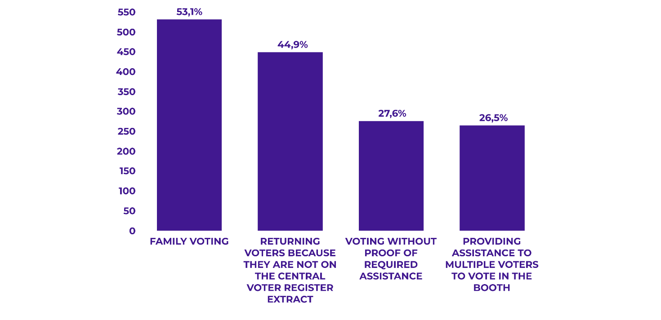
At 19 polling stations, observers filed complaints regarding the work of the polling boards.

Closing of Polling Stations

Polling Station Closing Time
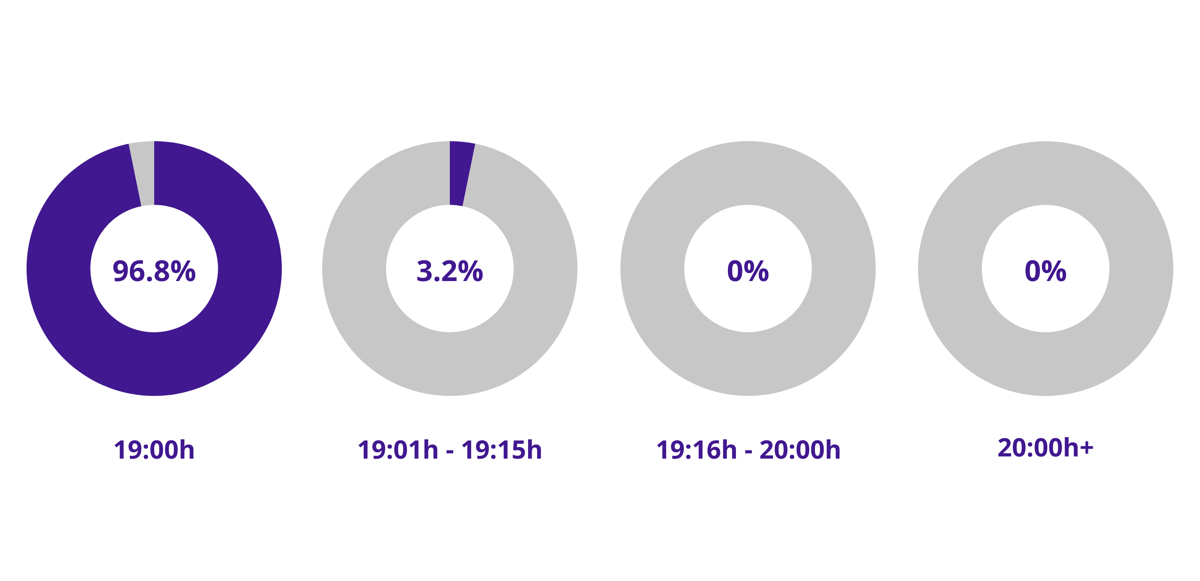
The closing of polling stations was generally carried out in accordance with regulations. 96.8% of polling stations were closed precisely at 19:00, while 3.2% of polling stations were closed by 19:15.

Vote Counting

Observation of the vote counting represents the next phase during which the Coalition “Pod lupom” monitors how ballots are processed and counted after the close of voting. Observers follow all steps of the process, including counting the total number of ballots, separating valid and invalid ballots, and recording unused or damaged ballots. Compliance with procedures related to stamps and signatures on ballots, proper invalidation of ballots, and the organization of space and conditions that allow observers to follow the counting process without hindrance are also monitored, as well as any irregularities such as altering votes.
Below is an overview of key statistical findings illustrating the situation at polling stations during the counting process:
- At 3.2% of polling stations, after opening the ballot box, a stamp or pen was present on the table where votes were being counted.
- At 3.2% of polling stations, ballots from the box did not have the stamp and signature of a polling board member as required.
- At 1.1% of polling stations, the invalidation of ballots was not carried out in accordance with CEC regulations.

Packaging of Election Material

Observation of the packing of electoral materials represents the next phase during which the Coalition “Pod lupom” monitors the entire process of preparing and closing polling stations after the vote count. During this phase, observers track compliance with procedures for packing the voting materials. They also monitor the completion of all activities at the polling station and any potential pressures or irregularities during the packing process.
In this section, we present statistical data regarding observed shortcomings in the packing of materials:
- At 14% of polling stations, the yellow copies of the forms with aggregate results were displayed, but they were illegible.
- At 2.2% of polling stations, observers experienced some form of pressure while monitoring the packing of electoral materials.

Acknowledgements

The Coalition for Free and Fair Elections “Pod lupom” expresses its sincere gratitude to all civic, non-partisan observers who took part in monitoring the election day of the Repeat Early Elections for the President of the Republika Srpska. Their dedication, professionalism, and commitment have made a significant contribution to strengthening the integrity of the electoral process.
We also extend our thanks to the media for their responsible and professional reporting, which enabled the wider public to follow our work and better understand the course of the electoral process. Special appreciation is extended to the electoral stakeholders who demonstrated a willingness to cooperate and to respect procedures throughout the process.
Finally, we thank all citizens who, through their engagement, demonstrated their commitment to democracy and to free and fair elections. Active citizen participation represents the foundation of credible and fair elections.
https://www.youtube.com/watch?v=EtJzVoED-C0

