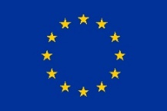

Funded by the
European Union

PRELIMINARY REPORT ON LONG-TERM OBSERVATION OF 2022 GENERAL ELECTIONS
(covering the period July 25 – September 25, 2022)

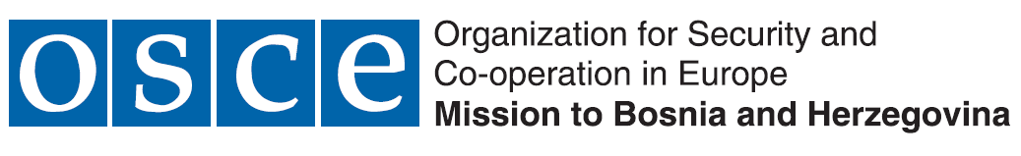
Project is partly co-financed by:

September 2022

TABLE OF CONTENTS
1. REPORT SUMMARY 2
2. METHODOLOGY OF LONG-TERM ELECTION OBSERVATION 5
3. ABOUT 2022 GENERAL ELECTIONS 6
4. LONG-TERM ELECTION OBSERVATION 8
4.1. Electoral irregularities and frauds 9
4.2. Work of the election administration 16
4.3. Media, civil society and citizens 20
5. ELECTORAL IRREGULARTIES REPORTED TO THE COMPETENT AUTHORITIES 21
6. ABOUT “STEP” PROJECT AND Coalition “Pod lupom” 22

1. REPORT SUMMARY
About 2022 General Elections
- 2022 General Elections are scheduled for Sunday, October 2, 2022
- The voters will elect:
- 3 members of the BiH Presidency,
- 42 members of the House of Representatives of the BiH Parliamentary Assembly,
- 98 members of the House of Representatives of the FBiH Parliament,
- 83 members of the RS National Assembly,
- 1 president and 2 vice-presidents of RS,
- 289 members of the assemblies in ten cantons in FBiH.
- A total of 3.368.666 registered voters will be able to exercise their right to vote at the 2022 General Elections
- The BiH Central Election Commission certified 145 different political subjects to participate in the elections (political parties, coalitions and/or independent candidates), whereof 90 political parties, 17 independent candidates and 38 coalitions).
- A total of 127 political subjects will appear on the ballots, because a portion of political subjects participates in the elections only as part of a coalition or do not have certified candidates’ lists.
- A total of 7.258 certified candidates will be competing for 518 direct mandates.
Electoral irregularities
- Long-term observers of the Coalition “Pod lupom” have registered 1.202 different electoral irregularities in the period from July 25 to September 25, 2022
- The highest number of electoral irregularities relate to 484 cases of premature campaigning in 67 municipalities/cities, whereof 157 irregularities relate to the proved cases of paid advertising on social media platforms at time when it is prohibited by the BiH Election Law, while 384 cases relate to abuse of public resources and/or positions for the purpose of election campaigning in 67 municipalities/cities.
- The practice of trading seats on polling station committees continues, and in line with the information from the ground the aforementioned irregularity was suspected in 55 cases in 36 different municipalities/cities.
- Numerous allegations of vote buying were recorded, and the price of a vote ranges between 50 and 200 KM.
- The practice of voter coercion continues and it is done through offering of employment, threats of job loss, intimidation and/or distribution of gift packages in exchange for a vote.
- The abuse of social media platforms has been prominent. The social media platforms were used to disseminate inappropriate speech and/or hate speech for the purpose of defaming candidates or political opponents, most frequently through the so-called bots.
- Unlike the previously observed electoral processes there were no reports were made of personal data abuse for by-mail voting, which is the result of introduction of additional safeguarding mechanisms for OCV registration by the BiH CEC. Furthermore, no reports were made concerning timeliness of the Central Voters’ Register (e.g. names of deceased persons on the voters’ lists)
- Cases of paid campaign, which is prohibited by the law and allegations on trading of seats on the polling station committees were forwarded to the BiH CEC for further action.
- Based on the reports of the Coalition “Pod lupom” the BiH CEC pronounced sanctions to political subjects for paid advertising on social media platforms at time before the official start of the election campaign.
- Based on the reports of the Coalition “Pod lupom” first sanctions were pronounced to political subjects and individuals for illegal trade of seats on polling station committees
- A total of 26 out of 50 recommendations of the Coalition “Pod lupom” were partially or entirely implemented through the electoral rules, whereof 14 was implemented in the last six months through changes and amendments to the BiH Election Law and the BiH CEC’s regulations.
Election administration
- The BiH CEC held more than 30 session in the period after the elections were announced.
- The BiH CEC’s sessions are public, and are live streamed through the official channel on the video service. Transparency and communication with the public has been improved by more frequent dissemination of information to the public and presence on the social media platforms.
- The BiH CEC adopted numerous amendments to the implementing acts during the preparations for the general elections aimed at protecting the integrity of the electoral process and reinstating the public trust in the electoral process. Majority of these amendments represent implementation of recommendations of the Coalition “Pod lupom” for improvement of the electoral process. The BiH CEC continued the practice of considering observed irregularities and sanctioning, but these were mostly actions taken on reports made by third parties.
- Long-term observers of the Coalition “Pod lupom” recorded 99 omissions in the operations of the local election commissions in the period from July 25 to September 25, 2022.
- The local election commission mostly observe the deadlines set forth by the election calendar, whilst the biggest challenge was completion of the polling station committees since the political subjects failed to nominate sufficient number of candidates for the members and alternate members in the polling station committees.
- A total of 21 complaints on the electoral process were filed with the local election commissions in 9 municipalities/cities which primarily relate to lottery draw for the seats on the polling station committees, and appointment of polling station committees.
- The cooperation of long-term observers of the Coalition “Pod lupom” and local election commissions is now traditionally at a correct level, with rare exceptions where the cooperation is made somewhat difficult.

2. METHODOLOGY OF LONG-TERM ELECTION OBSERVATION
The long-term election observation carried out by the Coalition for free and fair elections “Pod lupom” entails observation of the entire electoral process in BiH, which includes all stages of the electoral process from the day elections were called until the publication of final and confirmed results. Long-term observation is carried out in the period from July 25 to October 19, 2022 for the purpose of observing the electoral process. This mode of election observation serves for continuous monitoring of the entire electoral process as to be able to provide a comprehensive overview that includes the widest possible spectrum of election-related activities, and not only the Election Day as such.

The Coalition “Pod lupom” carries out long-term observation of the 2022 General Elections in cooperation with 85 civil society organizations, informal groups and activists from BiH and 100 long-term observers who cover all basic constituencies in BiH, 143 of them (municipalities, cities and Brčko District). The long-term observers observe operations and sessions of all municipal/city election commissions in BiH, activities set forth by the election calendar and observance of deadlines, electoral irregularities, and media reporting. The long-term observers report on their activities weekly, and so far they have turned in 1.287 regular reports on key observation findings. Long-term observers of the Coalition “Pod lupom” have so far held 1.710 meetings with different election stakeholders (election administration, political subjects, institutions, police administrations, civil society organizations, media and the others) aimed at the most objective assessment of the electoral process in BiH. The reports of the long-term observers are backbone of this preliminary report.

In addition to observing the operations of the election commissions of basic constituencies (municipal/city election commissions and election commission of Brčko District of BiH) Coalition “Pod lupom” also monitors the operations of the BiH CEC, which is regular practice since the establishment of the Coalition in 2014.

3. ABOUT 2022 GENERAL ELECTIONS
The 2022 General Elections were announced on May 4, 2022 and are scheduled for Sunday, October 2. The elections on October 2, 2022 are announced for the following levels of authority:
- Presidency of Bosnia and Herzegovina;
- House of Representatives of the Parliamentary Assembly of Bosnia and Herzegovina;
- House of Representatives of the Parliament of Federation of Bosnia and Herzegovina;
- National Assembly of Republika Srpska;
- President and vice-presidents of Republika Srpska, and
- Cantonal Assemblies in Federation of Bosnia and Herzegovina.

The election system in BiH established by the law represents a combination of election systems, namely depending on the body which is being elected we differentiate between: simple majority system and proportional representation system with open lists.

Simple majority system is used to elect:
- Members of the BiH Presidency (three members from the ranks of constituent peoples);
- President and vice-presidents of Republika Srpska (one president and two vice-presidents from the ranks of constituent peoples).
The proportional representation system is used to elect the following bodies:
- House of Representatives of the BIH Parliamentary Assembly (42 members);
- House of Representatives of the Federation of BiH Parliament (98 members);
- National Assembly of Republika Srpska (83 members);
- Cantonal Assemblies in Federation of BIH (289 members).
The BiH Central Election Commission certified 145 different political subjects to participate in the elections (political parties, coalitions and/or independent candidates), whereof 90 political parties, 17 independent candidates and 38 coalitions). A total of 127 political subjects will appear on the ballots, because a portion of political subjects participates in the elections only as part of a coalition or do not have certified candidates’ lists. A total of 7.258 certified candidates will be competing for 518 direct mandates, which are directly elected at the 2022 General Elections.
There are no guaranteed seats for members of national minorities at the general elections in BiH.
A total of 3.368.666 citizens of BiH, who are registered in the Central Voters’ Register as of August 18, 2022, will have the right to vote on October 2, 2022. A total of 69.966 voters are registered to vote outside BIH, while a total of 14.222 voters are registered to vote through a mobile team within BiH.
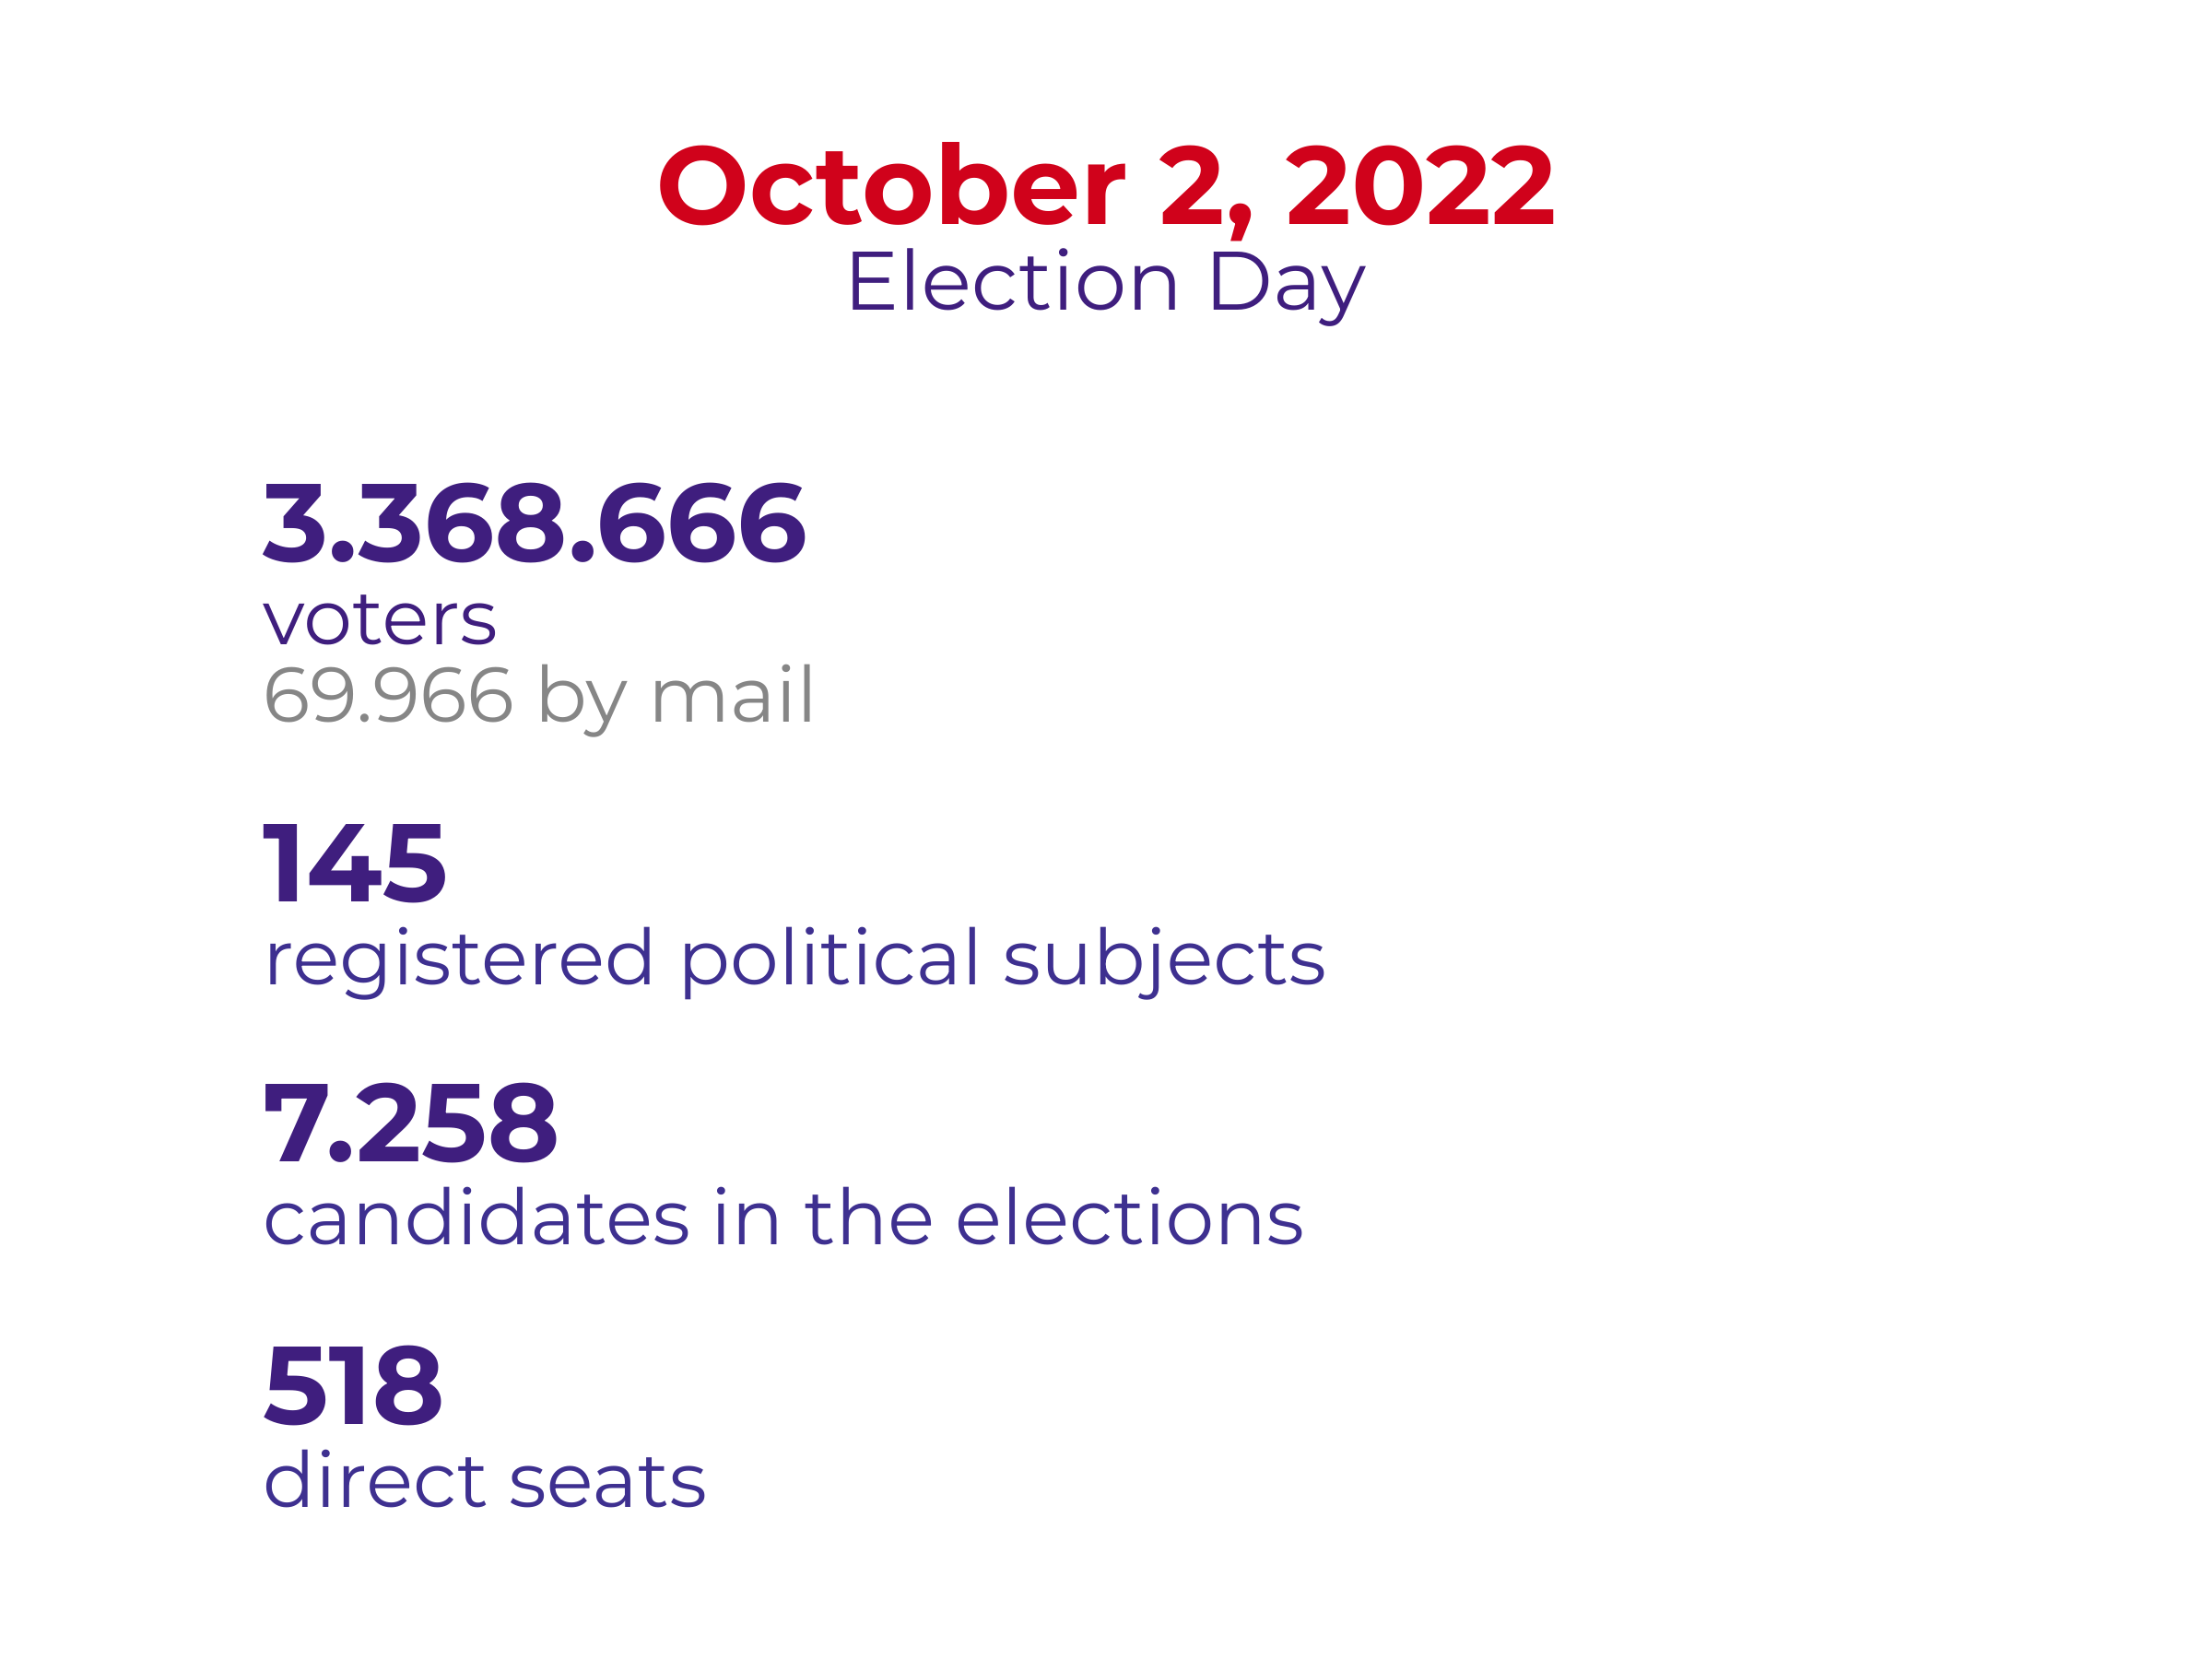
Infographics 1 – Summary on the 2022 General Elections

4. LONG-TERM ELECTION OBSERVATION
In the pre-election period the Coalition “Pod lupom” observes operations and sessions of local election commissions, activities set forth by the election calendar and observance of deadlines, electoral irregularities and also monitors media reporting. The observers of the Coalition “Pod lupom” recorded 1.202 different electoral irregularities in the period from July 25 to September 25, 2022.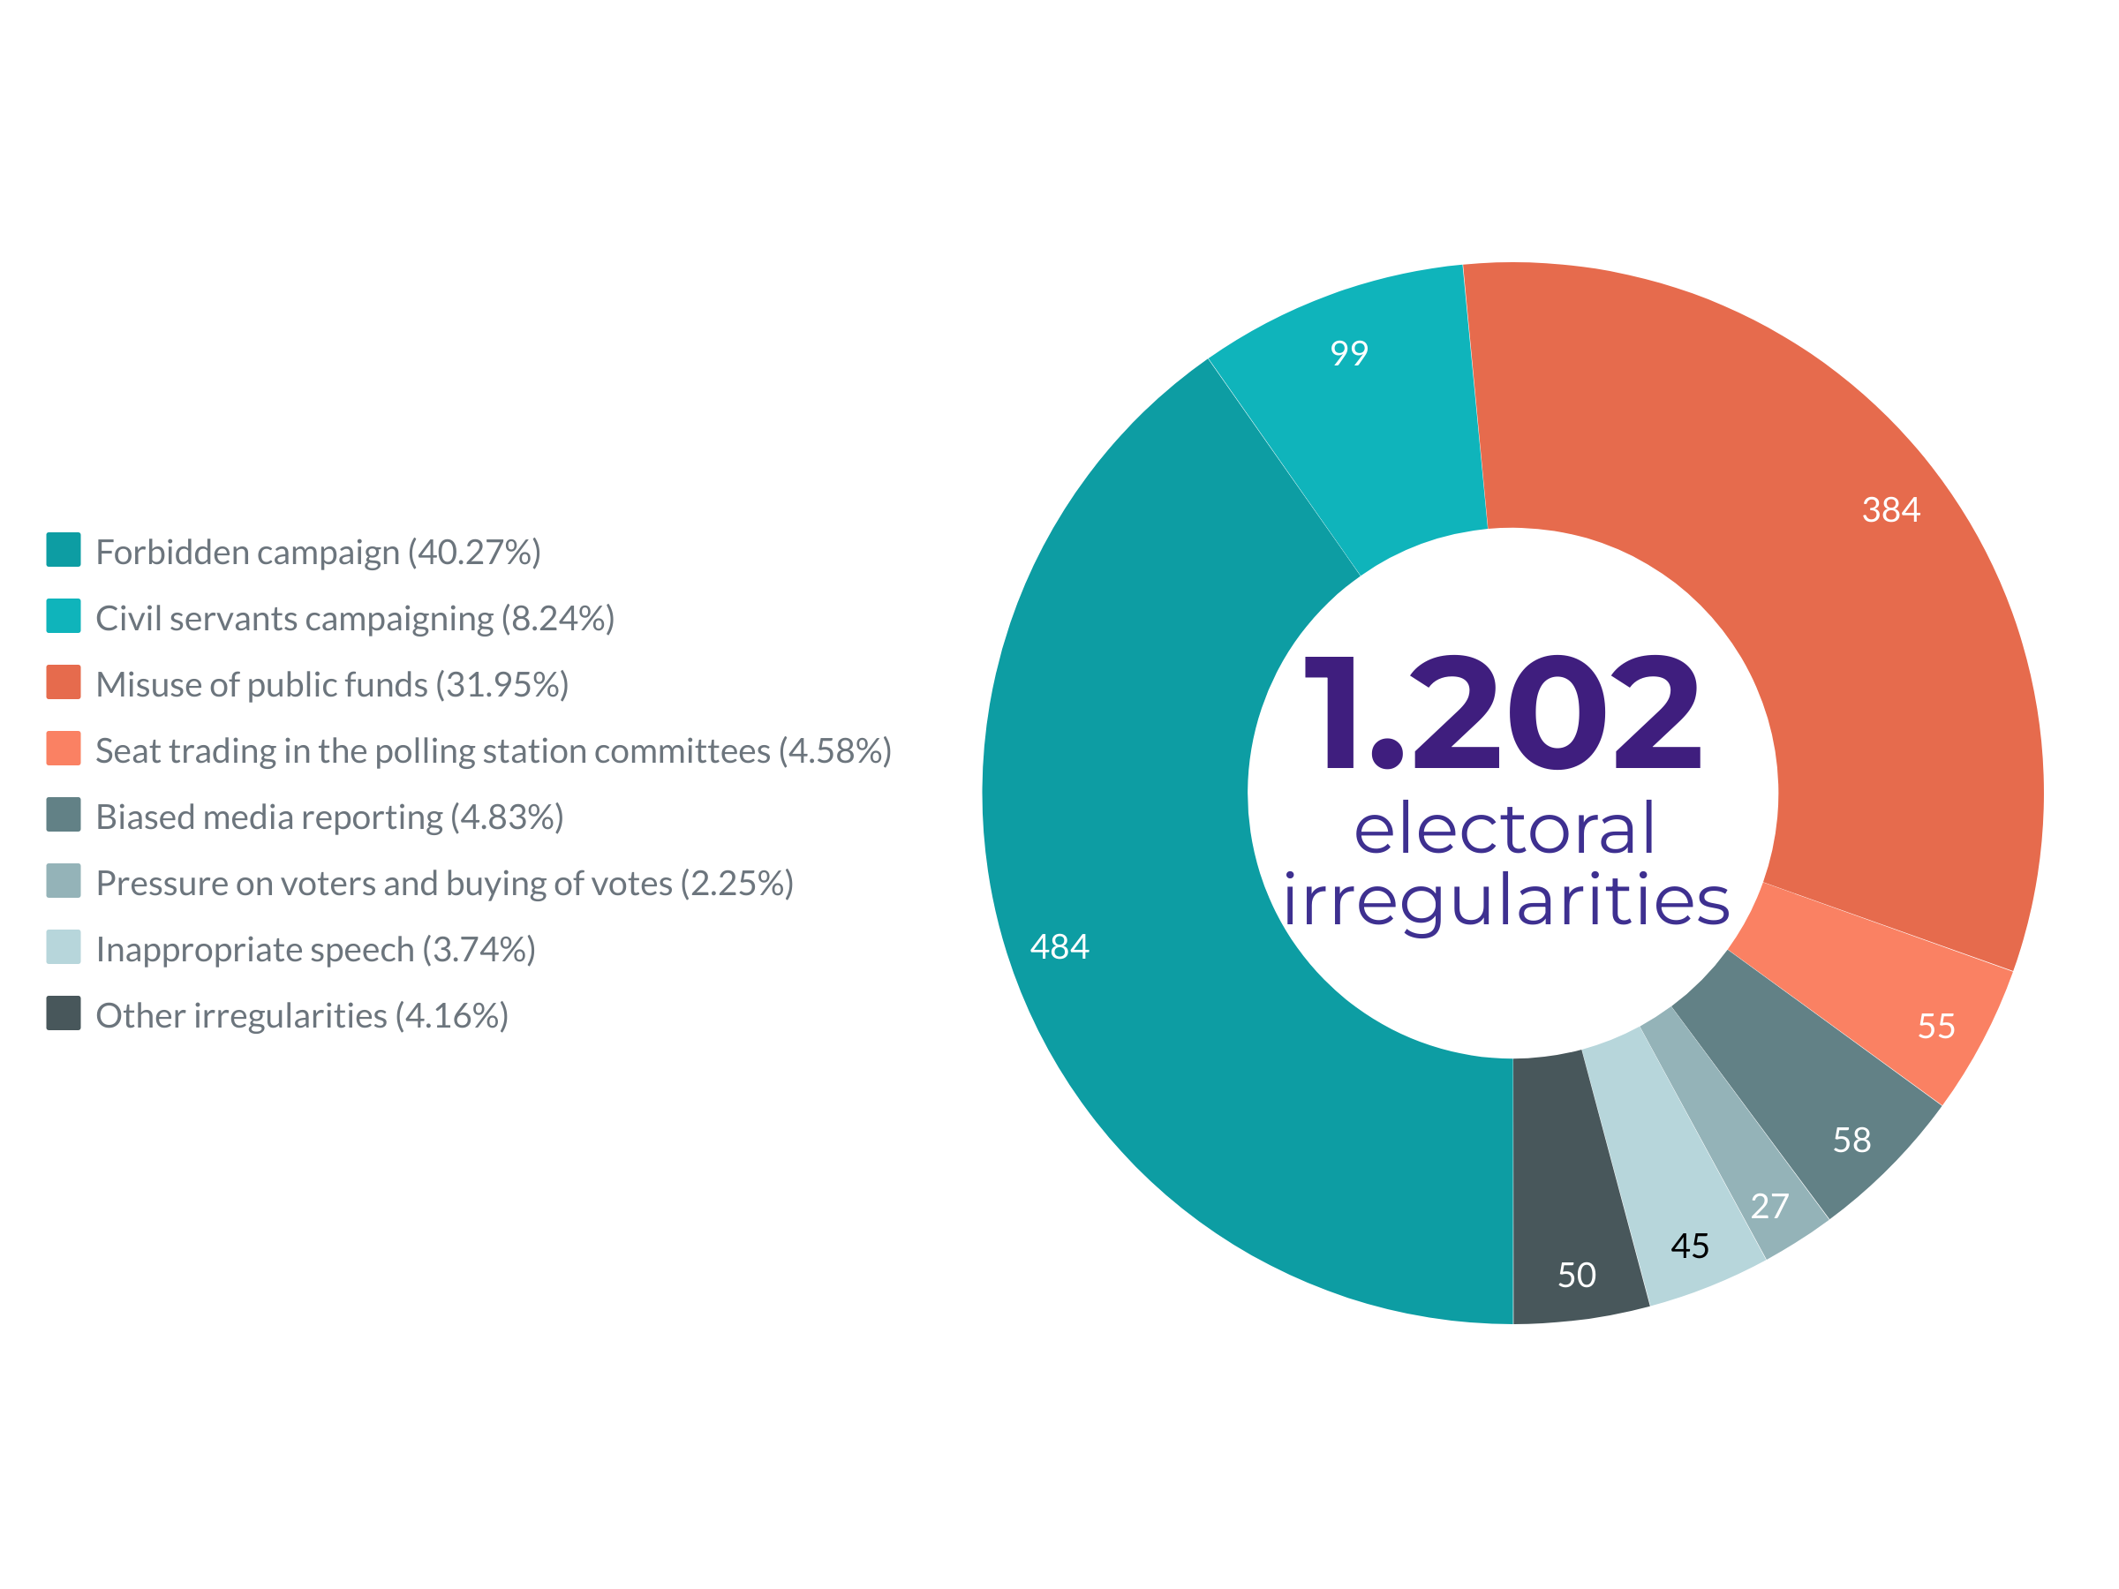
Chart 1 – Total number of electoral irregularities by type
In terms of observed irregularities on the ground (not considering paid campaigning when it is not allowed by the BiH Election Law), categorized by political subjects, the highest number of recorded irregularities related to SNSD (166), SDA (158), SDP BiH (71), HDZ BiH (56) and SDS (28).

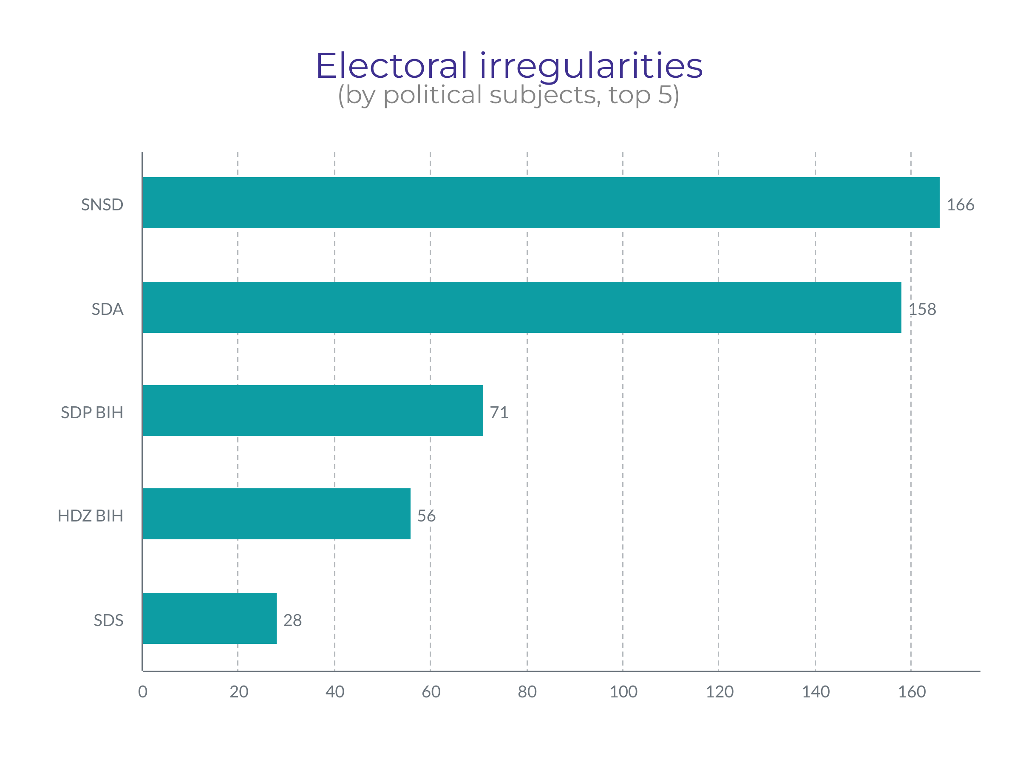
Chart 2 – Number of irregularities by political subjects (top 5)

4.1. Electoral irregularities and frauds
4.1.1. Premature election campaign
The BiH Election Law defines election campaign as a period of 30 days before the Election Day in which political subjects present their programs and candidates for the elections to the voters and the public. The election campaign for the 2022 General Elections started on September 2, 2022, which means that any paid public advertising, as well as all pre-election activities of political subjects are prohibited until this date, except for the holding of internal gatherings of authorities and statutory bodies of political subjects within the period between the day when elections are announced and the day of official start of the election campaign.
It was observed, as in previous election cycles, that a significant number of political subjects conducts election campaign before its official start, particularly in the segment of paid advertising on the social media platforms. The Coalition has recorded 157 individual cases of illegal paid advertising by 33 political subjects and/or their candidates.
In addition to paid advertising on the social media platforms it was recorded that some political subjects have started activities in the field that are de facto election campaign activities, and do not relate to internal activities of the political subject. In these cases the so-called grey zone of the BiH Election Law, which explicitly prohibits only paid advertising before the official start of the election campaign, is used to a great extent. The current statutory solutions neither recognize sanctions nor prohibit all of these other activities of election campaigning, where the 30-day campaigning period is somewhat made senseless as the campaign in practice lasts far longer. The political subjects inform the public and the voters about these activities through regular media reporting, and unpaid posts on private profiles or profiles of the political subject on different social media platforms. Observers of the Coalition “Pod lupom” recorded 484 such cases in 67 municipalities and cities in BiH (including the previously presented 157 cases of illegal paid advertising). The analysis of reports on premature campaigning, which is prohibited by the law, shows that the highest number of reports relate to the political subjects SDA (65), SNSD (50), SDP BiH (41), PDP (20) and Naša stranka (16).
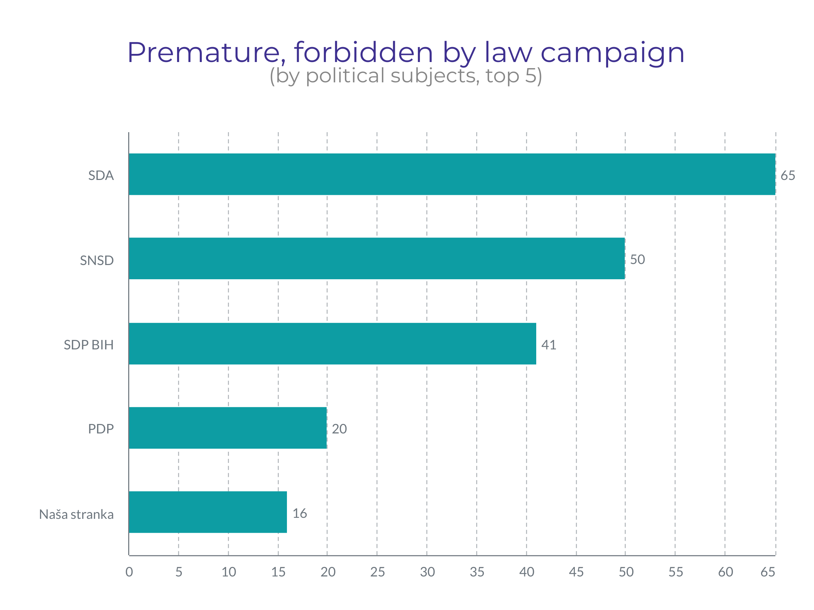
Chart 3 – Cases of premature campaigning by offenders/political subjects (top 5)
Continuing the practice started during the 2020 Local Elections, the BiH Central Election Commission has imposed fines to several political subjects and/or their candidates for paid advertising on the social media platform Facebook at time before the official start of the election campaign. The BiH CEC also imposed fines for cases of this irregularity that were reported by the Coalition “Pod lupom”. According to the information available to the Coalition, the BiH CEC had by September 5, 2022 imposed fines to the political subjects and/or their candidates for this breach of the BiH Election Law in the amount of 37.000 KM, which is not the final amount due to subsequent procedures and those that are still ongoing.
4.1.2. Timeliness of the Central Voters’ Register (CVR)
Registration of voters in BiH is passive since 2006, while active registration is still used for voters who want to vote outside Bosnia and Herzegovina or abroad. A total of 3.368.666 voters are registered in the Central Voters’ Register (CVR) as of August 18, 2022 for the 2022 General Elections.

In terms of the timeliness of the Central Voters’ Register it is very important to underline that there were no reports of a higher number of names of deceased persons on voters’ lists in basic constituencies, which was the case in previous election cycles, but only some incidental cases. The observers of the Coalition reported that the Center for Voters’ Register in Ključ municipality has not worked throughout the entire reporting period.

When it comes to by-mail voting, a record in numbers of applications for this mode of voting (approximately 130.000 applications) was broken for the 2020 Local Elections, but a record was also broken in the number (attempts) of personal data abuse for this mode of voting. One of the recommendations made by the Coalition “Pod lupom” after these elections was that it is necessary to introduce additional safeguarding mechanisms to prevent abuses of by-mail voting. For the 2022 General Elections the BiH CEC has prescribed additional mechanisms in its regulations stipulating that the OCV applications can only be submitted electronically through the portal E-izbori, available on the website, or via fax. Having in mind that limitations were imposed that one OCV application can be sent from only one e-mail address, that copy of a valid BiH document must be uploaded, that there has to be a proof of residence abroad, and that the applications cannot be sent through post, the space for abuses, which were observed in previous election cycles, was significantly narrowed. Narrowing of the space for potential manipulations has most likely affected the number of OCV applications, whose number for these elections was almost two times lower compared to the elections two years ago (69.966 voters registered to vote by mail).
4.1.3. Trade of seats on the polling station committees
Since 2014 the Coalition "Pod lupom" has been warning the public, election administration and decision-makers about the so-called trade of seats on the polling station committees between the political subjects. Although the Election Law of BiH is clear and stipulates that political subjects certified to participate in elections can only have one representative on one polling station committee, this is often not the case in practice and different methods have been used to circumvent this provision of the Law. The High Representative in BiH had in July 2022 passed the Decision on Amendments to the Election Law of BiH, which, among other things, prohibits the abuse of the statutory right to participate in the work of a polling station committee by fictitious representation, prohibiting also false impersonation of any political subject with the aim of favoring another political subject. Sanctions are provided for such violations of the Law.
Observers of the Coalitions reported allegations about 55 cases of trade of seats on the polling station committees in 36 different municipalities/cities. Inspection of the list of political subjects certified to participate at the forthcoming General Elections shows continuation of the trend across BiH where a certain number of political subjects applies and gets certified to participate in the elections in basic constituencies in which they neither have any activities, municipal board, official premises nor are planning to seriously participate in the race, which can indicate an intention to trade seats on the polling station committees. Having in mind the new legal provisions that prohibit trade of seats on the polling station committees and set forth high pecuniary finances, both for the individual offenders, but also for the political subjects, it seems that a certain number of political subjects has directly given up on these intention, which can be concluded from the fact that in a higher number of basic constituencies the political subjects did not nominate sufficient number of candidates for the members of polling station committees. Unfortunately, there are still some indications that trade of seats on the polling station committees has grown from party corruption into a worse form of systemic corruption. Coalition “Pod lupom” received reports from multiple cities and municipalities, containing both proofs, but also strong indications, that some local election commission take part in manipulation with the membership of the polling station committees by appointing party persons to the polling station committees as representatives of local election commission.

With this in mind, it can be already concluded that it is necessary to amend the legislative framework concerning appointment and composition of the polling station committees in order to the end to this abuses and has to be done immediately after the elections.

Coalition “Pod lupom” also conduct pilot methodology of monitoring membership of the polling station committees, which findings and recommendations will be presented in a special report after the elections.
4.1.4. Voter coercion and vote buying
Although illegal, voter coercion and vote buying have become a usual practice at the elections in BiH. Observers of the Coalition reported 27 such cases in 18 municipalities/cities. These cases relate to allegations on money being offered in exchange for a vote, coercion of employees in the public enterprises, and so on. The rumors on vote buying were recorded in several municipalities/cities, and the prices range from 50 to 200 KM. Concerns are raised by the reports of the observers that such negotiations are accepted and that citizens do not shy away from vote selling, as well as that there is no understanding of these actions actually being criminal offences. At the same time citizens who report such cases refuse to publicly talk about this in fear of retaliation in the local communities and are not willing to report it to the competent bodies.
4.1.5. Misuse of public resources and public functions for the purpose of campaigning
Misuse of public resources and/or public functions for campaign purposes refers to abuses in the use of public budget money and other public money owned by citizens of BiH, and misuse of public companies and assigned public functions by political entities or individuals who are candidates in the elections. Almost always, misuse of public resources occurs by those who enter the election race for various levels from the position of the current authority. The Coalition has been warning about this problem since the General Elections of 2014 and is advocating for the legal treatment of this irregularity.
In July of this year, the High Representative for Bosnia and Herzegovina (OHR), using the powers at his disposal, issued a Decision adopting the Law on Amendments and Addenda to the BiH Election Law, which introduced the term "public funds and resources". As amended, misuse of "public funds and resources" means any illegal use of funds and resources of the State of BiH, entities, cantons, Brčko District of BiH and other units of local administration and self-government, by which candidates in elections and election lists, as public or state officials, or directly elected persons, have at their disposal for the purposes of performing their official duties. This includes all movable and fixed assets, as well as all human resources of public institutions that are used during working hours. The Coalition is of the opinion that these changes are a step forward in the fight against this irregularity, but that it is necessary to monitor their effect, and possibly go in the direction of adopting even more restrictive provisions.
Observers of the Coalition "Pod lupom" reported on 384 cases of misuse of public resources in 67 municipalities/cities. Most of the reported cases relate to the intensification of works on local infrastructure, and frequent and intensified visits by officials from higher levels of government, who as a rule meet or visit those municipalities/cities headed by their party colleagues. The analysis of the received reports shows that the largest number of cases of misuse of public resources refer to political subjects SNSD (109), SDA (81), HDZ BiH (38), SDP BiH (36) and SBiH (18).
For these elections, various examples of introducing the rights of different categories and/or providing one-time forms of assistance to the population on different grounds were recorded: one-time financial assistance to pensioners, people with disabilities, civilian victims of war, beneficiaries of veteran's benefits, distribution of packages of basic foodstuffs, assistance to young people, and all with implementation exclusively until October 2, the election day. The same or similar examples were recorded at the level of both entities in Bosnia and Herzegovina.
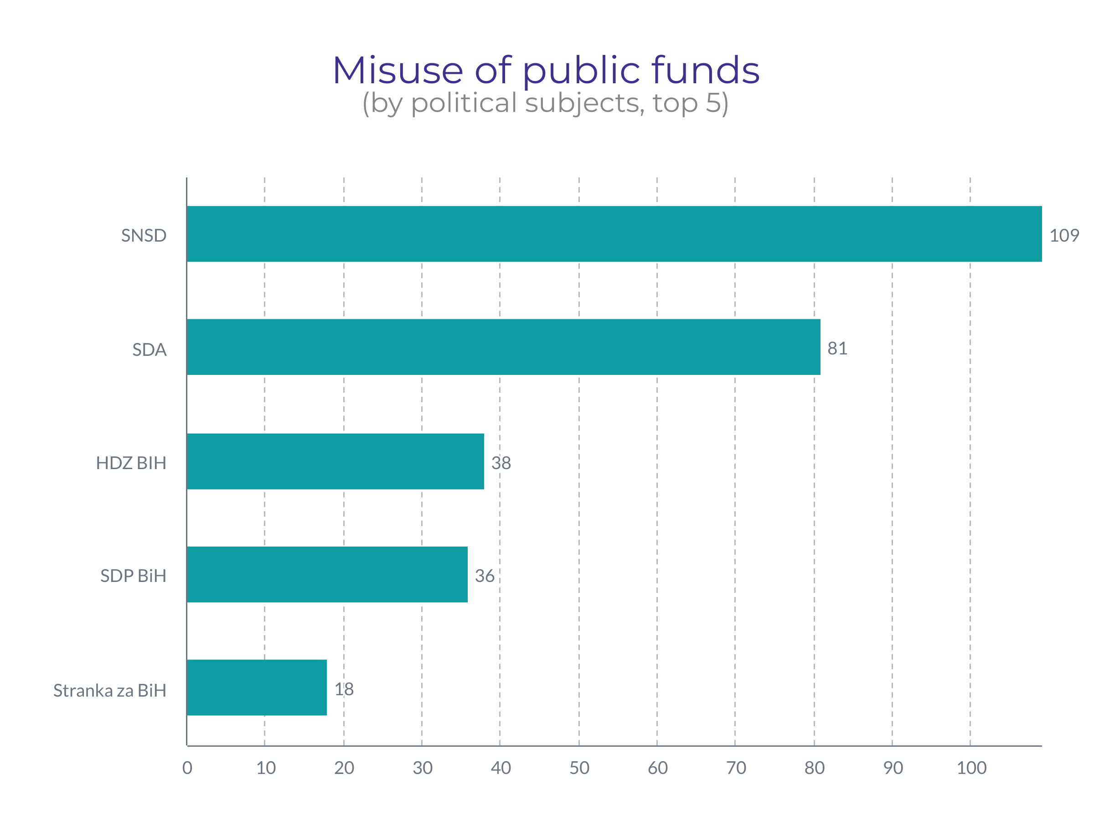
Chart 4 – Cases of misuse of public resources per violator /political subject (top 5)
The work of civil servants and other employees in the public administration or public enterprises for the purpose of the campaign of any political subject can be considered as misuse of public resources, and the observers of the Coalition reported on 99 such cases in 40 municipalities/cities in BiH.

4.1.6. Other irregularities
Through the previously mentioned amendments to the BiH Election Law adopted by the OHR, "hate speech" was added to the law, which is defined as any form of public expression or speech that causes or incites hatred, discrimination or violence against any person or group of persons, on the basis of race, color, nationality, sex or religion, ethnic origin or any other personal characteristic or orientation that incites discrimination, hostility and violence.
Inappropriate speech, content or speech that can encourage religious, national or bigotry on other grounds, most often belonging to a political option, was recorded in 45 cases in 23 municipalities/cities. Most of the cases refer to the latter, extremely inappropriate speech or bigotry based on political affiliation where, especially on social networks, through bots, fake profiles and the like, a lot of effort is invested in defaming candidates or political opponents.
In a few dozen cases, citizens have reported irregularities that mainly relate to allegations of vote buying, aggressive actions of party activists in attempts to find out who the citizen will vote for, which was interpreted and understood as pressure on voters, and misuse of data with telephone numbers by political parties for the same purpose. A certain number of reports also refer to the trading of seats in election committees, which citizens especially started sending after the announcement that a sanction had been issued for this violation of the BiH Election Law.

4.2. Work of the election administration
4.2.1. Central Election Commission of BiH (1)
The Central Election Commission of BiH (CEC BiH) is responsible for organizing and conducting all elections in BiH. The Central Election Commission of Bosnia and Herzegovina announced the elections within the deadline stipulated by law, May 4, 2022, and scheduled the elections for October 2, 2022. From the announcement of the elections to the publication of this report, the CEC of BiH held more than 30 sessions. The practice established during the 2020 election cycle of broadcasting the sessions of the CEC BiH live via the commission's official channel on the YouTube video service was continued, giving the public regular insight into the commission's activities and work. In its work, the CEC of BiH follows the established deadlines for the organization and implementation of election activities. In addition, in preparation for holding the general elections in 2022, the CEC of BiH showed proactivity in adopting acts from its field, which aim to increase the transparency of the commission's work, as well as to protect the integrity of the electoral process. In general, communication with the public in the preparation and organization of elections has been improved compared to previous election cycles, where it can be seen that an effort is being made to deliver essential information through various channels, especially social networks (Instagram and Twitter), to all interested parties.
Since the holding of the Local Elections in 2020, in light of the preparations for holding the General Elections in 2022, the Central Election Commission of BiH has introduced the following new procedures and/or practices: an online platform for training local election commissions has been introduced, as well as other tools to improve the work of election commissions of basic constituencies (frequently asked questions on the web that clarify dilemmas, etc.); additional mechanisms for securing applications for voting by mail were introduced to prevent possible misuses; received objections to the electoral process are publicized. As part of efforts to digitize certain processes, an application for the accreditation of election day observers was created. However, the application failed to meet the task due to various shortcomings, and the accreditation process remained, as in previous years, challenging and unnecessarily burdensome, especially for domestic observers, but also for the Secretariat of the CEC of BiH. When it comes to the election day itself, the CEC of BiH has prescribed that sensitive voting materials (ballots) must be kept at the polling stations the night before the election day under police protection; again, the provision has been further specified, stipulating that the lists with members of the election committee must be displayed at the polling station with an indication of the political subject that nominated each of the members; in order to prevent potential misuses by voters during the voting itself, it is stipulated that the voting booths are placed in such a way that the openings face the members of the polling committee and observers. Furthermore, in order to prevent various abuses during voting, the Central Election Commission of BiH prescribed an additional mechanism that should contribute to the prevention of abuse of assistance during voting in such a way that it is prescribed to provide evidence that the voter needs assistance, and exceptionally that the election committee independently assesses that the voter obviously needs help. Proof that the person is a blind, illiterate or physically disabled is a decision or certificate/confirmation from a competent institution, institute or commission, while the absence of a signature in an identity document is proof that the person is illiterate. In relation to previous election cycles, it is also a novelty that when determining the voter's identity, the name and surname of the voter who signs the Extract from the Central Voter's List (CBS) is not pronounced out loud. In order to prevent the misuse of ballots, especially unused ones after the closing of the polling stations, the Central Election Commission of Bosnia and Herzegovina has prescribed that, when issuing ballots, they must be stamped and signed by the member of the electoral committee in charge of issuing ballots. As an additional security element, the ballots have a watermark.
The Coalition "Pod lupom" welcomes all these improvements, especially because almost all novelties were the subject of the Coalition's recommendations for improving the electoral process , with a note that the Coalition did not offer certain solutions as such, but the adopted solution equally responded to the indicated problem, irregularity and/or misuse of the electoral process .

4.2.2. Local election commissions (143)
Election commissions at the local level (municipal, city and election commissions of Brčko District BiH) are responsible, among other things, for determining polling stations, forming and training polling station committees, organizing election day and consolidating election results from polling stations in their territory. The composition of the local election commission, respecting the provisions of the BiH Election Law and the Law on Gender Equality, should reflect the gender representation of at least 40% of members of the less represented gender. This defined gender representation in the composition was not respected in 8 election commissions at the local level. Also, at the moment of publication of this report, only the local election commission in the municipality of Centar Sarajevo is not functioning in its full composition. It should be pointed out that during the period of 9 weeks of long-term observation, 12 different local election commissions operated temporarily with an incomplete composition.
Most of the local election commissions carry out adequate preparations for holding elections. The Instruction on the working method and reporting of the election commission of the basic electoral unit in BiH stipulates the functioning of local election commissions in more detail. Among other things, the instruction prescribes the adoption of the Rules of Procedure on the work of the local election commission, which has been complied with by all local election commissions in Bosnia and Herzegovina. The instruction also foresees the possibility for local election commissions to appoint a secretary and/or technical secretary, which was decided by 95 election commissions or 66.43% of the total number of local election commissions, which is an increase compared to the Local Elections of 2020.
The vast majority of election commissions regularly hold weekly meetings. There are 3 local election commissions facing difficulties in their work in terms of inadequate working conditions.
Observers of the Coalition “Pod lupom” noted that 21 objections to the electoral process in 9 municipalities and cities were submitted to local election commissions. The submitted objections mainly refer to the drawing of lots for the allocation of positions to political subjects in the election committees, and to decisions on the appointment of members of the election committees. The central voters list is not available only in the municipality of Ključ.
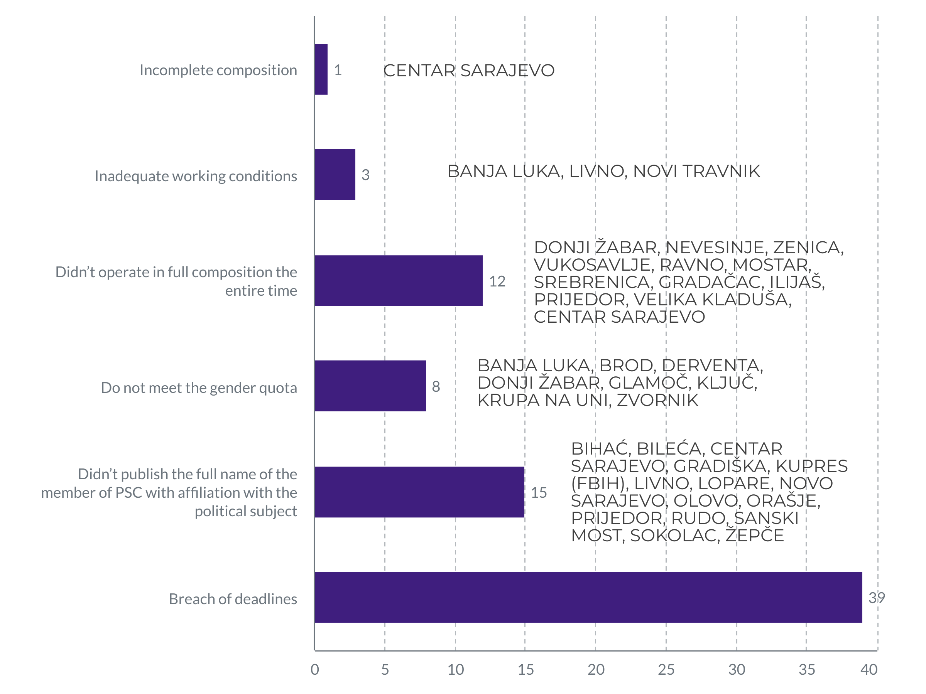
Chart 5 – Information on the work of local election commissions
When it comes to respecting the deadlines set by the election calendar, six local election commissions did not determine the locations of polling stations within the legal deadline (until September 17, 2022) and submitted the said decisions to the Central Election Commission of Bosnia and Herzegovina.
Also, according to findings from the field, it was established that in 34 municipalities/cities, the local election commissions did not complete the training for the members of the polling station committees within the legally stipulated deadline of September 25, 2022. The observers who attended the trainings rated them mostly as "very good". Unfortunately, some local election commissions do not take this segment of the electoral process seriously, given that the Coalition has knowledge that candidates for election committee members were read the correct answers during the training sessions in order to pass the intended test.
Since local election commissions have a legal obligation to publish the names and surnames of appointed members of all election committees with affiliation to a political subject, it was determined that 15 local election commissions did not fulfill this obligation.

4.3. Media, civil society and citizens
4.3.1. Media reporting
Long-term observers of the Coalition "Pod lupom" also followed the reporting of local and regional media. Observing the media coverage, the observers noted cases of biased media coverage, which in their content mostly positively or mostly negatively report on certain political subjects, as well as the transmission of inappropriate speech by officials or candidates in elections. 58 such cases were recorded in 29 municipalities/cities. No cases of direct pressure on the media were recorded.
The Coalition “Pod lupom” is also implementing a pilot media monitoring project, the findings and recommendations of which will be presented in a special report after the elections.
4.3.2. civil society and citizens
Indirect pressures on civil society organizations were reported in one municipality/city. In the past period, the Coalition “Pod lupom” did not record a single case of pressure on our long-term observers.

5. ELECTORAL IRREGULARTIES REPORTED TO THE COMPETENT AUTHORITIES
Recorded cases of paid advertising on the social network Facebook at a time when it is prohibited by the BiH Election Law, were reported to the CEC of BiH. Reports were submitted, i.e. initiatives to initiate proceedings against 33 different political subjects and/or candidates of political entities with 157 individual cases of illegal paid advertising. The CEC of BiH has conducted or is conducting procedures for each of the reports, and imposes monetary sanctions on those for which it determines that the paid advertising was for the purpose of a campaign.
The Coalition “Pod lupom” has also submitted an initiative to initiate proceedings for violation of the BiH Election Law in terms of running a campaign in a period when it is not allowed for two candidates for the Presidency of BiH. Although campaigning by these candidates does not necessarily belong to prohibited paid advertising, but de facto all other activities that are campaign activities (visits to cities, talks with voters, presentation of programs, plans, etc.), we believe that a certain reaction of the competent authority should follow because with such behaviors and activities, the very existence of the election campaign period, which is prescribed by the BiH Election Law for 30 days before the election day, becomes meaningless.
Although in earlier election cycles the Coalition "Pod lupom" regularly reported recorded cases of trading of seats in election committees, encouraged by amendments to the Election Law of BiH which explicitly prohibit it, until the publication of this Coalition Report, the CEC of BiH submitted initiatives to initiate proceedings for these violations of the Law in 6 different basic constituencies (Vitez, Jablanica, Tešanj, Ilidža, Maglaj and Čajniče). Until the publication of this report, the first sanctions were imposed for this violation of the Law, and that was based on the application for trading seats in the election committees in Jablanica. In both cases, monetary sanctions were imposed for political subjects that participated in the misuse of the right to participate in the work of the electoral committee (from 4,000 KM), and sanctions for persons who were appointed to election committees (1,000 KM monetary sanction and ban on working in election implementation bodies in a period of 4 years). For the reported cases of seat trading related to the basic constituencies of Vitez and Čajniče, the CEC of BiH made conclusions on the suspension of the procedure. Decisions are not legally binding, since appeals can be filed with the Court of Bosnia and Herzegovina.
All irregularities recorded or reported to the Coalition will, as in previous election cycles, be submitted to the competent authorities for action and/or as information. Also, in order to inform the public about them, the Coalition “Pod lupom” has prepared an online tool - the Map of Election Irregularities - which will give the public and interested parties the insight into the course of the electoral process in BiH through the reported/recorded irregularities themselves. The map of irregularities is available at the following link:
https://mapaizbornihnepravilnosti.podlupom.org/

6. ABOUT “STEP” PROJECT AND Coalition “Pod lupom”
Centers for Civic Initiatives (CCI), as the project coordinator, together with the Center for Civic Cooperation (CGS) Livno, the Citizens' Forum of Tuzla (FGT), the Association of Citizens "Democracy-Organization-Progress" - DON Prijedor and "Perpetuum mobile - Institute for Development of Youth and Communities" from Banja Luka, as partners in the project, and within the framework of the Coalition for Free and Fair Elections "Pod lupom", are implementing the project "System Transparency in the Electoral Process" (STEP) financed by the European Union (EU) and co-financed by the American Agency for international development (USAID) and Organization for Security and Cooperation in Europe (OSCE) - Mission in Bosnia and Herzegovina (BiH). The STEP project will directly increase the strength and visibility of civil society organizations (CSOs) in citizen observation of elections and support the development of civil society in the process of democratization in the country, including two election cycles in BiH: Local elections in 2020 and General elections in 2022.

The STEP project aims to strengthen citizen participation and strengthen the CSO movement across the country to support free and fair elections in Bosnia and Herzegovina, while reducing the risk of election fraud and manipulation. As part of the project, a series of activities divided into five components was designed, following the imperative of CSO capacity building in order to strengthen the civil sector to train for further, stronger, visible and sustainable election observation activities in the future. Project components include capacity building and network development, election observation, public policy development and advocacy, communication with the public and voter education, as well as media monitoring. The last three years have been intensively devoted to strengthening the roles and capacities of civil society and citizens of BiH to effectively support the democratization process by contributing to free and fair elections in BiH. In this way, as is was the case for the Local Elections of 2020, more than 85 civil society organizations, informal groups and individuals from all over Bosnia and Herzegovina are involved in the mission of civil, non-partisan observation.

The Coalition for Free and Fair Elections "Pod lupom" has existed since 2014 as an informal coalition of civil society organizations. So far, the Coalition has observed the General Elections in 2014 and 2018, and the Local Elections in 2016 and 2020, as well as 17 other elections (first, early, repeat and recall for the mayor). More than 13,000 civil, non-partisan observers were engaged in all the mentioned elections. The Coalition “Pod lupom” has so far worked directly with more than 60,000 citizens, of which 35,000 are young people. Twenty-six recommendations of the Pod lupom Coalition have so far been partially or fully implemented in the election rules, which has resulted in the improvement of the electoral process. According to IPSOS research from August 2018, the Coalition “Pod lupom” is the actor in the electoral process that citizens trust the most (more than the election administration, political parties, candidates on lists or the media).

In addition, the Coalition is engaged in research and preparation of international comparative analyses, monitoring the sessions of the Central Election Commission of BiH (CEC BiH), organizing round tables and conferences gathering representatives of legislative institutions of government, election administration, the international and academic community, as well as the media and civil society. The Coalition advocates the improvement of the electoral process in all its segments. In addition to the aforementioned activities, during the election year, the Coalition also educates young voters who are going to the polls for the first time, with the aim of motivating and encouraging them to actively participate in the electoral process .

Funded by the
European Union

This publication was developed with financial support of the European Union.

The content of the publication is the sole responsibility of the Coalition “Pod lupom” and does not necessarily reflect the views of the European Union.

The creation of this publication was made possible with the financial support of the United States Agency for International Development (USAID).

The content of the publication is the sole responsibility of the Coalition “Pod lupom” and does not necessarily reflect the views of USAID or the United States Government.

The OSCE mission in BiH supported the printing of this material.

Any point of view, statement or opinion expressed in this publication, which is not expressly indicated as coming from the OSCE Mission to BiH, does not necessarily reflect the official policy of the OSCE Mission to BiH.

Local election commissions is a joint term for the municipal and city election commission and the election commission of Brčko District of BiH
BANJA LUKA, BIHAĆ, BRATUNAC, BRČKO DISTRIKT BiH, BREZA, BUGOJNO, BUŽIM, ČAJNIČE, ČELIĆ, ČELINAC, CENTAR SARAJEVO, DERVENTA, DOBOJ, DOBOJ ISTOK, DOMALJEVAC – ŠAMAC, DONJI VAKUF,DONJI ŽABAR,FOJNICA, GRAČANICA, GRADIŠKA,HADŽIĆI, ILIDŽA, ,ILIJAŠ, ISTOČNO NOVO SARAJEVO, JABLANICA, KALESIJA, KLJUČ, KONJIC, KOZARSKADUBICA, KREŠEVO, LIVNO, LJUBUŠKI, LOPARE, LUKAVAC, MODRIČA, MOSTAR, NOVI GRAD, NOVI GRAD SARAJEVO, NOVI TRAVNIK, NOVO SARAJEVO, ODŽAK, OLOVO, ORAŠJE, OŠTRALUKA, PETROVO, PRIJEDOR, PRNJAVOR, RIBNIK, ŠAMAC, SANSKI MOST, SREBRENICA, SREBRENIK, STANARI, STARI, GRAD SARAJEVO, STOLAC, TEOČAK, TEŠANJ, TOMISLAVGRAD, TUZLA, VAREŠ, VELIKA KLADUŠA, VIŠEGRAD, VITEZ, VOGOŠĆA, ZENICA, ŽEPČE, ZVORNIK
More on reports of the Coalition „Pod lupom“ can be found in point 5 of this report.
Decision enacting the Law amending the BiH Election Law: https://bit.ly/3UC2Iw5
BIHAĆ, BOSANSKO GRAHOVO, BRATUNAC, BRČKO DISTRIKT BiH, ČAJNIČE, ČELIĆ DOBOJ, GORNJI VAKUF-USKOPLJE, GRAČANICA, GRADAČAC, HADŽIĆI, ILIDŽA, JABLANICA, KLJUČ, LIVNO, LOPARE, LUKAVAC, MAGLAJ, ORAŠJE, PELAGIĆEVO, PROZOR-RAMA, RIBNIK, RUDO, STANARI, STARI GRAD SARAJEVO,TEOČAK, TEŠANJ, TOMISLAVGRAD, TRAVNIK, VAREŠ, VELIKA KLADUŠA, VITEZ, VUKOSAVLJE, ZAVIDOVIĆI, ZVORNIK, ŽEPČE
BIHAĆ, BOSANSKA KRUPA, BRČKO DISTRIKT BiH, CENTAR SARAJEVO, DONJI ŽABAR , GRAČANICA, ISTOČNA ILIDŽA,ISTOČNO NOVO SARAJEVO, JABLANICA, MILIĆI, NOVI GRAD, OSMACI, PROZOR-RAMA, SANSKI MOST, STARI GRAD SARAJEVO, ŠEKOVIĆI, TRNOVO (RS), ZAVIDOVIĆI
OHR decision: https://bit.ly/3SmB58N
BIHAĆ, BILEĆA, BRČKO DISTRIKT BiH, BUGOJNO,CAZIN, CENTAR SARAJEVO, ČAJNIČE, DOMALJEVAC – ŠAMAC, DONJI VAKUF, GACKO, GRAČANICA,GRADAČAC, GRADIŠKA, HADŽIĆI, HAN PIJESAK, ISTOČNI STARI GRAD, ISTOČNO NOVO SARAJEVO, JABLANICA KOZARSKA DUBICA, LOPARE, LUKAVAC MILIĆI, MODRIČA, NEVESINJE, NOVI GRAD, NOVO GORAŽDE, OSMACI, PALE (FBIH), PELAGIĆEVO, RUDO, SANSKI MOST, STARI GRAD SARAJEVO, ŠAMAC, ŠEKOVIĆI, TEŠANJ, TRAVNIK,TRNOVO (RS), VITEZ, ZAVIDOVIĆI, ŽEPČE
BANJA LUKA, BIHAĆ, BOSANSKO GRAHOVO, DOBOJ ISTOK, GORAŽDE, ILIDŽA, ISTOČNO NOVO SARAJEVO, MODRIČA, MOSTAR, NOVO SARAJEVO, PALE (FBIH), PRIJEDOR, ŠAMAC, SANSKI MOST, STARI GRAD SARAJEVO, TRAVNIK, TRNOVO (FBIH), VITEZ, ZENICA, NOVI GRAD, BRČKO DISTRIKT BIH, SREBRENIK, SREBRENICA
BANJA LUKA, BROD, DERVENTA, DONJI ŽABAR, GLAMOČ, KLJUČ, KRUPA NA UNI, ZVORNIK
DONJI ŽABAR, NEVESINJE, ZENICA, VUKOSAVLJE, RAVNO, MOSTAR, SREBRENICA, GRADAČAC, ILIJAŠ, PRIJEDOR, VELIKA KLADUŠA, CENTAR SARAJEVO
BANJA LUKA, LIVNO, NOVI TRAVNIK
BIHAĆ, BRATUNAC, DRVAR, ILIJAŠ, LIVNO, LIVNO, ORAŠJE, TEŠANJ, ZENICA
CAZIN, KUPRES (FBIH), PALE (RS), SANSKI MOST, SAPNA, SOKOLAC.
BANJA LUKA, BIHAĆ, BOSANSKO GRAHOVO, BRATUNAC, BRČKO DISTRIKT BiH, BUGOJNO, ČAJNIČE, CENTAR SARAJEVO, DOBOJ JUG, ILIDŽA, ILIJAŠ, ISTOČNO NOVO SARAJEVO, JABLANICA, KREŠEVO, LAKTAŠI, MOSTAR, MRKONJIĆ GRAD, ODŽAK, ORAŠJE, OSMACI, PALE (FBIH), RIBNIK, RUDO, SAPNA, ŠIPOVO, SRBAC, STANARI, TEOČAK, TEŠANJ, TRAVNIK, TRNOVO (RS), VITEZ, ZAVIDOVIĆI, ZENICA
BIHAĆ, BILEĆA, CENTAR SARAJEVO, GRADIŠKA, KUPRES (FBIH), LIVNO, LOPARE, NOVO SARAJEVO, OLOVO, ORAŠJE, PRIJEDOR, RUDO, SANSKI MOST, SOKOLAC, ŽEPČE
BIHAĆ, BIJELJINA, DOBOJ, GRADAČAC, KLJUČ, MOSTAR, NEVESINJE,NOVI TRAVNIK, STARI GRAD SARAJEVO, ZVORNIK, CAZIN, CENTAR SARAJEVO, TEŠANJ, TRNOVO (RS), GRADIŠKA, NOVI GRAD SARAJEVO, SANSKI MOST, ZENICA, BRATUNAC, GLAMOČ, NOVO SARAJEVO, TOMISLAV GRAD, ISTOČNO NOVO SARAJEVO, DOMALJEVAC – ŠAMAC, LUKAVAC, PROZOR-RAMA, SREBRENIK, TRNOVO, (FBIH), VITEZ
TRAVNIK

