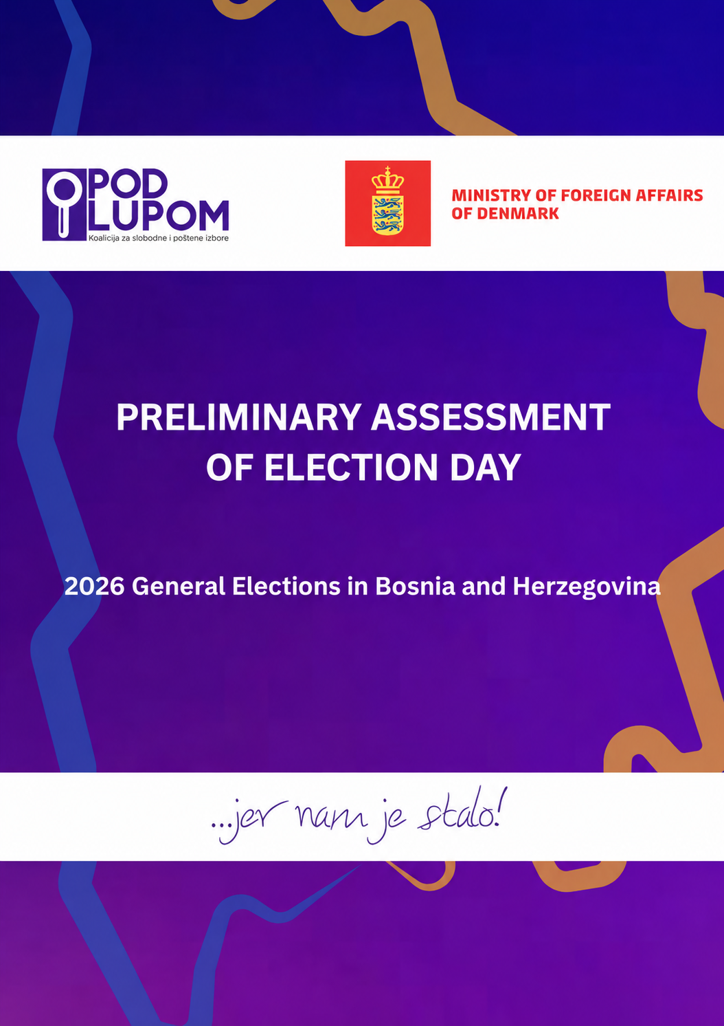
Table of Contents

Preliminary Assessment of Election Day 2
Verification of Results for the Election of Members of the Presidency of Bosnia and Herzegovina 3
Difference in Votes between the 2022 and 2026 General Elections 5
Verification of Turnout in the 2026 General Elections 5
Differences in General Election Turnout across Electoral Cycles 6
Chronological Overview of Election Day (Expanded Observation Findings) 6
Observers’ Access to Polling Stations 6
Preparations for the Implementation of New Technologies 8
Voting Process 9
Closing of Polling Stations 11
Packing Election Materials and Leaving Polling Stations 13
Summary of Serious Electoral Irregularities and/or Serious Incidents 14
Citizens’ Reports 14
Acknowledgements 14

Preliminary Assessment of Election Day

The Coalition for Free and Fair Elections “Pod lupom” assesses that election day was conducted successfully, with a significant improvement in the integrity of the electoral process through the use of new election technologies, namely biometric voter identification and authentication and optical ballot scanning.
The “Pod lupom” Coalition particularly welcomes the fact that technical problems with electronic identification and authentication devices at 14% of polling stations, as well as technical problems and interruptions in optical ballot scanning at 21.3% of polling stations, did not prevent the use of these technologies at polling stations.
For future elections, preparations should begin earlier, procedures for addressing technical difficulties should be improved, timely and comprehensive training of the election administration should be ensured, and technical support at polling stations should be further strengthened.
The “Pod lupom” Coalition considers it particularly significant that the introduction of new technologies strengthened confidence in the electoral process and did not lead to results being challenged on grounds related to the use of the technologies themselves. Acceptance of election results is an important indicator of democratic maturity and can be viewed as further confirmation that the use of new technologies passed a key test of public confidence in the electoral process.
However, the “Pod lupom” Coalition warns that the successful implementation of new technologies does not mean that the work of strengthening electoral integrity is complete. It is an important step, but only one part of a broader process. Elections extend beyond election day and are part of a broader, fundamental problem in society: systemic corruption and state capture. Findings from pre-election observation show that numerous electoral irregularities continue to pose a serious risk to electoral integrity, including pressure on voters, vote buying, misuse of public resources, irregularities in the formation of polling station committees, and others. Technological progress on election day must therefore be accompanied by stronger mechanisms for preventing, monitoring and sanctioning irregularities throughout the electoral cycle.
The “Pod lupom” Coalition therefore considers that the next phase of electoral reform should focus on strengthening integrity before election day. The legislative framework should be improved, the responsibilities of all electoral stakeholders clearly defined, the detection and prosecution of electoral irregularities made more effective, and sanctions for violations of electoral rules made more certain, swifter and more severe.
Election day in 2026 should therefore be viewed as an important milestone, but not as the end of electoral reform.

Verification of Results for the Election of Members of the Presidency of Bosnia and Herzegovina

Verification of results for the Bosniak member of the Presidency of BiH
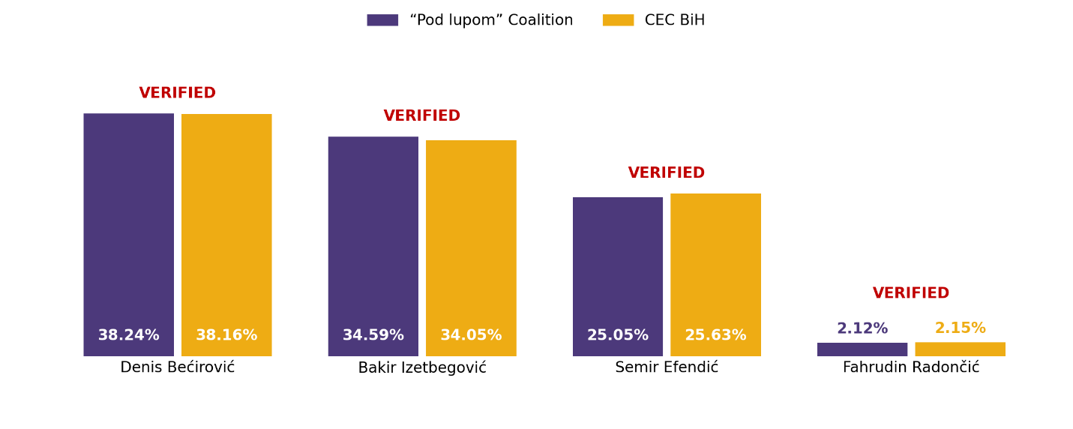
Verification of results for the Croat member of the Presidency of BiH
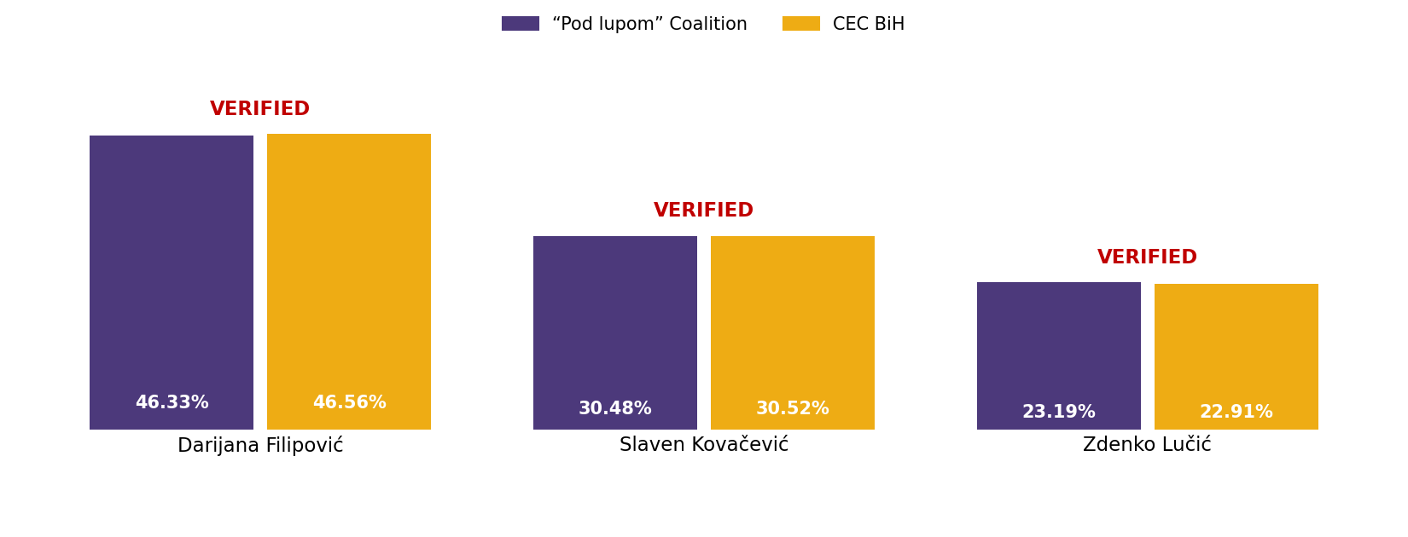
Verification of results for the Serb member of the Presidency of BiH
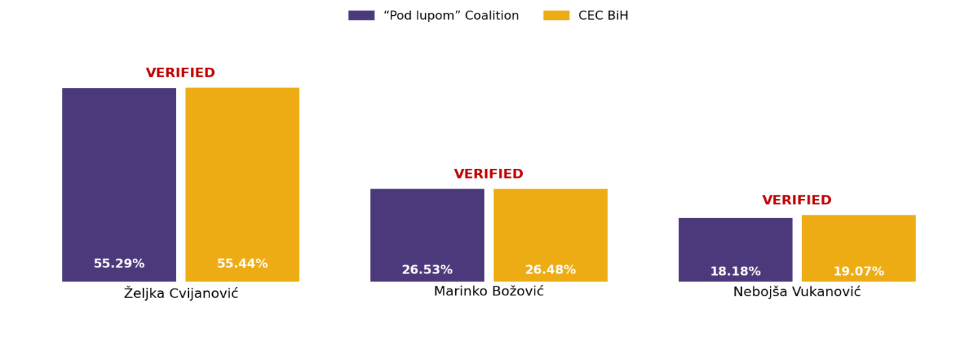

Difference in Votes between the 2022 and 2026 General Elections

Political party (regular votes) | GE 2022 | GE 2026 | Difference | % change
SDA | 234,254 | 237,530 | 3,276 | 1.40%
SNSD | 250,806 | 205,280 | - 45,526 | -18.15%
SDP | 125,102 | 117,494 | - 7,608 | -6.08%
HDZ BiH + | 132,040 | 98,112 | - 33,928 | -25.70%
PDP / PSS + | 72,347 | 75,083 | 2,736 | 3.78%
SBiH | 25,832 | 65,984 | 40,152 | 155.44%
SDS | 110,162 | 65,314 | - 44,848 | -40.71%
NiP + | 77,774 | 52,036 | - 25,738 | -33.09%
DF / GS | 96,160 | 47,920 | - 48,240 | -50.17%
HDZ 1990 + | 23,920 | 33,360 | 9,440 | 39.46%
NES + | 45,385 | 31,752 | - 13,633 | -30.04%
NS | 47,990 | 30,395 | - 17,595 | -36.66%
ZPR + | 32,428 | 29,134 | - 3,294 | -10.16%
DNS + | 20,656 | 26,420 | 5,764 | 27.90%
SP / DEMOS + | 52,602 | 23,549 | - 29,053 | -55.23%
US | 23,991 | 21,992 | - 1,999 | -8.33%
SBB | 22,656 | 9,523 | - 13,133 | -57.97%
BHI | 18,436 | 9,304 | - 9,132 | -49.53%

Verification of Turnout in the 2026 General Elections

The “Pod lupom” Coalition also monitors voter turnout. Recorded turnout in the 2026 General Elections by 19:00 was 42.9% (with a statistical margin of error of ±0.34%). The Central Election Commission (CEC) reported turnout of 42.02%. At the time of writing, the “Pod lupom” Coalition was able to verify the turnout reported by the CEC.

Turnout in the previous General Elections in 2022 by 19:00 was 50%, with 1,652,501 voters casting their ballots.

A decline in turnout was recorded at 89% of polling stations. An increase was recorded at the remaining 11%.
At polling stations where turnout declined, an average of 9.82% fewer voters cast their ballots. At individual polling stations in Prijedor, Zvornik, Posušje, Novi Travnik, Jablanica, Široki Brijeg, Zenica, Ravno, Derventa, Laktaši and Ljubuški, turnout was between 30% and 53% lower.

Although turnout appears lower, the “Pod lupom” Coalition considers it more realistic because irregularities that previously created a false picture of voter participation were absent, such as multiple voting, voting on behalf of people who did not turn out, voting on behalf of deceased persons, voting at multiple polling stations, or adding votes to ballot papers.

Differences in General Election Turnout across Electoral Cycles

Izbori | Turnout | Turnout change | Voters who voted | Change in number
GE 2010 | 56.52% |  | 1,770,388
GE 2014 | 54.14% | -2.38% | 1,788,083 | 17,695
GE 2018 | 54.02% | -0.12% | 1,812,839 | 24,756
GE 2022 | 51.45% | -2.57% | 1,652,501 | - 160,338
GE 2026 | 42.02% | -9.43% | 1,432,269 | - 220,232

Chronological Overview of Election Day (Expanded Observation Findings)

Observers’ Access to Polling Stations

For the 2026 General Elections, the “Pod lupom” Coalition deployed 893 citizen, non-partisan election day observers who monitored the entire electoral process at polling stations: opening, voting, closing, the use of new election technologies, vote counting and the packing of election materials.
At most polling stations, observers encountered no access problems. Certain access problems were recorded at a small proportion of polling stations, specifically 1.6%, where polling station committees had not received lists of accredited observers or did not allow observers to enter before 07:00. These were isolated procedural shortcomings that did not jeopardise the “Pod lupom” Coalition’s observation mission and were resolved in a timely manner.
Uređenje i otvaranje biračkog mjesta

Polling station opening times
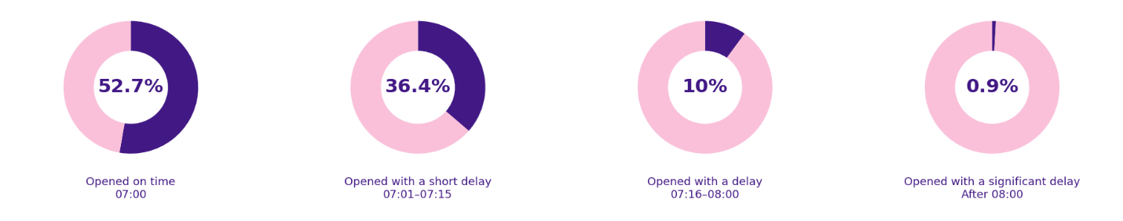
Regarding opening times, 52.7% of polling stations opened at 07:00. A further 36.4% opened between 07:01 and 07:15, 10% between 07:16 and 08:00, and 0.9% after 08:00.

Opening time | GE 2022 | GE 2026
Exactly at 07:00 | 79.50% | 52.70%
07:01 - 07:15 | 17.80% | 36.40%
07:16 - 08:00 | 2.70% | 10.00%
After 08:00 | 0.00% | 0.90%

Presence of polling station committee members
All polling station committee members were present at 06:00 at 92.6% of observed polling stations, while this was not the case at 7.4%.
Manual counting of ballot papers before opening
Ballot papers were counted manually before opening at 96.8% of polling stations, while this was not done at 3.2%.
Secrecy of the vote
Observers also monitored whether voting secrecy was ensured so that no one could see whom a voter voted for in the voting booth. Voting secrecy was ensured at 99.9% of polling stations.
Display of the list of polling station committee members
The list of all polling station committee members, including the names of the political entities they represented, was prominently displayed at 98% of polling stations, while it was not displayed at 2%.
Affiliation of the chairperson or deputy chairperson with political parties
At 2.3% of polling stations, there were suspicions, indications or complaints that the chairperson or deputy chairperson of the polling station committee was affiliated with a political party. No such suspicions, indications or complaints were recorded at 97.7% of polling stations.
Suspected misrepresentation by polling station committee members
Observers also monitored whether there were suspicions, indications or complaints that a polling station committee member represented a political entity other than the one stated on the list of committee members. Such cases were recorded at 1.3% of polling stations, while none were recorded at 98.7%.
Gender of polling station committee chairpersons
Regarding the gender composition of polling station committee chairpersons, women chaired committees at 48.9% of polling stations and men at 51.1%.
Accessibility of polling stations for persons with disabilities
Regarding accessibility for persons with disabilities who use wheelchairs or other mobility aids, 83.2% of polling stations were accessible, while 16.8% were not.
Symbols within 50 metres of polling stations
Political entity symbols or posters, religious symbols, or markings that could have a discriminatory meaning were recorded within 50 metres of 2% of polling stations, while none were recorded at 75.7%. Observers had no information on this for 22.3% of polling stations.
Displaying and sealing the ballot box
The ballot box was shown to be empty before the scanner was installed and was then properly sealed at 99.2% of polling stations. At 0.8%, this procedure was not carried out in the prescribed manner.

Preparations for the Implementation of New Technologies

Presence of new election technology operators
The new election technology operator was present at 06:00 at 97.4% of observed polling stations, while the operator was absent at 2.6%.
Readiness of specific election technologies for use
The specific election technologies, namely the biometric voter identification and authentication device and the optical ballot scanner, were operational and ready for use before opening at 99.5% of polling stations, while they were not ready at 0.5%.
Instructions to voters on marking and scanning ballot papers
The prescribed instructions to voters on marking and scanning ballot papers were prominently displayed at 98.5% of polling stations, while they were not displayed at 1.5%.
Initial report from the biometric voter identification and authentication device
The initial report from the biometric voter identification and authentication device, showing a starting count of “0”, was printed at 99% of polling stations, while it was not printed at 0.6%. The device was not used at 0.5% of polling stations.
Initial scanner report
The initial scanner report, showing a starting count of “0”, was printed at 99% of polling stations, while it was not printed at 0.5%. The scanner was not used at 0.5% of polling stations.
Observers’ access to initial reports
Observers were allowed to inspect the initial reports from the specific election technologies at 99.8% of polling stations. These technologies were not used at 0.2% of polling stations.

New technologies | GE 2026
Made operational | 99.50%
Identification used | 99.20%
Scanner used | 99.40%
Identification technical problems | 14.00%
Scanner technical problems | 21.30%
Identification properly closed | 99.20%
Scanner properly closed | 99.40%

Voting Process

Discontinuation of the use of voter identification and authentication devices
None of the observed polling stations discontinued the use of voter identification and authentication devices during voting. At a small proportion, 0.8%, their use had been discontinued earlier, either before or immediately after opening.
Discontinuation of the use of ballot scanners
None of the observed polling stations discontinued the use of ballot scanners during voting. At a small proportion, 0.6%, their use had been discontinued earlier.
Technical problems with electronic identification and authentication devices
Technical problems and interruptions in electronic voter identification and authentication that disrupted identification were recorded at 14% of polling stations.
Technical problems with ballot scanners
Technical problems and interruptions in optical ballot scanning that disrupted voting were recorded at 21.3% of polling stations.
Actions taken by polling station committees and operators in the event of technical problems
In cases where technical problems with the new technologies were recorded during voting, the polling station committee and operator followed the prescribed procedures in 36.1% of cases, while they did not do so in 0.5% of cases.
Insertion of ballot papers without scanning while the scanner was operational
Cases of allowing ballot papers to be inserted without scanning, despite the scanner being operational, were recorded at 0.2% of polling stations.
Insertion of ballot papers into the scanner by another person
At 1.3% of polling stations, observers noticed that a polling station committee member, an operator or another person inserted ballot papers into the scanner on behalf of a voter.
Voting without the required identification documents
Cases of voting without the required identification documents were recorded at 0.1% of polling stations.
Voting without fingerprint scanning
Cases of voting without fingerprint scanning were recorded at 39.8% of polling stations (up to 10 cases), while more than 10 such cases were recorded at 3.8% of polling stations.
Family voting
Family voting, meaning the presence of more than one person in a voting booth regardless of their relationship, was recorded at 44.7% of polling stations (up to 25 cases). More than 25 cases were recorded at 0.2%.
Abuse of assistance by another person during voting
Cases in which the same person assisted multiple voters were recorded at 21.3% of polling stations (up to five cases). More than five cases were recorded at 0.1%.
Prevention of abuse of assistance through identification and authentication technology
Identification and authentication technology prevented assistance being provided to a voter at 13.6% of polling stations (up to five cases).
Evidence or certification of the need for voting assistance
Of the voters who used another person’s assistance during voting, 26.7% did not have evidence or certification that they actually needed such assistance.
Open persuasion or calls to vote for a political entity
Open persuasion or calls directed at voters to vote for a particular political entity were recorded at 0.7% of polling stations or in their immediate vicinity.
Intimidation and pressure on voters
Cases of intimidation or pressure on voters were recorded at 0.1% of polling stations or in their immediate vicinity.
Photographing ballot papers
At 2.9% of polling stations, observers noticed voters photographing their ballot papers in the voting booth.
Unauthorised presence and disruption of voting
At 0.8% of polling stations, unauthorised persons remained unnecessarily on the premises and disrupted voting.
Secrecy of the vote
Voting secrecy in the booth or during ballot scanning was compromised at 2.8% of polling stations.
Other irregularities that could seriously jeopardise voting
Other irregularities that could seriously jeopardise voting were recorded at 0.6% of polling stations.
Ability to observe voting without obstruction
Observers were unable to monitor voting without obstruction at 5% of polling stations.
Written comments or complaints by observers
Written comments or complaints by observers were recorded at 9.6% of polling stations during voting.

Voting process | GE 2022 | GE 2026
Family voting | 52.40% | 44.70%
Abuse of assistance | 15.50% | 21.30%
Improper identification | 2.20% | 0.10%
Carousel voting | 0.30% | 0.10%
Pressure at polling stations | 4.70% | 0.10%

Closing of Polling Stations

Polling station closing times
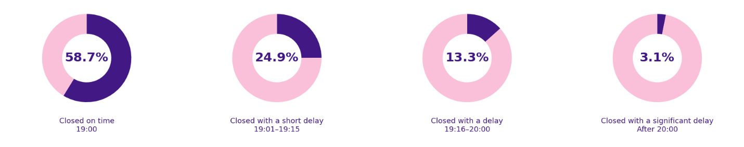
The proportion of polling stations that closed at 19:00 was 58.7%. A further 24.9% closed between 19:01 and 19:15, 13.3% between 19:16 and 20:00, and 3.1% after 20:00.
Closing time | GE 2022 | GE 2026
Exactly at 19:00 | 79.80% | 58.70%
19:01 - 19:15 | 16.80% | 24.90%
19:16 - 20:00 | 3.20% | 13.30%
After 20:00 | 0.20% | 3.10%

Treatment of voters present at polling stations at closing time
The “Pod lupom” Coalition monitored the treatment of voters who were at or outside polling stations at closing time. According to observers’ findings, voters were allowed to vote at 30.8% of polling stations, while this was not allowed at 3.8%. At 65.4% of polling stations, no voters were at or outside the polling station at 19:00.
Presence of polling station committee members at closing time
The “Pod lupom” Coalition monitored whether all polling station committee members were present at closing time. According to observers’ findings, all members were present at 99.1% of polling stations, while this was not the case at 0.9%.
Presence of operators at closing time
At polling stations using new election technologies, the operator was present at closing time at 97.3% of polling stations, while the operator was absent at 2.7%.
Setting the scanner to “polling station closed” status
After the last voter had voted, the “Pod lupom” Coalition monitored whether the polling station committee chairperson used a PIN to set the scanner to “polling station closed” status. This procedure was completed at 99.4% of polling stations, while it was not completed at 0.5%. The scanner was not used at 0.1%.
Printing the consolidated voting results report (FER)
The “Pod lupom” Coalition monitored whether, after voting ended, the scanner printed the consolidated polling station voting results report for all levels of government, known as the FER. According to observers’ reports, the scanner printed the FER at 99.2% of polling stations, while it was not printed at 0.7%. The scanner was not used at 0.1%.
Providing observers with a copy of the consolidated scanner report
The “Pod lupom” Coalition checked whether observers received a copy of the consolidated scanner report. Observers received a copy of the FER at 94.6% of polling stations, while at 4.8% they did not receive a copy despite clear CEC instructions. The scanner was not used at 0.6%.
Setting the electronic voter identification and authentication device to “election closing” status
For the electronic voter identification and authentication device, observers monitored whether, after voting ended, the polling station committee chairperson used a PIN to set the device to “election closing” status. This procedure was completed at 99.2% of polling stations, while it was not completed at 0.8%.
Electronic transmission of results before manual counting
The “Pod lupom” Coalition monitored the electronic transmission of results from scanners before manual counting began. Results were transmitted electronically at 98.3% of polling stations, while at 1.3% they were not transmitted before manual counting began.
Problems during electronic transmission of results
The “Pod lupom” Coalition also recorded any problems during electronic transmission of results. Transmission problems were recorded at 10.7% of polling stations, while no such problems were recorded at 88.9%. The scanner was not used at 0.4%.
Vote Counting

Entry to polling stations after closing
Entry to polling stations after closing was allowed at 3.8% of polling stations.
Removal of felt-tip voting pens before counting
Before the ballot box was opened and vote counting began, felt-tip voting pens were removed from the table or counting area at 99.9% of polling stations, while they were not removed at 0.1%.
Declaration of invalid ballot papers
Ballot papers were declared invalid in accordance with CEC regulations at 99.7% of polling stations, while this was not done in accordance with the regulations at 0.3%.
Ballot papers without a QR code
Ballot papers without a QR code were declared invalid at 37.7% of polling stations, while at 0.4% they were not declared invalid. No ballot papers without a QR code were found at 61.9% of polling stations.
Adding votes to ballot papers
Adding votes to ballot papers during counting was recorded at 0.1% of polling stations, while no such cases were recorded at 99.9%.
Ability to observe vote counting
All observers were able to monitor vote counting for all levels clearly and without obstruction at 97.3% of polling stations, while this was not possible at 2.7%.
Consistency between electronic and manual vote counts
Electronic and manual vote counting results for all levels matched at 59% of polling stations, while they did not match at 41%.

Packing Election Materials and Leaving Polling Stations

Irregularities in the packing of election materials
Irregularities in the packing of election materials were observed at 1.5% of polling stations.
Signing finalised SIT ZR forms
All polling station committee members signed the finalised SIT ZR forms containing aggregate results at 98% of polling stations, while at 2% the forms were not signed by all committee members.
Display of yellow copies of SIT ZR forms
Yellow copies of SIT ZR forms containing aggregate results were prominently displayed at 92.2% of polling stations, while they were not displayed at 7.8%.
Display of FER copies
Copies of the FER containing electronic vote counting results were prominently displayed at 93.2% of polling stations, while they were not displayed at 6.8%.
Photographing displayed forms
Observers photographed the displayed forms at 93% of polling stations, while they did not do so at 7%.
Taking a copy of the FER
Observers took their copy of the FER with them at 91% of polling stations, while at 9% they did not collect a copy.
Packing and handing over new election technology devices
The biometric voter identification and authentication device and ballot scanner were properly packed and handed over to the election commission at 98.7% of polling stations, while this was not done at 1.3%.
Completion of all polling station procedures
All polling station procedures had been completed at 97% of polling stations, while at 3% they had not been completed.
Departure of polling station committee members, operators and observers
Polling station committee members, the operator and other observers had left the polling station at 88.9% of polling stations, while this was not the case at 11.1%.
Pressure during observation
Observers experienced some form of pressure during observation at 4.4% of polling stations.

Summary of Serious Electoral Irregularities and/or Serious Incidents

By 19:00, a total of 107 serious violations of electoral rules had been recorded. By frequency, these involved: prohibition or obstruction of electoral observation (18), problems with new technologies (18), problems with election materials (11), violations of the campaign silence period (10), voting process irregularities (12), breaches of voting secrecy (6), failure to display lists of polling station committee members (5), and various other electoral irregularities (27).

Citizens’ Reports

On election day, the “Pod lupom” Coalition received 202 reports of electoral irregularities from citizens.

Acknowledgements

The Coalition for Free and Fair Elections “Pod lupom” expresses its sincere gratitude to all citizen, non-partisan observers who participated in observing election day for the 2026 General Elections. Their dedication, professionalism and commitment made a significant contribution to strengthening electoral integrity.
We thank the media for their responsible and professional reporting, which enabled the wider public to follow our work and understand the electoral process. We also extend special thanks to the electoral stakeholders who demonstrated a willingness to cooperate and respect procedures throughout the process.
Finally, we thank all citizens whose contributions demonstrated their commitment to democracy and free and fair elections. Active citizen participation is the foundation of fair elections.

