Funded by
the European Union

The 2020 Local Elections from the perspective of local election commissions

Analysis of the evaluation questionnaire for the local election commissions in Bosnia and Herzegovina after the 2020 Local Elections

TABLE OF CONTENTS
INTRODUCTION ___________________2

METHODOLOGY ________________________________________________________4

ANALYSIS OF QUESTIONNAIRE BY ARES 5
Conduct of the 2020 Local Elections______________________________________5
Preparation for the 2020 Local Elections___________________________________8
Election Day_________________________________________________________14
Recommendations for improvement of electoral process in BiH______________17
Cooperation________________________________________________________ 18
INSTEAD OF A CONCLUSION ____ 22

ANNEX 1
Evaluation questionnaire for the municipal/city election commissions_______________________________________________________________24

INTRODUCTION
The 2020 Local Election were held on Sunday, November 15, 2020, while the local elections for the City of Mostar were finally held on December 20, 2020, after 12 years. The following levels of authority were directly elected at the elections on November 15:
- Councilors in 64 municipal and 14 city councils in Federation of BiH,
- Councilors in 56 municipal and 7 city assemblies in Republika Srpska,
- 120 municipal mayors,
- 22 city mayors and
- Representatives in the Assembly of Brčko District of BiH.

The City Mayor of Brčko District of BIH is elected indirectly in the District Assembly, and the mayors of the City of Sarajevo and the City of Mostar are also elected indirectly. The direct election of the mayor of the City of Istočno Sarajevo was established by adoption of the Law on the City of Istočno Sarajevo that consists of six municipalities and where at the previous electoral cycles the City Mayor was elected indirectly.

Election administration in BiH consists of election commissions and polling station committees. Election commissions are: the BiH Central Election Commission (BiH CEC) and 143 municipal/city election commissions and the Election Commission of Brčko District BiH (hereinafter: local election commissions LECs). The BiH CEC and 143 local election commission in BiH are permanent bodies. The local election commissions appoint polling station committees, which are also part of election administration, for every election separately. Members of all election commissions are appointed for a 7-year term, while the members of the polling station committees are appointed for every election. Members of the election commission are elected by political parties in the representative bodies at different levels of authority, and all members of polling station committees are persons directly nominated by the political entities.

Election commissions at the local level (municipal, city and election commission of Brčko District of BiH) are responsible, among other things, for determining polling stations, establishing and training the polling station committees, organizing the Election Day and consolidating election results from polling stations on their territory. The composition of the local election commission, taking into account the provisions of the BiH Election Law and the Law on Gender Equality, should reflect the gender representation of at least 40% of members of the underrepresented gender. So defined gender representation in the composition was not respected in 12 election commissions at the local level. Also, composition of two local election commissions during preparation and conduct of the elections was incomplete.

The election administration at the local level had mostly adequately completed the preparations for the conduct of elections with some minor deviations in the process thereof. The local commissions also faced challenges caused by the pandemic, particularly concerning arrangement of the polling stations and obtaining the material and technical means necessary for the conduct of election process in the context of the pandemic.

The Election Day, including the one in Mostar, had passed in line with the BiH Election Law and by-laws at most polling stations, accompanied with the irregularities that are already traditionally repeated every electoral cycle. However, given everything that was happening in the election campaign, and all irregularities documented (trade of positions on the polling station committees, vote buying, misuse of public resources, voter coercion, abuse of by-mail voting), including the irregularities during voting and in the process of determining the results, these elections, based on the assessment of the Coalition "Pod lupom", were not held in a democratic environment where voters could freely and without any pressure decided on their electoral will.

METHODOLOGY
Taking into account the competencies of local election commissions, their role is crucial for the successful organization and conduct of all elections in BiH. Therefore, the opinion of local election commissions on the conducted elections is very important, both from the aspect of conducted elections and from the aspect of what can be done differently and/or better, with the aim of improving the electoral process. The Coalition “Pod lupom” has been surveying local election commissions since 2014 in order to obtain the opinion of local election commissions. Following this practice, a Questionnaire was also compiled and submitted to all local election commissions in BiH after the 2020 Local Elections.

The questionnaire consists of five parts: a general part relating to the evaluation of the conduct of elections and the challenges and/or problems faced by the commissions; the second part relating to the preparation for the Election Day, with particular regard to the process of appointment of the polling station committees and their performance; the third part relating to the Election Day, the fourth part relating to the opinion of the commissions on the offered recommendations for improving the electoral process, while the fifth part covers to the cooperation of local election commissions with all relevant stakeholders in the electoral process.

Out of 143 local election commissions, 85 of them or 59.4% submitted completed questionnaires, and this analysis was made based on the answers provided. The analysis will be submitted to all local election commissions, the Central Election Commission of BiH, and will be presented to the public as part of the activities of the Coalition “Pod lupom”, which aim to improve the electoral process in BiH.

ANALYSIS OF QUESTIONNAIRE BY AREAS
Conduct of the 2020 Local Elections
The conduct of the 2020 Local Elections was assessed as excellent by 23 (or 27.1%) surveyed election commissions, which is lower compared to the answer provided to same question after the 2018 General Elections, when the conduct of elections was assessed as excellent by slightly more than 32% of surveyed commissions. For the sake of comparison, 40% of the surveyed commissions assessed the conduct of elections as excellent after the 2016 Local Elections. In order to correctly interpret the data, it must be underlined that the earlier response of the local election commissions to participate in this activity was at a higher level: in 2016, the questionnaire was completed by 84% of local election commissions, and in 2018 by 73%.
The largest number of local election commissions, 46 of them or 54.1%, assessed the conduct of elections as “very good”; 15 commissions or 17.6% assessed the conduct of elections as “good”, while only one election commission assessed it as “satisfactory”. No local election commission assessed the conduct of the 2020 Local Elections as bad/poor.

Chart 1: overall assessment of the conduct of the 2020 Local Elections
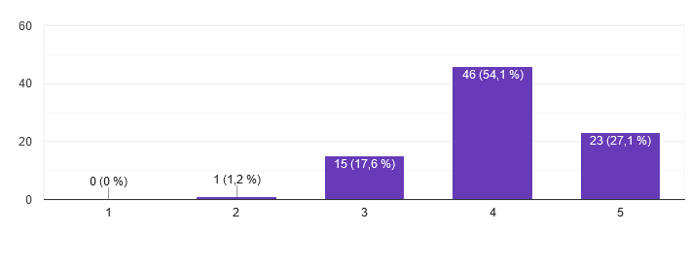 The local election commissions identified the lack of human resources (28 answers), inadequate premises and equipment for work (16 and 10 answers, respectively), insufficient financial resources for work (7 answers), non-payment of remuneration or delays in payment (15 answers), the presence of obstructions by political entities (11 answers), and the inability to implement the Covid-19 instruction issued by the BiH CEC (21 answers) as the biggest problems in their work.

Chart 2: operational issues
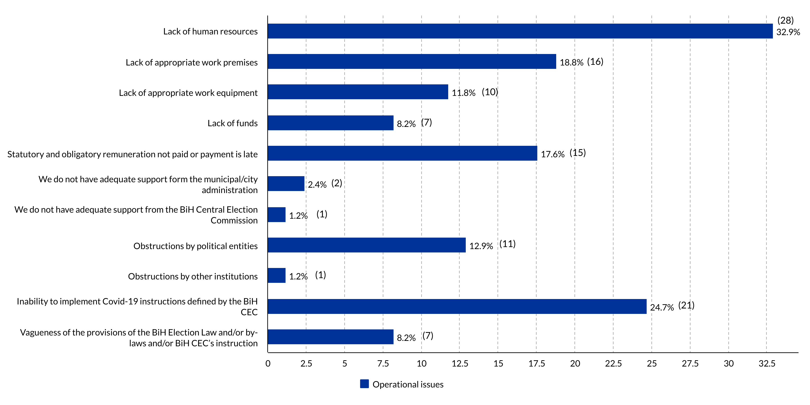
Analogous to the noted problems, the local election commissions underscored the following as conditions necessary to improve efficiency of their work: more human resources was underlined by 30 commissions; more financial resources for work was underlined by 28 commissions; 20 commissions consider that better working conditions, i.e. better premises and equipment, are necessary for more efficient work; that more support from the Central Election Commission is needed for more efficient work was underlined by 11 local election commissions ; while 7 commissions believe that more support is needed from the local city/municipal administration.

Chart 3: What is needed to achieve greater efficiency?
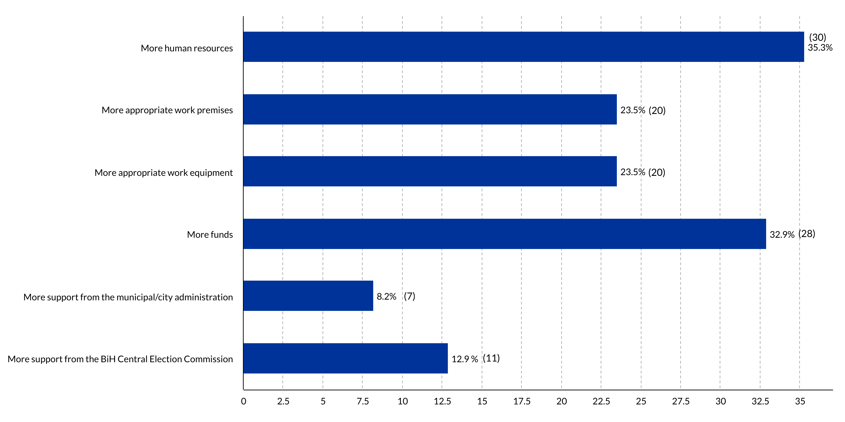

In relation to the same question asked for the 2018 General Elections, the opinion of local election commissions that more human resources would contribute to more efficient conduct of the elections is being repeated. At that time, a total of 37 commissions shared that opinion. The other priorities mentioned by the election commissions generally correspond to the priorities pointed out by the commissions after the 2018 elections, except in the part of greater support from the BiH Central Election Commission when it was considered necessary by twice as many commissions than after the 2020 Local Elections, 21 of them in total.

Among other proposals for the improvement and greater efficiency of the local election commissions, the following was highlighted:

* professionalization of election commissions * equal engagement of all members of the local election commissions, and achieving this would require having at least the majority of members appointed from among civil servants employed in the local self-government body * professionalization of a certain number of members of the polling station committee, thus helping election commissions to conduct the electoral process * it is necessary to adopt by-laws that will not be subject to almost everyday change * changes in regulations on the appointment of polling station committees * it is necessary that political entities have a more serious approach when appointing members of polling station committees *

Most of the surveyed local commissions, 40 of them or 47.1%, assessed their own work in organizing and conducting the 2020 Local Elections as excellent, and 34 of them or 40% assessed their work as "very good". A total of 11 election commissions (or 12.9%) evaluated their work as "good", which is more than double compared to the assessment made for the 2018 General Elections, when only 5% of the commissions assessed their work as good.

Chart 4: Assessment of their own work by the local election commissions (grade 1 = poor; grade 5 = excellent)
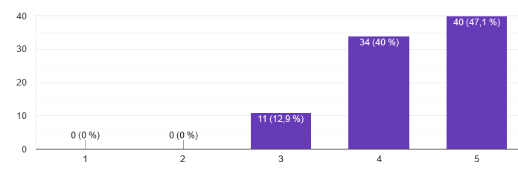
The assessment of the cooperation between the local election commissions and the competent registry office of the municipality/city with regard to the competencies concerning the Central Voters' Register is shown in the following chart:

Chart 5: Cooperation with the competent registry offices (grade 1 = poor; grade 5 = excellent)
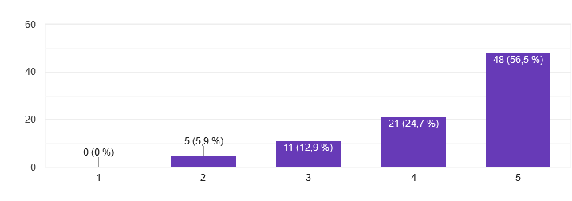Preparations for the 2020 Local Elections
Most local election commissions believe that adequate preparations had been made for the organization and conduct of the 2020 Local Elections. Only one local election commission stated that preparations for the organization and conduct of elections were generally inadequate.

Chart 6: Adequate preparation for organization and conduct of elections

The most common channel of communication of election commissions at the local level with voters about election-related activities and deadlines is the official website of municipalities/cities, which was answered by 69.4% of commissions, followed by the media outlets (television, radio, newspapers, social networks), which was answered by 63.5% of the commissions, and bulletin boards in the municipalities/cities, which was answered by 62.4% of the commissions. Compared to the data from 2018, when the most common way of communication reported by the commissions was through the bulletin boards, we now can see an increase in communication through the media and the official website. It is important to point out that this was a multiple-choice question, which means that all election commissions use a combination of at least two ways of communicating with voters.
The answers of the local election commissions to the question concerning the sufficient amount of material and technical means needed for the observance of epidemiological measures are shown in the chart below:
Chart 7

From the moment it was delivered by the BiH Central Election Commission until its distribution to the polling station committees the sensitive polling material was in most cases stored in the municipal/city premises.
Chart 8

Local election commissions believe that they have enough time to distribute polling material because 72.1% of the surveyed commissions answered affirmatively, and 27.1% of them believe that they mostly have enough time for this election activity.
When asked if the sensitive polling material was stored at the polling stations from the time it was distributed until the Election Day, the commissions answered as follows:

Chart 9

Most of the surveyed election commissions deem that the handover procedure and the practice of storing sensitive polling material are satisfactory. The question "Do you think that the handover procedure, as well as the practice of storing sensitive election material, is satisfactory?" was answered "Yes" by 45 election commissions; 34 elections commissions answered "Mostly yes", 5 answered "Mostly no" while one commission answered "No". Some of the proposals of the local election commissions concerning this issue implicated the following: that it would be good to deliver sensitive and non-sensitive polling material earlier, taking into account the number of voters and polling stations per basic constituency; that polling material can be taken over 48 hours before the Election Day; that the competent Ministries of Interior should have precise procedures for storing sensitive polling material; that the storage of sensitive polling material requires the engagement of a larger number of police officers; to store the polling material at polling stations in the presence of police officers, and to introduce video surveillance systems or similar security systems; one election commission is of the opinion that sensitive polling material is currently safer in the house of the polling station committee president because the members of the commission or polling station committee do not know how many people have the keys to the premises in which polling station is located, thus allowing unauthorized access.

Most local election commissions responded that they had no problems in the process of determining the number, type and location of polling stations. This process was assessed as excellent by 49 (57.6%) commissions, very good by 24 (28.2%), good by 11 (12.9%), while only one local election commission (1.2%) assessed this process as satisfactory.

Almost all local election commissions consider the facilities where the polling stations are located appropriate for conduct of the elections (18 commissions answered “Yes”, 65 “mostly yes”, while two commissions answered “Mostly no”).

Polling station committees
When asked if the local election commissions had problems in the process of appointing members of polling station committees, the commissions answered the following:
Chart 10

Some of the reasons listed by the local election commissions that stated they had problems in the process of appointing polling station committees are: political entities failed to submit proposals for appointment of all members and deputy members of polling station committees for positions allotted to them in the lottery draw; a number of submitted proposals did not meet the requirements prescribed by the BiH Election Law for appointment to the polling station committees, and on the other hand, political entities submitted a large number of requests for accreditation of observers; at the time when the Decision on the appointment of polling station committees for 156 regular polling stations and 20 mobile teams was made, the missing number of members and deputies was already approximately 500 persons, and this problem was addressed in line with Article 2.19 of the Election Law, meaning that the election commissions had exhausted their reserve list during passing of the main Decision already; political entities did not submit enough proposals for deputy members of polling station committees; lack of skilled people; withdrawal of members before training, as well as withdrawal of members after successful training, and even withdrawal the day before the elections; failure to attend the training sessions; problems due to withdrawal of PSCs' members and deputies, related to the consequences of the Covid-19 pandemic (a high number of commissions pointed out the problem related to the Covid-19 pandemic and the consequences thereof had reflected in the withdrawal of the PSCs' members); political entities proposed “inadequate” candidates (without electoral experience, the elderly, etc.) for members of polling station committees, later on complaining that they have not been appointed president of the PSC; a good portion of the proposed candidates did not have the appropriate qualifications for membership in the polling station committee; citizens not interested in participating in the election activities, withdrawal of members caused by the pandemic, and pre-election tensions, etc.; lack of interest in working in the PSC due to low remuneration for a lot of work, and large penalties in case of a mistake; a certain number of political entities are not sufficiently interested in filling positions on the PSCs (they do not submit proposals, submit inadequate proposals, do not submit replacements for those who withdrew...); insufficient financial resources for planning a larger reserve; short time for appointment and quality training due to the large number of withdrawals; there were many requests for withdrawal and change of positions on the PSCs both by appointed members and the political entities as nominators.
When asked about the so-called trade of the positions on the polling station committees, the majority of surveyed local election commissions answered that they were not aware of such cases (77.6% of them); 18.8% of commissions answered that there was no such trade, while three (3.5%) commissions stated that there was trade of positions on polling station committees by political entities.

In terms of greater withdrawal from membership in the polling station committees just before the Election Day, the commissions gave the following answers:
Chart 11

The training of polling station committees was generally assessed positively by the local election commissions: 31.8% of them evaluated the training as excellent, 42.4% as very good, 23.5% as good, while two commissions (2.4%) evaluated the training as satisfactory.

When asked how the current unique methodology for training of polling station committees, developed by the BiH CEC, has improved the training system, the commissions answered as follows:

Chart 12

In relation to the same question that was asked after the 2018 General Elections, there is an increase in the number of positive answers, i.e. the contribution of the uniform methodology was assessed more positively than before. At that time 60% of the commissions answered that the uniform methodology had mostly improved the training system, now it is 74% of the surveyed commissions. Also, 12% of the commissions assessed that the methodology did not improve the training system at that time, while now this answer was given by 7% of the commissions.

Most of the surveyed election commissions answered that they had enough time to prepare and to train the members of the polling station committees. A total of 96.4% of the commissions answered "mostly YES" and "yes", while three commissions answered "no" or "mostly no" (3.6%). The election commissions answered the question "Are political entities nominating persons with knowledge and/or experience in the electoral process for membership in the polling station committees" as follows:
Chart 13

The local election commissions had the opportunity to present proposals for improving this segment of the electoral process in the questionnaire. Below are the recommendations made by the individual commissions: professionalization of the position of president and deputy president of polling station committee; selection of educated and experienced persons; proposing and appointing professional presidents of the PSCs; amending the Rulebook on Determining Qualifications and the Procedure for Appointment of the Polling Station Committee Members in the sense that the President of the PSC is not proposed by a political entity, but is appointed from among the staff in the administration; more frequent education; to clearly tell political entities that PSC is not a social institution where someone should earn a "per diem", but that it is a body that conducts elections and is the most important in the electoral process, requiring knowledge and experience of the electoral process; establish a procedure specifying that priority will be given to persons with experience and physically fit persons who can both capable and know how to count ballots; prescribe qualifications and conditions for performing duties in the PSC; it is necessary to amend the laws and by-laws and make those positions permanent and to define duration of the term; persons who are employed in public administration to participate in the membership of PSC.
In terms of the protection of electoral right under competence of the local election commissions, the commissions that participated in the questionnaire reported that a total of 221 complaints were submitted to these commissions by November 15, 2011. It was stated that the complaints were resolved within the deadlines prescribed by the law, and that a large number of them were unfounded or had other shortcomings. A number of complaints were forwarded to the BiH CEC, and according to the data reported, the BiH CEC confirm majority of the local election commissions' decisions.

Election Day
Local election commissions assessed the Election Day in their basic constituency positively, i.e. the Election Day was assessed as “excellent” by 23 surveyed commissions (27.1%), “very good” by 48 commissions (56.5%), and “good” by 13 of them (15.3%), while the Election Day was assessed as satisfactory by only one commission (1.2%). No local election commission assessed the Election Day as "unsatisfactory".

In terms of the problems that the surveyed commissions encountered on the Election Day, majority of them or 72.9% stated that they did not encounter any problems to a significant extent. The problem of withdrawal of a significant number of polling station committees' members was reported by 8.2%; while 4.7% of the commissions opted for the answer that these were incidental situations at the polling stations; the same percentage of commissions stated that there was a significant number of voters who were not on the excerpt from the CVR. One answer each had problems such as: a number of voters was registered to vote by-mail against their will; withdrawal of PSC's members the day before the elections; a larger number of voters registered to vote by-mail; PSC members arriving after 6 a.m. to the polling station; one person providing assistance to a large number of voters because of their poor eyesight, etc.

In relation to the implementation of the 2016 Local Elections, the election commissions were asked what was done better this time. The largest number of surveyed local election commissions (55.3%) believe that everything is the same or similar to the previous elections. A total of 31.8% of commissions said that this time the voters' register contained fewer names of deceased persons; 18.8% of them think that the number of reported irregularities had decreased compared to the elections four years ago; 10 local election commissions believe that the training for polling station committee were better this time, and that the members of the PSCs were less absent than four years ago.

Performance of the polling station committees at the 2020 Local Elections was evaluated by the surveyed local election commissions as follows:

Chart 14

No local election commission assessed the performance of polling station committees as "poor".

When asked if there were voters who reported their data being misused for by-mail voting 82.4% of local election commissions gave a negative answer, while 17.6% of the surveyed commissions affirmatively answered this question. The answers offered show that there were over 800 such cases, some of which reported the misuse before the Election Day, and a significant number of misuses were detected on the Election Day. Voters, as shown by the answers, were allowed to vote by tendered ballots, while the reports of misuse made before the Election Day were, judging by the answers given, forwarded to the BiH CEC.

Determination of the results at the polling stations was evaluated by the surveyed local election commissions as follows:

Chart 15

No local election commission assessed the process of determining election results at the polling stations as “poor”.

The process of polling material handover by the polling station committees was assessed mostly positively: 27.1% of the surveyed commissions assessed this process as "excellent", 45.9% as "very good", 20% as "good", while 7.1% of the surveyed commissions assessed this process as "satisfactory".

A total of 40 out of 85 surveyed local election commissions (47.1%) stated that there was no recount of ballots in the municipal/city election commission. Other local election commissions stated that there was a recount of ballots in the premises of the commissions.

When asked about the observed positive or negative trends at the 2020 Local Elections, the majority of surveyed commissions (85.9%) answered that they did not notice any trends. The remaining 14.1% stated that they had noticed certain trends. The following trends were given: abuse of insufficiently defined implementing processes by certain political entities; attempts by political entities to question the impartiality of the MEC's members; a large number of voters registered to vote by-mail; poor coordination of activities by the CEC, delays in the delivery of materials, unilateral interpretation of laws and by-laws, illegal transfer of competencies from the CEC to the LECs (voters' register for Covid positive voters was prepared by the LECs, and the voters' registers are sole responsibility of the CEC), lack of partnership relations with the LECs; the number of PSC members proposed by the political entities lower than the number of allotted positions; increased number of certified political entities "satellites", which implies greater abuse of positions on the PSCs and accreditation of observers; there were more registered political entities at these local election that are "unknown" and that neither have their own organizational unit on the territory of the basic constituency, nor public activities (presentation of candidates, programs, etc.); registering voters for by-mail voting without their knowledge, so that a large number of voters learned this after the BiH CEC published the list of by-mail voters; the counting of ballots in the first round of counting is no longer "slow" and "less interesting" than the counting of votes by candidates within one candidate list in the second round of counting; offensive and aggressive political campaign, there was more talk about what others are doing and their shortcomings, than about programs and what they offer as an improvement, which significantly contributed to lower voter turnout because the voters have obviously become tired of it all.

The most common irregularities reported
When it comes to the most common irregularities in the 2020 Local Elections, the surveyed local election commissions answered as follows (it was possible to select multiple answers). A total of 40 local election commissions (47.1%) answered that there were no irregularities on the Election Day. According to the answers of the commissions, the largest number of irregularities related to irregularities in the packaging of polling material (wrong bags used for packing, incorrectly filled out forms, a part of the material missing, etc.). These were the answers of 26 commissions or 30.6%. Other irregularities mentioned related to irregularities in entering of the votes (8 commissions or 9.4%); irregularities in the counting process (5 commissions or 5.9%), etc. Other answers are mainly individual cases related to: omissions in the arrangement of the polling station, irregularities in the voting process, incorrectly consolidated results for one polling station, unnecessary lingering of candidates at polling stations and in their vicinity, etc.

When asked if the local election commission filed charges for crimes committed during the electoral process, only one of the surveyed commissions answered affirmatively. No details of the report or type of crime were given.

Recommendations for improvement of the electoral process in BiH
In this part of the Questionnaire the Coalition "Pod lupom" asked for the opinion of the commissions on the priority recommendations of the Coalition "Pod lupom" (multiple choice questions). Their answers are presented below:

57 or 67.1% of the commissions believe that new technologies have to be introduced into the electoral process as to ensure determining the true will of voters at the polling stations on the Election Day, thereat following the standards and criteria of security, feasibility and longevity of the chosen solution.

53 or 62.4% commissions believe that the way in which members of the polling station committees are appointed should be changed

22 or 25.9% commissions believe that the height of the voting booths should be reduced to a maximum height of 30 cm, which ensures the secrecy of voting and prevents certain irregularities.

15 or 17.6% commissions believe that separate translucent ballot boxes should be introduced for every level of authority elected at the elections.

7 or 8.2% believe that lodging of complaints to the electoral process should be allowed to everybody at every stage of the electoral process.

Some of the other proposals for the improvement of the electoral process are:
scanning of ballots * enable electronic voting * increase remuneration for members of polling station committees, reduce payments to parties from the budget * enable the MEC to directly appoint the president of the PSC and to have the PSC president be adequately paid for it * persist in harmonizing legal regulations (BiH Election Law - by-laws) * in order to improve the electoral process, the proposal is to semi-professionalize local election commissions * greater control of by-mail voting * cautious and gradual introduction of technologies would improve the process * introduce greater accountability for unlawful work of the election management bodies starting from PSCs, LECs, and CEC * allow MECs to appoint PSC presidents * to prescribe by the law that MEC appoints PSC presidents *It would be good to introduce electronic voting or at least electronic counting of ballots, because polling station committees make the most mistakes in counting, filling in the forms and packing, or to have counting done at the CEC or the Main Counting Center* introduce strict sanctions for the first recommendation, for example, taking away the position on the PSC from a political entity that appoints inadequate members, and for the second recommendation, scanning of the ballots immediately after the voting, which would eliminate any possible fraud by the PSC and immediately produce the election results and turnout after the voting* to thoroughly regulate the by-mail voting procedure * introduction of new technologies, especially in the segment of determining the results * to prevent the registration of parties for elections that register fictitiously and do not receive any or hardly any votes, all for the purpose of staffing the PSCs and proposing observers.

Cooperation
In order for any elections to be held successfully, there is a need for optimal and quality cooperation, primarily of the bodies in charge of organizing and conducting elections. However, cooperation with other electoral stakeholders, such as political entities and election observers, is also important in order to make the electoral process open and transparent in the interests of the public and restitution of the confidence in the electoral process. For this purpose, part of the questions in the questionnaire related to the cooperation of local election commissions with all the listed stakeholders. The results are as follows:

Chart 16

No local election commission assessed the cooperation and communication with the BiH CEC as “poor”. These answers almost completely correspond to the answers from 2018.

Chart 17

No local election commission assessed the cooperation and communication with political entities from its basic constituency as “poor”.

Chart 18

Chart 19

Chart 20

The local election commissions that took part in this survey, 85 of them, answered that they accredited a total of 38.166 observers of political entities for the 2020 Local Elections.

IN STEAD OF A CONCLUSION
If we review the answers of local election commissions to the same or similar questions over the past several election cycles, it can be concluded that since 2016 local commissions have seen the polling station committees as a source of most problems, but also a source of potential solutions: the way they are established, obligations and responsibilities, status, work on the Election Day, and the amount of remuneration that has been particularly underline as inadequate. Concerns about the functioning of polling station committees are entirely justified, given that they are perhaps the most important link on the Election Day. It largely depends on the polling station committees if the elections are to be held in accordance with applicable regulations or not. The local election commissions had on several occasions made recommendations for modification of the way in which polling station committees are appointed, particularly in the part concerning appointment of the president of the polling station committee, where the option to elect and appoint them by the local election commission has been mentioned several times. It has been repeatedly pointed out that greater responsibility and thoughtfulness of political entities is needed when nominating persons for membership on the polling station committees, emphasizing that a special focus should be placed on experience, as well as physical fitness, given the difficulty of tasks that the polling station committee has to perform on the Election Day.

As to make their work more efficient, the local election commissions mainly pointed out that more human resources are needed for better organization and conduct of elections, followed by financial resources, more adequate premises and better equipment.

Local election commissions, which took part in the questionnaire, expressed significant support to the presented priority recommendations of the Coalition "Pod lupom", especially in the segment of changing the method of selecting and appointing polling station committee's president, and introducing new technologies in the electoral process that will contribute to determining genuine voters' will on the Election Day.

Communication with the electoral stakeholders, the BiH CEC, political entities, observers (non-partisan, party, international) was assessed mostly positively by the surveyed local election commissions.

Election Day was assessed very positively by the majority of local election commissions, as were the overall preparation and organization of the elections.

The Coalition "Pod lupom" wants to use the opportunity and thank the local election commissions for their cooperation so far, as well as for all the recommendations and suggestions for improving the work of the Coalition "Pod lupom". We hope that the analysis of the answers from the questionnaire will be used by the competent bodies, especially the BiH CEC, as a useful document on the basis of which certain solutions can be introduced to the BiH Election Law or by-laws, leading to the improvement of the electoral process.

ANNEX 1
Evaluation questionnaire on the 2020 Local Elections for the municipal/city commissions.
PART I – General questions

1. How do you assess the overall conduct of the 2020 Local Elections your municipality/city??
Excellent Very good Good Satisfactory Poor

2. What problems did you encounter in your work? (Multiple answers can be selected)
Lack of human resources
Lack of appropriate work premises
Lack of appropriate work equipment
Lack of funds
Statutory and obligatory remuneration not paid or payment is late
We do not have adequate support from the municipal/city administration
We do not have adequate support from the BiH Central Election Commission
Obstructions by political entities
Obstructions by other institutions
Inability to implement Covid-19 instructions defined by the BiH CEC
Vagueness of the provisions of the BiH Election Law and/or by-laws and/or BiH CEC’s instructions
Other _____________________________________________________________________(Please specify)

3. How do you assess performance of the election commissions at the local elections in your municipality/city?
Excellent Very good Good Satisfactory Poor

4. How do you assess the cooperation with the registry office in your municipality/city concerning the competencies related to the Central Voters' Register?
Excellent Very good Good Satisfactory Poor

5. Š What needs to be done to make the work of your election commission more efficient?
More human resources
More appropriate work premises
More appropriate work equipment
More funds
More support from the municipal/city administration
More support from the BiH Central Election Commission
Other
PART II – Preparation for the local elections

6. Have, in your opinion, adequate preparations been made for the local elections in your municipality/city??
Yes Mostly yes Mostly no No

7. How did you inform the voters about your activities and election deadlines? (Multiple answers can be selected)
Through the media (TV, radio, newspapers, social networks)
Municipal/city bulletin board
Official website of the municipality/city
In other ways_________________________________________________________(Please specify)

8. Did you receive/have enough material and technical resources to comply with all prescribed epidemiological measures on the Election Day, November 15, 2020?
Yes No Not completely

Your comment:

9. Where was the so-called sensitive polling material kept from the moment it was delivered by the BiH CEC until it was distributed to the PSCs?
In the premises of the municipal/city election commission
In the premises of the Ministry of Interior
In the municipal/city premises
Other _______________________________________________________________________ (Please specify)

10. Do you think that the municipal/city election commission has enough time to distribute polling material to the polling station committees?
Yes Mostly yes Mostly no No

11. Was sensitive polling material stored at the polling stations after distribution until the beginning of the Election Day?
Yes Mostly yes Mostly no No

12. Do you consider the handover procedure, as well as the practice of safekeeping the sensitive polling material, satisfactory?
Yes Mostly Improvements needed No

Your proposals for improvement:

13. How was the process of determining the number, type and location of polling stations in your area?
Excellent Very good Good Satisfactory Poor

14. Do you think that the facilities where the polling stations are located are appropriate for the conduct of elections (size, lighting, heating, number of seats for observers, etc.)?
Yes Mostly yes Mostly no No

15. Did you have any problems when appointing members of the polling station committees?
Yes | No

If your answer is YES, what problems did you have?

16. Were there cases of unlawful “trade” of positions on the polling station committees by the political entities?
Yes No I don’t know

17. Did you have any major withdrawals of appointed PSC members just before the Election Day?
Yes No Withdrawals were at the level of 2018 General Elections

18. If you answered YES to the previous question, who did you staff PSCs and how, in your opinion, unjustified withdrawal of the appointed PSC members can be prevented?

19. How do you assess the training for members of the polling station committees in your municipality/city?
Excellent Very good Good Satisfactory Poor

20. Has the current uniform methodology for training of polling station committees, developed by the BiH CEC BiH, improved the training system for members of polling station committees:

Yes Mostly yes Mostly no No

If your answer is “Mostly NO” and “NO”, what would you propose to improve the uniform BiH CEC’s methodology for training of the polling station committees’ members? ____________________________________________________________________________________________________________________________________________________________________________________________

21 Did your commission had enough time to prepare and hold the training for the PSC members:
Yes Mostly yes Mostly no No

Your comment: ___________________________________________________________________________________

22. Political entities nominated persons with knowledge and/or experience in the electoral process as members of polling station committees:
Da Mostly yes Mostly no Ne

If your answer is “NO”, what would you propose as improvement in that context? ____________________________________________________________________________________________________________________________________________________________________________________________

23. How many complaints concerning the electoral process were filed with your election commission in the period from the day local elections were announced until the Election Day, November 15, 2020? If you have not received any complaints during this period, please indicate this, giving your comment:

Total number of complaints:__________ There were no complaints in our municipality/city

Your comment:__________________________________________________________________________________

PART III – Election Day

24. How would you assess the Election Day in your municipality/city?
Excellent Very good Good Satisfactory Poor

25. What problems did you mostly encounter on the Election Day? (multiple answers can be selected)
Withdrawal of a greater number of polling station committees’ members
Significant delays in opening of polling stations
Incidents at the polling stations
Significant number of voters was not on the excerpts from the CVR
Crowding at the polling stations
We haven’t encountered any of the listed problems to a significant extent
Other (Please specify) _____________________________________________________________

26. What was better than at the 2016 Local Elections at the 2018 General Elections in BiH? (Multiple answers can be selected)
Level of training of polling station committees’ members
Lower number of absences of polling station committees’ members
Lower number of reported electoral irregularities
Less deceased persons’ names on the voters’ register
Voter turnout at the local elections
Everything is more or less the same as at the previous elections
Other (please specify) _____________________________________________________________

27. How do you access the work of polling station committees?
Excellent Very good Good Satisfactory Poor

28. Were there voters who reported that their personal data were misused for by-mail voting?
Yes No

29. If you answered “YES” to the previous questions, how many of such voters were recorded?

30. How do you access the process of determining the results at the polling station committees in your municipality/city?
Excellent Very good Good Satisfactory Poor

31. How did the process of delivering the polling material to the polling station committees go?
Excellent Very good Good Satisfactory Poor

32. How many recounts of ballots were done at the municipal/city election commission?
Give an exact number:________

33. Have you noticed any positive trends at this year’s local elections in BiH?
Yes No

If your answer is “YES”, which trends did you observe:

34. Have you noticed any negative trends at this year’s local elections in BiH?
Yes No

If your answer is “YES” please specify:

35. What are the most common irregularities recorded on the Election Day at the 2020 Local Elections in BiH? (Multiple answers can be selected)
Oversights made in arranging the polling station (all PSC members did not come at 6 a.m., some polling material was missing - ballot box, ballots, screens, etc., manual counting of ballots was not performed and an empty ballot box was shown to the PSC members and observers, the list of PSC members indicating affiliation to a political entity was not visibly displayed at the polling stations, etc.);
Irregularities in the voting process (family voting, the same person provided assistance in voting multiple times, improper identification of voters, voting on behalf of persons who did not go to the polls or deceased persons who were on the voters' register, so-called 'Bulgarian train '', etc.);
Irregularities in the process of counting votes (adding preferences to candidates on electoral lists, annulling votes for certain political entities ("political opponents"), misuse of unused ballots, the so-called "yellow copy" with the election results from the polling station was not displayed in a visible place (bulletin board, etc.);
Irregularities in the packaging of polling material (ballot bags not properly used, incorrectly filled out forms, portions of the material missing, etc.);
Irregularities in entering results into the Integrated Election Information System (JIIS) (errors in entering votes by political parties or preferential/personal votes by operators, incorrect accuracy tests, other logical errors in the results - e.g. a candidate won more votes than a political party, intentional manipulations by operators in the municipal/city election commission - altering the results from the PS, etc.);
Other irregularities (please specify):_______________________________________________________
There were no irregularities on the Election Day
Your comment:

36. Has your election commission reported criminal offenses committed during the electoral process to the competent law enforcement bodies or the BiH CEC?
Yes No

If your answer is “YES” please specify:

PART IV – Recommendations for improvement of electoral process in BiH

37. Which of the priority recommendations of the Coalition 'Pod lupom' for the improvement of electoral process in BiH do you consider most important, having them adopted in the non-election year 2021 or at latest by time the 2020 General Elections are announced? (Multiple answers can be selected)
Change the way in which members of the polling station committees are appointed;
To introduce new technologies into the electoral process as to ensure determining the true will of voters at the polling stations on the Election Day, thereat following the standards and criteria of security, feasibility and longevity of the chosen solution;
To allow lodging of complaints to the electoral process to everybody at every stage of the electoral process;
To introduce separate translucent ballot boxes for every level of authority elected at the elections;
To reduce the height of the voting booths to a maximum height of 30 cm, ensuring the secrecy of voting and preventing certain irregularities.
Your comment/proposal/suggestion:

PART V – Cooperation

38. How do you assess cooperation and communication with the BiH Central Election Commission?
Excellent Very good Good Satisfactory Poor

39. How do you assess cooperation with the political entities on the territory of your municipality/city?
Excellent Very good Good Satisfactory Poor

40. How do you assess cooperation with the international observers?
Excellent Very good Good Satisfactory Poor

41. How do you assess cooperation with the party observers?
Excellent Very good Good Satisfactory Poor

42. How would you assess the cooperation and communication with non-partisan, civic observers of the Coalition "Pod lupom" and other non-governmental organizations?
Excellent Very good Good Satisfactory Poor

43. How many observers of political entities, independent lists and candidates have you accredited in your municipality for the 2020 Local Elections in BiH?

Give an accurate number:________

Please write below your recommendations for improving cooperation with the Coalition 'Pod lupom' in the upcoming period, recommendations for improving the electoral legislation of BiH, as well as your opinion on any segment of the electoral process at this year's local elections in BiH, which has not been covered by the above questions (if necessary, you can add space for your comments and suggestion). THANK YOU!

Funded by the European Union

This publication has been produced with the financial assistance of the European Union

The sole responsibility for the content of this publication lies with the Coalition Pod lupom and it does not necessarily reflect the opinion of the European Union.

Office Gazette of Republika Srpska, no. 18/20 of March 13, 2020.
Sokolac, Istočna Ilidža, Istočni Stari Grad, Istočno Novo Sarajevo, Pale and Trnovo
The responsibility for conducting the elections in the period from 1996 to 2000 rested on the international organizations, primarily the OSCE, which in this period organized and conducted the elections in line with the so-called election rules and regulations, through the Provisional Election Commission. The 2001 BiH Election Law conditioned the establishment of a permanent BiH Election Commission. Amendments to this law in 2006 ended the mandate of three international members of the Election Commission (Two OSCE representatives and one OHR representative), since when the members of the commission are BiH citizens, and the commission was renamed the BiH Central Election Commission (BiH CEC).
In total 143 election commission at the local level, including Brčko District of BiH
Glamoč, Ilidža, Istočno Novo Sarajevo, Kostajnica, Kotor Varoš, Kozarska Dubica, Krupa na Uni, Novo Sarajevo, Široki Brijeg, Stolac, Visoko and Zvornik
Istočno Novo Sarajevo and Tuzla
The questionnaires were completed by the election commissions of the following basic constituencies: Banja Luka, Bijeljina, Bileća, Bosanska Krupa, Bosansko Grahovo, Bratunac, Brčko distrikt BiH, Brod, Bugojno, Busovača, Bužim, Čelinac, Čitluk, Derventa, Doboj Istok, Foča FBiH, Foča, Fojnica, Glamoč, Goražde, Gračanica, Gradiška, Grude, Hadžići, Istočni Drvar, Istočni Mostar, Istočni Stari Grad, Istočno Novo Sarajevo, Jablanica, Jajce, Jezero, Kalesija, Kalinovik, Kiseljak, Kneževo, Konjic, Kozarska Dubica, Kreševo, Krupa na Uni, Kupres RS, Laktaši, Lopare, Milići, Modriča, Novi Grad Sarajevo, Novi Grad, Novi Travnik, Novo Goražde, Novo Sarajevo, Odžak, Olovo, Orašje, Osmaci, Oštra Luka, Pale FBiH, Pelagićevo, Petrovac, Petrovo, Posušje, Prijedor, Prnjavor, Prozor-Rama, Ravno, Ribnik, Rogatica, Sanski Most, Srbac, Stari Grad Sarajevo, Šekovići, Šipovo, Široki Brijeg, Teočak, Teslić, Travnik, Trnovo, Tuzla, Ugljevik, Usora, Vareš, Velika Kladuša, Visoko, Višegrad, Vitez, Vogošća and Zavidovići.
Four local election commissions didn’t answer this question.

